WP1.2 -Testing, Validation, and Results (TVR)

ESA Contract No. 4000138171/22/NL/AF

The European Space Agency funds the 5G Emerge project. The information and views set out in this deliverable are those of the author(s) and do not necessarily reflect the official opinion of the Consortium partners. The information in this document is provided “as is”, and no guarantee or warranty is given that the information fits any specific purpose. This document complements the Consortium Agreement and its Amendments.

This document presents the situation at the date of the version number and will be periodically reviewed and updated
.


Ref.: 5GEMG-P2-WP1.2-TVR

Title: Testing, Validation, and Results

WP1.2 - Architecture

Project:

5G-EMERGE Phase 2
ESA Contract No. 4000138171/22/NL/AF

Version: 2.2
Status: Draft
Date of issue: XX.03.2026
No. of pages: 174
Class: Confidential
Internal ref. 5GEMG-P2-WP1.2-TVR

Prepared by Darko Ratkaj, EBU
WP1.2 participants

Disclaimer:
Work described in this document was done under ESA contract 400013171/22/NL/AF. Responsibility for the contents resides in the author or organisation that prepared it and can in no way be taken to reflect the official opinion of ESA.

Distribution list

Company
Arctic Space Technologies AB
BFBS
Broadcast Critical
Cysec
European Broadcasting Union
Eutelsat
Fondazione LINKS
FTA Communication Technologies SARL
G-Core
HPE ITALIANA
Humans not Robots
Keysight Finland
Keysight UK
M.B.I. S.r.l.
Magister Solutions
MediaTek Finland
MediaTek UK
MinWave
Nextworks
NorthBase
Oulu University
RAI - Radiotelevisione Italiana SPA
RomARS
SES Techcom S.A.
SixSq SA
SnT (University of Luxembourg)
Swiss TXT
Telenor (Research) ASA
TNO
Varnish Software AB
Verkotan
Viasat Antenna Systems SA
VTT

Change record

Issue and Revision number | Sections affected by the changes | Change reason
Issue: 1.0  Date: 28.01.2025  Pages: 91 | All | First issue
Issue: 1.1  Date: 09.10.2025  Pages: 125 | - New chapter 2: Testing and evaluation framework  - Revised and updated chapters 1, 3, 4, 5, 6, and 7 | Changes required for the Delta MS1 review, in accordance with AP.143 recorded in the MS1 MoMs.
Issue: 1.1.1  Date: 10.11.2025  Pages: 127 | - Missing KPIs added in sections 2.4.6, 3.3.3, 5.1.3, and 7.3.3  - 5.2.1.1 - updated text on KPIs on Load & Stress testing  - 5.2.2.1 - updated text on 5G connectivity test  Answers to RIDs comments are provided in sections 3.3.3, 5.1.3, 5.2.1.1, and 5.2.2.1 | Changes in response to the RID comments for the Delta MS1 review
Issue: 2.0  Date: 13.02 2026  Pages: 172  (178 pages with revision marks) | Chapter 2 has been updated as a result of the merger of the Strand 2 TVR document (considered at Delta MS1) into this document.  Appendix 1 contains a complete list of test defined in Strand 2.  All other chapters have been updated to reflect progress in testing and validation of results. | Updated version for MS2:  Merger of Strand 2 TVR  Updated test plans  Preliminary test results
Issue: 2.1  Date: 04.03 2026  Pages: 174 | 2.9.2 Strand 3: Direct to Home  2.9.3 Strand 4: Direct to Vehicle  3.3.3 Test cases; EBU  4.1.3.5 Stage 5 (validation of antenna within 5G-EMERGE ecosystem  5.1.2 WP5.1 planned tests  5.4.1 KPIs and tests  6.2.4 Key results  6.5.4 Key results | Changes in response to the RID comments for the MS2 review
Issue: 2.2  Date: XX.03 2026  Pages: 174  (YYY pages with revision marks) | 2.7.4: Compute, AI and security related KPIs  4.1.3.5: Security related KPIs added to TC07: ARCA SATCOM VPN  7.1: WP2.2 Edge Security  7.3: 5G-Components at the edge  7.4: Mapping Strand 2 components to 5G-EMERGE test beds  Appendix 1: Test scenarios | Implementation of actions agreed at the MS2 review meeting.

Table of Content
LIST OF FIGURES 8
LIST OF TABLES 9
LIST OF APPLICABLE AND REFERENCE DOCUMENTS 10
1.Introduction 11
1.1. Objectives of the Document 11
1.2. Structure of the Document 11
1.3.Relation to other deliverables 12
2.Testing and evaluation framework 13
2.1 Test Structure 13
2.2 Test Execution 13
2.3 Test Scale 13
2.4 Test Types 13
2.5 Test Reporting 14
2.6The scope of testing and evaluation in Phase 2 15
2.7Test metrics 16
2.7.1Engagement and usage KPIs 17
2.7.2Technical performance KPIs 17
2.7.3Energy & resource efficiency KPIs 18
2.7.4Compute, AI and security related KPIs 19
2.8End-to-end service scenarios 19
2.9High-level test plans per strand 20
2.9.1Strand 2: Cross-edge functionalities 20
2.9.2Strand 3: Direct to Home 21
2.9.3Strand 4: Direct to Vehicle 22
2.9.4Strand 5: Direct to Edge 22
2.9.5Strand 6: Direct to Device 24
2.9.6End to-end performance tests in Phase 2 24
3.Test and validation plan for Strand 3: Direct to Home 28
3.1High-level description of the test plan 28
3.1.1SES DTH testbed 28
3.1.2EBU DTH testbed 28
3.2Test bed(s) and setup(s) 29
3.2.1SES DTH testbed 29
3.2.2EBU DTH testbed 33
3.3Validation methodology 35
3.3.1Functional testing methodology 35
3.3.2Operational testing methodology 35
3.3.3Test cases 35
3.4Key results 47
3.4.1 Results of Test Cases of WP3.1.1 47
3.4.2 Results of Test Cases of WP3.1.2 47
3.4.3 Results of Test Cases of WP3.1.3 47
3.4.4 Results of Test Cases defined in WP3.1.4 47
3.4.5 Results of Test Cases defined in WP3.1.5 47
3.4.6 Results of Test Cases defined in WP3.2.1 53
3.4.7 Results of Test Cases defined in WP3.2.2 53
3.4.8 Results of Test Cases defined in WP3.2.3 53
4.Test and validation plan for Strand 4: Direct to vehicle 54
4.1Viasat - DTV testbed 54
4.1.1High-level description of the test plan 54
4.1.2Testbed and setup 55
4.1.3Validation methodology 56
4.1.4Key results 72
4.2Links Turin DTV testbed 73
4.2.1High-level description of the test plan 73
4.2.2Testbed and setup 74
4.2.3Validation methodology 75
4.2.4Key results 77
5Test and validation plan for Strand 5: Direct to edge 78
5.1WP5.1 - EBU DTE Testbed 78
5.1.1High level description of the EBU DTE Testbed 78
5.1.2WP5.1 planned tests 79
5.1.3WP5.1 test cases 82
5.2WP5.2 Arctic Space (WIP) DTE Testbed 87
5.2.1High-level description of the Test Plan (WIP) 88
5.2.2Test bed and setup (WIP) 89
5.3WP5.3 Maritime testbed 99
5.3.1Testing on a vessel 99
5.3.2Optimization of 5G orchestration functions 100
5.3.3 WP5.3 test cases 102
5.3.4Key results 107
5.4WP 5.4 5G Broadcast integration test bed 108
5.4.1KPIs and tests 108
5.4.2Test procedures 109
6Test and validation plan for Strand 6: Direct to device 112
6.1System Modelling and Simulations – WP 6.1 114
6.1.1High-level description of the test plan 114
6.1.2Validation methodology 115
6.1.3Key results 116
6.2Keysight Functionality Testbed – WP 6.3: DTD Technology Development 117
6.2.1High-level description of the test plan 117
6.2.2Test bed and setup 118
6.2.3Validation methodology 118
6.2.4Key results 120
6.3 Keysight Performance Testbed – WP 6.4.2: Verification in System Emulator 123
6.3.1 High-level description of the test plan 123
6.3.2 Test bed and setup 123
6.3.3 Validation methodology 124
6.3.4Key results 126
6.4 Verkotan OTA Testbed – WP 6.4.3: Towards OTA Testing 126
6.4.1 High-level description of the test plan 126
6.4.2 Test bed and setup 126
6.4.3 Validation methodology 127
6.4.4Key results 128
6.5Core Network Testbed – WP 6.3.11: Support of mandatory R-17 feature for MBS within the Core Network 128
6.5.1High-level description of the test plan 129
6.5.2 Test bed and setup 129
6.5.3 Validation methodology 129
6.5.4Key results 133
6.6 DTD End-to-End Testbed – WP 6.4.4 134
6.6.1 High-level description of the test plan 134
6.6.2 Test bed and setup 134
6.6.3 Validation methodology 135
6.6.4Key results 137
7Strand 2: Cross-edge functionality tests and validation 138
7.1WP2.2: Edge Security 138
7.2WP2.4: Optimising storage, cache efficiency and content steering at the edge 139
7.3WP2.5: 5G Components at the Edge 139
7.3.1High-level description of the test plan 140
7.3.2Test bed and setup 140
7.3.3Validation methodology 141
7.4Key results 153
8.Conclusions 154
Appendix 1 155
A.1 Performable Tests 156
Scenario B: Assess if watch time drops with degraded quality 156
Scenario E: Test correlation between delivery method and playback continuity 156
Scenario G: Test if completions are higher in resilient methods (less buffering) 157
Scenario J: Identify abandonment spikes after buffering events 157
Scenario K: Test if users drop at predictable quality loss points 158
Scenario M: Directly test startup times distribution across methods 158
Scenario O: Stress-test buffering under poor networks vs resilient distribution 158
Scenario P: Compare buffering frequency under different methods 159
Scenario R: Track frequency of resolution switches under different delivery 159
Scenario T: Test retries under network drops or overloaded servers 160
Scenario V: Measure load effect on failure rates under stress tests 160
Scenario W: Quantify cost of wasted connection attempts 160
Scenario A.2: Track downtime as resilience indicator 161
A.2 Non-Performable Tests 162
Scenario A: Compare watch times across regions/distribution methods to test accessibility 162
Scenario C: Evaluate trade-off between longer engagement vs. Energy consumption 163
Scenario D: Measure whether different methods (CDN vs Edge) support longer sessions globally 163
Scenario F: Compare energy per minute of viewing across methods 164
Scenario H: Measure impact of delivery on full content enjoyment 166
Scenario I: Quantify wasted resources if streams are abandoned early 166
Scenario L: Calculate energy/data wasted due to mid-stream exits 167
Scenario N: Estimate resource cost of longer startup overheads 168
Scenario Q: Energy wasted during idle buffering quantified 169
Scenario S: Test link between bitrate volatility and energy inefficiency 170
Scenario U: Evaluate impact of failures on playback experience 171
Scenario X: Record app crashes under varying load/network conditions 172
Scenario Y: Test if crashes correlate with poor QoE 173
Scenario Z: Costs linked to re-initializing playback sessions 173
Scenario A.1: Verify geographic reach by uptime reporting across regions 173
Scenario A.3: Measure uptime under simulated high concurrency 174
Scenario A.4: Calculate costs of downtime incidents 175
Scenario B.1: Test resilience to sudden spikes (flash crowd scenarios) 175
Scenario B.2:Measure load balancing efficiency at scale when 2 milions, 5m, 10m, 15m, 20m people are watching 175
Scenario B.3: Test performance & resilience when 2m, 5m, 10m, 15m, 20m people are watching 176
Scenario B.4: Model cost of overprovisioning vs. efficient load sharing 176
Scenario C.1: Measure response times across different geographies 177
Scenario C.2: Compare latency effects on playback smoothness 177
Scenario C.3: Test multi-region scaling capabilities 178
Scenario C.4: Estimate impact of latency on energy use 178
Scenario D.1: Direct measurement of kWh required to deliver one stream under each method 179
Scenario E.1: Standardized test: measure kWh per viewing hour across methods 179
Scenario F.1: Compare idle vs active energy use under stress 179
Scenario F.2: Measure energy use under scaling workloads 180
Scenario F.3: Efficiency gains of high vs. low utilization 180
Scenario G.1: Compare network-level energy usage per GB delivered 181
Scenario H.1: Test resilience of systems under demand spikes 181
Scenario H.2: Compare scaling cost during peaks vs. baseline 181
Scenario H.3: Identify inefficiencies caused by peak overcapacity 182
Traceability Matrix 182

LIST OF FIGURES

Figure 1: Conceptual diagram of SES DTH Testbed 32
Figure 2: Diagram of the full configuration of the 5G-EMERGE satellite bidirectional platform used by the EBU testbed for Phase 2, including the foldable antenna (Minwave), the 5G multigateway Orchestrator (Nextworks) and the Open Telemetry (SES) 34
Figure 3: Telemetry data via the OTel collector deployed on an SES VM on the cloud 48
Figure 4: Remote GW traces shared to the OTel collector 48
Figure 5: Monitoring the HTTP responses of the content server at RAI 49
Figure 6: Content on the satellite available on the Player App provided by FTA 50
Figure 7: HTTP Get traceability 50
Figure 8: Start-up time measurement 51
Figure 9: End buffering duration 51
Figure 10: Video resolution changes 52
Figure 11: Error playback counting 52
Figure 12: TERESA test flow 54
Figure 13: Viasat - DTV testbed functional bloc diagram 55
Figure 14: Block diagram reporting the test flow. 73
Figure 15: Block diagram of the LINKS Turin DTV testbed 73
Figure 16: Functional block diagram of EBU DTE Testbed 78
Figure 17: Simplified diagram of possible integration of the EBU DTE Far Edge into a 5G Mobile Network infrastructure 78
Figure 18: Planned architecture for Phase 2 - DTE Arctic Space 87
Figure 19: List of testing scenarios for the maritime testbed 99
Figure 20: Test setup with only ETSI OSM orchestrator and 5G Magma core 100
Figure 21: Test setup with ETSI OSM orchestrator, 5G Magma core, simulated gNB and simulated UEs 101
Figure 22: Test setup with ETSI OSM orchestrator, 5G Magma core, physical gNB and physical UEs 101
Figure 23: Test procedure for M1 Adapter Module integration at LTE-based 5G Terrestrial Broadcast transmitting site 109
Figure 24: Test procedure for evaluation of M1 Adapter Module latency 110
Figure 25: Test procedure for evaluation of the end-to-end additional latency 110
Figure 26: High-Level Block Diagram of the DTD end-to-end Testbed 112
Figure 27: WP6.3 Test setup representing NR NTN Setup 118
Figure 28: Keysight Performance Testbed for handheld device over NT-NTN 124
Figure 29: OTA test environment is built in Verkotan’s anechoic chamber 127
Figure 30: MBS Enabled R17/R18 5G Network 129
Figure 31: High-Level Block Diagram of the DTD end-to-end Testbed 135
Figure 32: Conceptual diagram of WP2.5 Testbed 140
Figure 33: 5G NPN Management and Orchestration system for functional tests 142

LIST OF TABLES

Table 1:End-to-end service level scenarios 19
Table 2: End-to-end performance tests defined in Strands 3-6 23
Table 3: Tests defined in Strand 2 that will be carried out in Phase 2 26
Table 4: Main components of SES DTH Testbed 33
Table 5: Main components of EBU DTH Testbed 34
Table 6 : Viasat DTV first results 72
Table 7: FWD link throughput (7MHz bandwidth) 72
Table 8: RTN link throughput (5MHz bandwidth) 72
Table 9: Main components of the LINKS Turin DTV testbed 74
Table 10: Beamforming and antenna tests performed/scheduled 74
Table 11: Integration tests scheduled 76
Table 12: Planned tests of the EBU DTE Testbed 81
Table 13: Planned tests of the 5G orchestration functions 102
Table 14: Considered KPIs and tests for the 5G Broadcast integration test bed 108
Table 15: Main components of WP2.5 Testbed 140

LIST OF APPLICABLE AND REFERENCE DOCUMENTS

To be completed

[1] Phase 1 Test Plan, Procedure and Report
[2]

1. Introduction

Objectives of the Document
The purpose of this document is to provide information about test plans, testing and validation methodologies, as well as the test results obtained in the 5G-EMERGE project and their evaluation. The detailed description of the testbeds, the methodologies, and the test results is provided in the Technical Notes provided by the corresponding work packages in strands 2-6.
The version of the TVR document submitted to the MS 1 review contains an initial version of the end-to-end testing and evaluation framework and a high-level description of the testbeds and the respective test plans that will be performed in Phase 2 of the project.
This includes the elements developed in Strand 2:
- A common approach to end-to-end testing.
- The expression of Key Value Indicators (KVIs) via measurable Key Performance Indicators (KPIs).
- Reporting standards for consistent evaluation.
- Scenarios pertinent to assessing the media delivery platform as a whole.
This document also details testing for common service functions and edge capabilities delivered under Strand 2. Testing specific to Strands 3–6 (component-level and strand-specific validation) is documented separately and therefore out of scope here.
Since Strand 2 components are integral to understanding the end-to-end system, Strand 2 will support the project in utilising these elements. However, the execution and ownership of component testing remain the responsibility of the respective organisations.
The testing and evaluation framework and the test plans have been updated and the Strand 2 TVR, previously considered at the Delta MS1, has been folded into this document.
For those tests where preliminary test results are available a summary is included in the document. Detailed test results have been provided in Strand/WP specific Technical Notes.
An evaluation of the final test results is foreseen at MS3.

Structure of the Document
The material in this deliverable is organised as follows:
Chapter 2 provides the testing and evaluation framework.
Chapters 3-6 provide the information relevant for different use case classes:
- Chapter 3 - Direct to home (DTH) - populated by Strand 3
- Chapter 4 - Direct to vehicle (DTV) - populated by Strand 4
- Chapter 5 - Direct to edge (DTE) - populated by Strand 5, and
- Chapter 6 - Direct to device (DTD) - populated by Strand 6.

Chapter 7 includes the information provided by Strand 2 about the cross-edge functionality tests and validation.

In Chapters 3-7 the material is divided into the following parts:
- High-level description of the test plan
- Test bed(s) and setup(s)
- Validation methodology
- Key results
Where multiple test beds are implemented for a given use case class, separate test plan is defined for each test bed.

Chapter 8 will include an overall analysis of the test results and the conclusions (foreseen at MS3).

Appendix 1 consists of the all the Test Cases that were part of the Strand 2 TVR.

1.3. Relation to other deliverables
The Testing, Validation, and Results (TVR) document is one of the three overall project deliverables that also include:
- Service Architecture and Interfaces (SAI) document, and
- Ecosystem Service Deployment (ESD) document
The Service Architecture and Interfaces (SAI) document provides the architectural blueprint designed to meet the future requirements for the distribution of media content and services. It also describes the key innovations developed in the Phase 2 of the project.
The Testing, Validation and Results /TVR) document describes the tests and provides validation of the test results that demonstrate the technical performance of the 5G-EMERGE systems implemented in the Phase 2 test beds, covering the four considered use case classes: DTH, DTV, DTE, and DTD.
The Ecosystem Service Deployment (ESD) document presents the value proposition of the 5G-EMERGE ecosystem to the industry and contributes to the development of viable industrialisation strategies.
These three deliverables, namely SAI, TVR, and ESD documents are complementary and as a package form a package. provide an account of the key results of phase 2 of the 5G-EMERGE project. They have been produced in Strand 1, WP 1.2 of the project based on the contributions from Strands 2-6 and their work packages.
Detailed information about the work carried out in Strands 2-6 and the achieved results is provided in the strand-specific deliverables.

2. Testing and evaluation framework
Testing is a cornerstone of systems engineering. It ensures quality, reduces risks, and verifies that solutions perform reliably in real-world conditions. Within 5G-Emerge, testing serves to:
- Identify Defects - uncover bugs, glitches, and performance issues before they reach end-users.
- Ensure Quality - confirm the system meets requirements, performs consistently, and provides a positive user experience.
- Reduce Risks - minimise risks relating to quality, security, and performance.
- Lower Costs - detect and resolve issues early, avoiding expensive fixes after deployment.
All components must also comply with relevant standards for the technologies and regions in which they operate. These may include physical, accessibility, and intellectual property standards, among others.

2.1 Test Structure
Testing is organised into a clear hierarchy for comprehension and manageability. The smallest unit of testing is known as a Test Case and tests one specific scenario, consisting of inputs, steps and expected outcomes. Related test cases are organised into collections known as a Test Suite. A Test Script is a sequence of steps for running a test case.
Traceability Matrices are used to map requirements, risks, or coverage areas to test cases.

2.2 Test Execution
Execution of tests can be either conducted manually (Manual Testing) or automated through tools (Automated Testing).
Test Harnesses support component testing; for end-to-end validation in 5G-Emerge, these are referred to as Test Beds. Where real components are unavailable, simulated components (mocks, stubs) may be substituted.
Execution scope is tailored according to risk and impact:
- Smoke Testing - quick checks for build stability.
- Sanity Testing - focused validation of specific fixes/changes.
- Regression Testing - ensuring unchanged functionality is intact.
- Full Testing - comprehensive execution of all test cases.
- Automated testing conducted after each change is commonly known as Continuous Testing.
It is recommended that where possible, testing should be automated and continuous, with full testing periodically and change based testing on each change.
For clarity, any additional deliverables related to the test beds (e.g. design of demos) will be covered by the deliverables in the associated work packages and therefore out of scope for this document.

2.3 Test Scale
In Phase 2, the test beds are designed for supporting the necessary Test Levels but are not scaled sufficiently to consider load tests and soak tests at production expected volumes and as such, the list of Test Cases have been added to Appendix 1 for completeness. Any such test scenarios can be conducted on scaled volumes instead, to assess behaviour and determine limiting factors, although they should be designed such that they do not simply identify issues with an architectural constraint that is already a known limiting factor due (e.g. limited by available spectrum, cluster sizes, throughput etc).

2.4 Test Types
Different types of tests are used to focus on aspects of the system and its usage in order to target, isolate and evaluate those specific characteristics. Types fall into one of 2 main categories; Functional and Non-functional.
Functional Testing checks the system to ensure it’s doing exactly what it’s supposed to be doing.
Non-functional Testing verifies the readiness of a system according to non-functional parameters (performance, accessibility, UX, etc.) which are never addressed by functional testing.
Key non-functional testing types are:
- Performance Testing - examines the throughput, latency, stability, reliability, scalability, and resource usage of a software application under a specified workload.
- Security Testing - unveils the vulnerabilities of the system to ensure that the software system and application are free from any threats or risks. These tests aim to find any potential flaws and weaknesses in the system that could lead to a loss of data, revenue, or reputation.
- Accessibility Testing is the practice of ensuring all the apps are working and usable for users without and with disabilities such as vision impairment, hearing disabilities, and other physical or cognitive conditions. As 5G-Emerge is at a research and development point, we will not be considering accessibility at this stage.
- Load Testing is used to determine how the system behaves while being accessed by multiple consumers simultaneously.
- Stress Testing is a testing activity that tests beyond normal operational capacity to test the results.
5G-Emerge Phase 2 is predominately focused on non-functional testing, and in particular, performance testing.

2.5 Test Reporting
To ensure that results from the distribution research are comparable, reproducible, and interpretable, each test is conducted under a standardized framework. This framework defines inputs, outputs, and expectations for every use case, regardless of KPI category. By harmonizing these standards, the project can deliver consistent metrics across distribution methods, regions, and experimental conditions.
Inputs
All tests must begin with a clear definition of required inputs, which typically fall into three categories:
- System-Level Metrics: Network logs, playback sessions, server utilization, concurrency levels, energy monitoring, crash/error reports.
- Environmental Parameters: Geographic distribution of test nodes, network variability (latency, packet loss, bandwidth), simulated user loads.
- Method Identifiers: Explicit classification of the distribution method under test (CDN, Edge, etc).
Inputs must be captured in structured, timestamped logs with uniform schema so that results can be aggregated across test campaigns.

Outputs
Each test must produce outputs that are quantitative, comparable, and traceable. Outputs should include:
- Primary Metrics aligned to the KPI (e.g., watch time, session duration, completion rate, video resolution and fps, latency, kWh consumed).
- Derived Indicators such as correlations (e.g., between buffering and abandonment) or efficiency ratios (e.g., energy per GB delivered).
- Comparative Data presented per distribution method, region, and test condition.
All outputs should be stored in a centralized results repository in standardized units (e.g., ms, %, kWh, MB, GB).

Expectations
Each use case is guided by explicit expectations to:
- Benchmark Performance: Define what resilience, scalability, or quality should look like under given conditions (e.g., near-linear energy scaling, <2s startup delay, >95% uptime under stress).
- Identify Inefficiencies: Highlight scenarios, where energy, capacity, or network performance deviate from expected efficiency.
- Support Comparability: Ensure differences in performance can be attributed to the distribution method rather than test inconsistency.
Expectations must be written as testable hypotheses (e.g., “Edge delivery will reduce latency and energy per viewing minute compared to centralized CDN”) to maintain a scientific research framework.

Reporting
Test reports must:
- Document Context: Record test date, location, duration planned/actual network conditions, and distribution method.
- Present Structured Results: Use consistent table and chart formats to display inputs, outputs, and derived metrics.
- Enable Cross-Test Analysis: Support aggregation across methods and KPIs for holistic evaluation.
- Flag Deviations: Clearly identify where results diverge from expectations (either positively or negatively).
All reports should be archived and versioned, allowing stakeholders to reproduce or validate findings.
This standardized approach to inputs, outputs, and expectations creates a uniform testing language across all KPIs, ensuring that resilience, reach, quality, scalability, security, and cost/energy efficiency can be evaluated consistently. By enforcing these standards, the research project guarantees comparability across experiments and provides robust, defensible evidence on the performance trade-offs of different distribution methods.

2.6 The scope of testing and evaluation in Phase 2
5G-EMERGE aims to utilise the comparative effectiveness of different video distribution methods, with a focus on their ability to support reliable, high-quality, and sustainable content delivery.
The 5G EMERGE ecosystem targets a range of market segments served with a common infrastructure that is capable of serving different use cases. Four different use case categories are considered, each with its own specific service requirements and potential deployment scenarios. These are:
- Direct to Home (DTH)
- Direct to Vehicle (DTV)
- Direct to Edge (DTE)
- Direct to Device (DTD)
5G-EMERGE supports different service scenarios for the delivery of audiovisual media services at scale, including both the legacy services, such as a linear radio and TV and OTT VoD, and the future innovative media services. Deployment challenges and the service requirements that 5G-EMERGE needs to satisfy depend to a large extent on the local availability of terrestrial infrastructure.
The following end-to-end service scenarios are considered to be representative from the media delivery perspective:
Scenario 1
- Distribution of linear / live TV channels at scale
- Adequate terrestrial internet infrastructure available to end users
Scenario 2
- Distribution of VoD services at scale
- Adequate terrestrial internet infrastructure available to end users
Scenario 3
- Distribution of linear / live TV channels at scale
- No adequate terrestrial internet infrastructure available to end users
Scenario 4
- Distribution of VoD services at scale
- No adequate terrestrial internet infrastructure available to end users

These scenarios can be applied in all use case categories. DTH, DTV, DTE, and DTD.
Further information about the use case categories and the service scenarios is provided in the Service Architecture and Interfaces (SAI) document which also defines the system architecture.
A substantial effort in the project is dedicated to testing and validation of the results. In Phase 1 the focus was primarily on functional testing to ensure that the system components are correctly designed and implemented. Only limited end-to-end tests were carried out.
In Phase 2, testing and validation goes beyond the functional and component testing. The aim is to verify that 5G-EMERGE system meets the end-to-end service level performance requirements and the key non-functional parameters (e.g. security, accessibility, load and stress testing).
To achieve this, the project employs a structured set of Key Value Indicators (KVIs) that are aligned with six overarching evaluation dimensions: Reach, Resilience, Quality, Scalability, Security, and Cost Efficiency. These dimensions serve as the analytical framework through which different distribution approaches can be compared. Each KVI is linked to specific tests, allowing the consortium to examine not only user-facing outcomes such as watch time, session duration, and completion rates, but also system-level characteristics including latency, error rates, and energy consumption. Together, these indicators provide a comprehensive view of how distribution methods perform under controlled pilot conditions, enabling a balanced assessment of their technical feasibility, user impact, and sustainability profile.
Each test bed has defined a set of end-to-end tests designed to evaluate the performance of the implemented 5G-EMERGE solution.
Furthermore, a comprehensive set of end-to-end tests has been defined in Strand 2 including a number of tests aiming to verify that the 5G-EMERGE system indeed achieves the KVIs. The aim is to ensure
- A common approach to end-to-end testing.
- The expression of Key Value Indicators (KVIs) via measurable Key Performance Indicators (KPIs).
- Reporting standards for consistent evaluation.
- Scenarios pertinent to assessing the media delivery platform as a whole.
Testing specific to Strands 3–6 such as component-level and strand-specific functional testing validation is documented separately and is a pre-condition for end-to-end service level testing.

2.7 Test metrics
Functional tests primarily aim to verify that the components and system functions are implemented correctly and the end-to-end delivery chain works according to specifications and functional requirements. This was the focus in Phase 1 of the project.
Beyond that, media service providers monitor a number of end-to-end KPIs which can be classified into three broad categories:
- Engagement and usage KPIs - to gather empirical evidence on how distribution channels and strategies affect viewing behavior.
- Technical performance KPIs - objective metrics on how service delivery performs under varying conditions, such as network load, geographic distribution, or device diversity.
- Energy and resource efficiency KPIs - to assess the resource use and the environmental impact of the service delivery

Most KPIs are recorded and stored as a dataset and therefore it is possible to provide statistical measures that better describe the value than mean alone. This allows for identification of edge cases or indeed significant outliers and anomalous behaviours. Typically, the following statistical measure may be considered for a dataset: mean, standard deviation, lower and upper quartile, 95th and 99.9th percentile (p95 and p99.9 respectively).

2.7.1 Engagement and usage KPIs
For the 5G Emerge project examining distribution approaches, engagement and usage metrics serve as indicators of how different methods influence user interaction patterns.
Measures such as average watch time per user (dividing the total cumulative watch duration (all users) by the total number of unique users during a specific period)and average session duration (taking the total length of all user sessions (in seconds or minutes) and dividing it by the total number of sessions within a specific time period) provide insight into whether a given distribution method (e.g., digital streaming vs. satellite delivery, or CDN vs. edge computing) enables uninterrupted and sustained consumption. For example, longer watch sessions under one method compared to another may suggest that users perceive the experience as smoother or more accessible.
Similarly, content completion rates (dividing the total number of completed views by the total number of initiated views (starts), then multiplying by 100 to get a percentage) and abandonment points (also known as drop-off points—are calculated by tracking when users stop watching a video, close an app, or leave a session before completing a desired action. The calculation involves identifying the precise timestamp of departure relative to the total video length or user journey) offer a lens into how delivery mechanisms shape attention and satisfaction. A higher rate of early exits in one distribution model might reflect technical interruptions, discovery friction, or inconsistent quality of service. On the other hand, search-to-play conversion (measures the effectiveness of your search functionality and content discoverability. It calculates what percentage of users who perform a search actually play a video or audio track within a short timeframe afterward) and recommendation engagement (where applicable, involves dividing the total number of actions taken (clicks, watches, saves) by the total number of impressions (times the recommendation was shown)) reveal whether the distribution pathway supports effective content discovery and navigation.
In the context of this research, engagement KPIs function as proxies for usability and adoption potential under different delivery frameworks. They help identify not only which distribution methods sustain attention, but also why users might disengage, informing both technical refinement and theoretical insights into media access.
- Average Watch Time per User – indicates how long users remain engaged under each distribution method.
- Average Session Duration – measures the length of continuous usage sessions.
- Total Watch Time (aggregate) – provides a broad measure of usage volume for each distribution approach.
- Content Completion Rate – % of content completed; reflects stability and user satisfaction.
- Content Abandonment Points – where in the stream users typically stop watching.
- Sessions per User – frequency of return visits or retries, potentially linked to technical quality.
- Search-to-Play Conversion Rate – % of searches that result in playback (where content discovery is relevant).
- Recommendation Engagement Rate – effectiveness of distribution methods that integrate recommendation systems.

2.7.2 Technical performance KPIs
Technical performance KPIs are central to evaluating distribution strategies, as the study aims to compare the efficiency, reliability, and scalability of different delivery methods.
Key indicators include startup delay and buffering ratio, which capture the immediate and ongoing stability of playback. Variations across distribution methods in these metrics directly reflect differences in efficiency: for example, whether edge caching reduces latency compared to a centralized CDN.
Quality of experience (QoE) metrics such as bitrate stability and error rates further assess how well each method adapts to inconsistent bandwidth or device limitations. Reliability measures, including crash rates and failed stream attempts, provide additional evidence of robustness across distribution environments.
At the system level, uptime/availability and load distribution performance are especially important. These metrics reveal the resilience of different approaches to scaling, highlighting whether they can maintain service levels under stress tests or diverse geographic conditions. For 5G-Emerge, such findings are critical for evaluating the feasibility and scalability of experimental distribution strategies before considering real-world deployment.
- Startup Delay (Video Start Time) – time taken for playback to begin after request.
- Buffering Ratio – proportion of playback time spent buffering. Ideally it should be zero.
- Rebuffering Events per Session – number of interruptions during playback. Ideally it should be zero.
- Throughput - bitrate provided to the end-user
- Bitrate Stability / QoE – consistency of video quality across varying conditions.
- Error Rate (Failed Playback Attempts) – % of streams that fail to start or crash.
- Application / Platform Crash Rate – failure frequency across devices or environments.
- Availability (Uptime %) – proportion of time the system is available for use.
- Load Distribution Performance – effectiveness in managing concurrent users and traffic spikes.
- Latency by Region – speed of delivery across different geographic locations (important for comparing CDN vs. edge, etc.).

2.7.3 Energy & resource efficiency KPIs
In a research context that examines alternative distribution methods, energy usage becomes a crucial dimension of evaluation. Different approaches to distribution—such as centralized cloud-based CDNs, or edge-based architectures—carry distinct energy and resource footprints. Assessing these impacts is essential not only for understanding operational efficiency but also for contributing to broader debates on sustainability in digital media infrastructure.
Key indicators include energy consumption per stream and energy consumption per hour of viewing, which provide standardized measures of the power required to deliver content under each distribution approach. These metrics allow for direct comparison across methods and help identify trade-offs between user experience and energy efficiency. Similarly, network energy intensity, measured as the energy required per gigabyte of data transferred, offers insights into the relative efficiency of different network pathways and caching strategies.
In addition, measures such as server energy utilization rate (the proportion of energy used for active delivery versus idle capacity) and peak versus average energy demand highlight how distribution models perform under different load scenarios. For instance, edge distribution may optimize for latency but require additional localized infrastructure.
By incorporating these energy-related KPIs, the research project ensures that evaluations of distribution methods move beyond technical feasibility and user engagement to also account for environmental and systemic impacts. This holistic approach provides stakeholders with a comprehensive understanding of the costs and benefits of each distribution pathway, aligning the study with broader societal and research priorities around sustainable digital infrastructure.
- Energy Consumption per Stream (kWh/stream) – total energy required to deliver a single stream from request to completion.
- Energy Consumption per Hour of Viewing (kWh/hour) – standardized measure to compare energy efficiency across distribution methods.
- Server Energy Utilization Rate (%) – proportion of server energy used for active content delivery versus idle operation.
- Network Energy Intensity (kWh/GB) – energy consumed per gigabyte of data transferred through the distribution network.
- Data Transfer Volume per User (GB/user) – total data delivered to a user, linked to energy use.
- Carbon Intensity per Stream (gCO₂e/stream) – estimated greenhouse gas emissions associated with delivering one stream.
- Peak vs. Average Energy Demand (kWh / kWh) – comparison of energy consumption during high-demand periods versus baseline usage.

Some of the proposed tests assume a large scale deployment and adoption of the 5G-EMERGE system which is out of scope of Phase 2. Those tests that are feasible in the Phase 2 test beds have been included in the overall test plan, in addition to the strand-specific performance tests.

2.7.4 Compute, AI and security related KPIs
Performance of the cloud infrastructure is a prerequisite for meeting the service requirements. The following KPIs are defined to validate cloud implementation and performance:
- Computing KPIs: Peak and average usage of RAM, disk, and CPU resources
- AI-related KPIs: XXX
- Security-related KPIs: These KPIs focus on the ability of the system to ensure confidentiality, integrity, and availability of both the edge infrastructure and the communication channels. Where applicable, these KPIs are measured through controlled test scenarios, including attack simulations, misconfiguration attempts, and performance measurements under secured conditions.
For far-edge security we will consider the following KPIs:
  - Secure boot integrity verification rate (%): percentage of successful system boots where the full chain of trust is verified. A failed verification results in the system not booting or not releasing sensitive data.
  - Unauthorized system modification detection rate (%): ability of the system to detect and prevent execution of tampered bootloaders, kernels, or system images.
  - Data protection at rest effectiveness: validation that data stored on disk remains inaccessible when accessed outside the legitimate OS (e.g., disk extraction scenarios).
  - System recovery and Key Management robustness: capability to securely manage key release, recovery, and rotation mechanisms linked to TPM usage.
For secure and performant communication over satellite links, we wll consider the following KPIs:
- Encryption coverage (%): percentage of traffic transmitted through the satellite link that is encrypted end-to-end.
- Secure tunnel establishment success rate (%): rate of successful authentication and establishment of secure tunnels between endpoints.
- Resistance to traffic Interception (qualitative validation): verification that 100% of intercepted traffic appears as encrypted QUIC streams and cannot be interpreted without the appropriate cryptographic keys.
- Throughput efficiency under Encryption (%): ratio between throughput achieved with ARCA SATCOM VPN enabled versus baseline (non-secured or plain connection), reflecting the ability to preserve performance while securing traffic.
- Packet Loss resilience under secure transport (%): ability of the solution to maintain stable throughput and communication quality under lossy satellite conditions.

2.8 End-to-end service scenarios
The end-to-end tests carried out in 5G-EMERGE test beds cover all service scenarios described in section 2.1 above. The mapping of the service scenarios to test beds is provided in Table 1:

Table 1:End-to-end service level scenarios

End-to-end service scenarios |  |  |  | Satellite return channel | Test bed | Satellite segment
ID | Media service | Use case class | Terrestrial IP Infrastructure available?
1 | Linear | Direct to Home | Yes | No | SES-DTH | SES-Receive Only
2 | On-Demand | Direct to Home | Yes | No | SES-DTH | SES-Receive Only
3 | Linear | Direct to Home | No | Yes | EBU-DTH | Eutelsat-Bidirectional
4 | On-Demand | Direct to Home | No | Yes | EBU-DTH | Eutelsat-Bidirectional
5 | Linear | Direct to Vehicle | Yes | Yes | Viasat | SES-Bidirectional
6 | On-Demand | Direct to Vehicle | Yes | Yes | Viasat | SES-Bidirectional
7 | Linear | Direct to Vehicle | No | No | Links | Eutelsat (GEO)-Receive Only
8 | Linear | Direct to Edge | Yes | No | EBU-DTE, Arctic Space | SES-Receive Only  Space Norway-Receive Only
9 | On-Demand | Direct to Edge | Yes | No | EBU-DTE, Arctic Space | SES-Receive Only  Space Norway-Receive Only
10 | Linear | Direct to Edge (with LEO sat) | Yes | Yes | Arctic Space | Eutelsat (LEO)-Bidirectional
11 | On-Demand | Direct to Edge (with LEO sat) | Yes | Yes | Arctic Space | Eutelsat (LEO)-Bidirectional
12 | Linear | Direct to Edge | No | No | Telenor Maritime | Space Norway-Receive Only
13 | On-Demand | Direct to Edge | No | No | Telenor Maritime | Space Norway-Receive Only
14 | Linear | Direct to Edge | No | No | Rai 5G broadcast | SES-Receive Only
15 | Linear | Direct to Device | Yes | Yes | Media Tek
16 | On-Demand | Direct to Device | Yes | Yes | Media Tek

2.9 High-level test plans per strand
This section provides a high-level overview of test plans per strand. Detail information including details of the foreseen tests is provided in chapters 3 - 7 of this document.

2.9.1 Strand 2: Cross-edge functionalities
Many of Strand 2's outputs are not directly tied to specific test beds – and much work has been delayed by the withdrawal of Brightcove. Equally, some partners present in strand 2 have described work on their own test beds (e.g. Arctic Space)
That said, some specifics are relevant here: WP2.1 involves the end to end content chain and associated tests, WP2 .3.1 involves collecting generic testing plans for the projects. WP2.4 features will be part of the components (e.g. CDN) and will be part of all the test beds and all tests. WP2.5 has a large number of relevant functionalities to be tested as part of the 5G Components at the Edge test plan. These functionalities will be initially validated in a local testbed distributed among NXW, RomARS, MBI, and HPE premises, to guarantee their readiness for the deployment and performance evaluation in Strand 3-5 testbeds.
Within this, we have the high-level plans listed in Table 3, section 2.46.
We also have produced a series of KVIs and KPIs.
- Reach
- Resilience
- Quality
- Scalability
- Security
- Cost Efficiency

KPIs
- Average Watch Time per User – indicates how long users remain engaged under each distribution method.
- Average Session Duration – measures the length of continuous usage sessions.
- Total Watch Time (aggregate) – provides a broad measure of usage volume for each distribution approach.
- Content Completion Rate – % of content completed; reflects stability and user satisfaction.
- Content Abandonment Points – where in the stream users typically stop watching.
- Sessions per User – frequency of return visits or retries, potentially linked to technical quality.
- Search-to-Play Conversion Rate – % of searches that result in playback (where content discovery is relevant).
- Recommendation Engagement Rate – effectiveness of distribution methods that integrate recommendation systems

2.9.2 Strand 3: Direct to Home

SES DTH Testbed
The test plan for the SES DTH testbed in 5G-EMERGE Phase 2 includes end-to-end testing using the FTA or HNR player App. The tests will be conducted via SES GEO satellites which will cover both on-demand and linear streams aiming to test and measure the efficiency and reliability of the streaming capabilities over a geostationary satellite link. More information about the end-to-end tests is provided in Section 2.4.6, as well as in Section 3.3.3.

EBU DTH testbed
The test plan for the EBU DTH testbed in 5G-EMERGEhase 2 includes end-to-end testing using the FTA player App. They are subject to availability of the Eutelsat bidirectional capacity.
The tests will be conducted with three different antennas: Egatel fixed rooftop dish (75 cm), Technisat fixed small roof top dish (33 cm) and Minwave portable phased array antenna with foldable reflector.
The metrics will be collected using the Open Telemetry Platform and the user data will be recorded in PEACH, subject to generation of user data by the FTA player App.
The test plan includes functional end-to-end tests, with reception on a web client and on the Mobile FTA App.
It will also include end-to-end performance tests, following those tests specified by Strand 2 that are identified as feasible in Phase 2. They include measuring average startup times, buffering frequency, frequency of resolution switches and downtime. They all use the data published by the FTA Player App to publish the relevant data.

2.9.3 Strand 4: Direct to Vehicle

Viasat
The test plan for the Viasat DTV testbed is designed to evaluate various streaming and communication capabilities over NTN. This testbed includes several key test cases. The first involves bi-directional link over the ASTRA GEO satellite, owned by SES, which will cover both on-demand and linear streams. This aspect aims to test and measure the efficiency and reliability of the streaming capabilities over a geostationary satellite link.
Moreover, this will be performed thanks to the new Viasat's satellite antenna mounted on the roof of a bus to assess the terminal's pointing and tracking capabilities. This dynamic environment will allow for testing under realistic conditions, ensuring that the antenna can maintain a stable connection while in motion. Additionally, the return link functionality will be tested using two solutions provided by MBI: narrow band and broad band. This will help to evaluate the performance and versatility of different bandwidth solutions, ensuring robust and adaptable communication links.

LINKS
The 2D-scan (hybrid) antenna system fabricated in Phase 1 and finalized during the WP4.2.1 will be mounted on a vehicle in Turin and three kinds of tests with increasing complexity will be performed. First, the antenna system will be tested in a static scenario, receiving a text message to verify the ability of the antenna to establish the connection with the satellite. Then, the same test will be performed with the moving vehicle, showing the ability of the tracking system to maintain the connection with the satellite despite the movement of the vehicle. Finally, the antenna system will be tested in a mobile scenario where media content will be received and directly visualized on a screen mounted inside the vehicle and redistributed to passengers’ personal devices via Wi-Fi / 5G-N3IWF technology. The final goal is indeed the demonstration in a realistic environment of the 5G-EMERGE architecture in the direct-to-vehicle (DTV) scenario, using the antenna designed by LINKS for GEO satellite reception in the Ku band. No return channel is envisioned, since the fabricated antenna is receive-only.

2.9.4 Strand 5: Direct to Edge
There are four testbeds in Strand-5. A high-level description of the test plans for each of them are given below.
In the EBU testbed there are planned tests on 5G Media Streaming (on Unicast) and 5G MBS:
- 5G Media Streaming:
  - Functional end-to-end tests:
Reception on the Mobile FTA App – Pre-condition: FTA Player operational with 5G Unicast
  - Functional components tests:
Publishing user data following 5G-MAG specs – Pre-condition: FTA Player App publishes the relevant data
  - Performance end-to-end tests:
  - Scenario M: Directly test average startup times across methods
  - Scenario P: Compare buffering frequency under different methods
  - Scenario R: Track frequency of resolution switches under different delivery
  - Scenario A.2: Track downtime as resilience indicator -
NOTE! A precondition for these tests is that the FTA Player App can access the Streams delivered by the Application Server and can publish the relevant data.
- 5G MBS:
  - Component functional tests, using API calls:
  - MBSTF
  - MB-UPF
  - MB-SMF
  - AF/AS with MBSTF
  - Verification that 5G MBS gNodeB transmits on the selected frequency a unidirectional signal.
  - UE
The tests are subject to availability of 5G NR MBS components from external sources (External entities following their own development time plan) .

In the Arctic Space testbed the planned test are:
- Linear Stream performance tests E2E
Linear Video Stream ingested from RAI source processed using FENIX protocol, transmitted over GEO link. Measure the different KPIs such as timing in each step of the chain and latency how far behind the player receives segments.
- Cache miss E2E
Content that is not stored in cache, measure how long it takes until this is available in cache from the first request by requesting content to be populated via API
- Pre-cached content over 5G:
Measure the throughput / performance of precached content over 5G network

The KPIs that will be measured in these tests are throughput, latency, TTFB and TTLB.

The tests planned the maritime testbed are:
- Infrastructure Monitoring Tests:
  - TVR Scenario M - Startup Delay (partial) - Measure HTTP manifest to first segment at Edge Gateway, but not true player startup
  - TVR Scenario O - Buffering under poor networks (partial) - Detect MABR segment downloads >80% duration indicating upstream congestion
  - TVR Scenario P - Buffering frequency (proxy only) - Use HTTP request gaps >1.3x segment duration as stall indicator, not actual buffer events
  - TVR Scenario T - Network drops/retries (partial) - Identify origin server issues via MABR error messages, but not client retries
  - TVR Scenario V - Load effect on failures (partial) - Track Edge Gateway 404 rate increase with 10-20 concurrent 5G users
  - TVR Scenario W - Wasted connection attempts (partial) - Count 404 errors as failed requests, cannot measure actual resource waste
  - TVR Scenario A.2 - Downtime tracking (partial) - Monitor service availability through error logs, but not actual user access
Note: A precondition: These tests are dependent on the far edge and near edge components. The far-edge GW provided by FTA can be able to collect statistics from the media player application called QStream. As of writing this, this is only supported on the Android devices and not on iPhone devices as of yet, which will limit the test samples.
- 5G Network Tests (Vessel-Specific):
  - Bandwidth stress testing - Multiple video streams and Teams calls with ~10-20 users maximum
  - Small cell coverage - Map signal strength across vessel decks
  - Handover testing - Performance between 5G cells as users move
- ETSI OSM/Magma core/RAN integration component tests:
  - Deployment time for various components including Magma Access Gateway, Magma Orchestrator and complete 5G core.
  - 5G system performance – throughput, latency, etc.

The test plan envisioned for the 5G Broadcast testbed consists of a combination of component and end-to-end tests. In the former category we can find all the tests related to the M1 Adapter Block, the main new block deployed within Phase 2 WP 5.4 activities. The tests aim to show both the correct functionality of the block and its quantitative performance, mainly in terms of added latency and estimated error rate.
In the latter category, the tests will assess the correct functionality of the overall chain where the M1 adapter module reside, taking for granted the functional aspect, while focusing on overall performances, using KPIs such as service continuity, latency and peak bit-rate.
Of the Strand-2 proposed test, scenario B, E, G, J, K, P and A.2 can be carried out in the 5G broadcast testbed.

2.9.5 Strand 6: Direct to Device
The test plan for the DTD testbeds in phase 2 includes comprehensive end-to-end verification of the 5G NR-NTN MBS solution, utilizing both laboratory and real-world environments. Testing will be conducted using commercial test equipment, a MediaTek Android test phone with NR-NTN and MBS support, and, in the final stage, a real satellite link and end-user video player application.
The verification process is structured across multiple testbeds, each focusing on specific aspects:
- Technology verification of NR-NTN and MBS broadcast features in a lab environment
- Performance testing in both controlled and wireless RF chamber setups
- Core Network functionality validation for 5G MBS services
- Full end-to-end integration, including content provisioning and real satellite transmission
Simulation environments will also be used to provide theoretical performance insights across various scenarios, complementing the physical testbed results.
The test plan includes both functional and performance tests, such as validating end-to-end video delivery, measuring system startup times, evaluating broadcast efficiency, and assessing service continuity. Metrics will be collected throughout the process to ensure a thorough evaluation of the DTD solution’s capabilities and readiness for future service deployment.

2.9.6 End to-end performance tests in Phase 2
End-to-end performances tests will be carried out in all test beds. An overview the test beds defined in Strands 3-6 is provided in Table 2.

Table 2: End-to-end performance tests defined in Strands 3-6

WP | Use Case | Test bed | Partners | Test Title | Description | KPI
3.1.5 | DTH | SES | WP3.1.5 partners | Directly test average start-up times across methods | Inputs:  - Time measurements from user request initiation to video playback start across CDN, Edge, etc.  - Controlled tests under consistent network conditions  Outputs:  - Average startup delay (seconds) for each method  - Comparative dataset of responsiveness across methods | Start-up delay
3.1.5 | DTH | SES | WP3.1.5 partners | Compare buffering frequency under different methods | Inputs:  - Playback logs recording frequency of buffering events per stream  - Method identifiers (CDN, Edge, etc.)  Outputs:  - Average buffering frequency per session across methods  - Comparative quality dataset ranking methods by smoothness of playback | Buffering Ratio / Rebuffering Events
3.1.5 | DTH | SES | WP3.1.5 partners | Track frequency of resolution switches under different delivery | Inputs:  - Playback logs recording resolution/bitrate changes during sessions  - Distribution method identifiers (CDN, Edge, etc.)  - Session metadata (network conditions, location)  Outputs:  - Frequency of resolution switches per stream across delivery methods  - Comparative dataset of playback stability | Bitrate Stability / QoE
3.1.5 | DTH | SES | WP3.1.5 partners | Track downtime as resilience indicator | Inputs:  - Continuous monitoring of service availability across distribution methods  - Logs of outage events, duration, and cause  Outputs:  - Percentage of uptime vs downtime across methods  - Frequency and severity of downtime incidents | Availability (Uptime %)
3.2.3 | DTH | EBU | EBU | Average startup time | This end-to-end/performance test aims at measuring the quality of experience of receiving a stream | Start-up delay
3.2.3 | DTH | EBU | EBU | Average buffering frequency | This end-to-end/performance test aims at qualifying the network quality | Buffering Ratio / Rebuffering Events
3.2.3 | DTH | EBU | EBU | Frequency of resolution switches | This end-to-end/performance test aims at checking that the player switches between different resolutions | Bitrate Stability / QoE
3.2.3 | DTH | EBU | EBU | Percentage of uptime vs downtime | This end-to-end/performance test aims at qualifying the availability of the stream | Bitrate Stability / QoE
4.1 | DTV | Viasat | MBI | Content reception in mobile scenario | Satellite reception on a moving vehicle and content redistribution inside the vehicle | Throughput  Bitrate Stability / QoE
4.2 | DTV | LINKS | LINKS | Content reception in mobile scenario | Satellite reception on a moving vehicle and content redistribution inside the vehicle | Bit-rate, MODCOD / BER
5.1 | DTE | EBU | EBU | Average startup time | This end-to-end/performance test aims at measuring the quality of experience of receiving a stream using Media Streaming and 5G Unicast | Start-up delay
5.1 | DTE | EBU | EBU | Average buffering frequency | This end-to-end/performance test aims at qualifying the network quality, using Media Streaming and 5G Unicast | Buffering Ratio / Rebuffering Events
5.1 | DTE | EBU | EBU | Frequency of resolution switches | This end-to-end/performance test aims at checking that the player switches between different resolutions, using Media Streaming and 5G Unicast, when the quality of the network changes. | Bitrate Stability / QoE
5.1 | DTE | EBU | EBU | Percentage of uptime vs downtime | This end-to-end/performance test aims at qualifying the availability of the stream, using Media Streaming and 5G Unicast | Bitrate Stability / QoE
5.2 | DTE | Arctic Space | Arctic Space, Varnish | Linear Stream performance tests E2E | Linear Video Stream ingested from RAI source processed using FENIX protocol, transmitted over GEO link. Measure the different KPIs such as timing in each step of the chain and latency how far behind the player receives segments. | End-to-End performance  Throughput, latency, TTFB, TTLB
5.2 | DTE | Arctic Space | Arctic Space, Varnish | Cache miss E2E | Content that is not stored in cache, measure how long it takes until this is available in cache from the first request by requesting content to be populated via API | End-to-End performance  Throughput, latency, TTFB, TTLB
5.2 | DTE | Arctic Space | Arctic Space, Varnish | Pre-cached content over 5G | Measure the throughput / performance of precached content over 5G network | 5G Performance Test  Throughput, latency, TTFB, TTLB
5.3 | DTE | Telenor Maritime | FTA, Telenor Maritime | Multimedia Test | Capture the different metrics from the satellite transmitter and receiver | QoE metrics
5.3 | DTE | Maritime testbed | Telenor, R&I | 5G system performance | Validate the performance of the 5G network | Throughput, latency, jitter, packet loss
5.3 | DTE | Maritime testbed | Telenor, R&I | Deployment time for a new 5G site | Measure time from command given in OSM to the new site is up and running | Deployment time
5.4 | DTE | RAI | RAI | Service continuity on end-to-end 5G Broadcast integration | Laboratory evaluation of the correct functioning of the end-to-end chain, including satellite link, M1 Adapter Module at transmitter side and 5G Broadcast receiver at far edge side | A/V service continuity
5.4 | DTE | RAI | RAI | End-to-end additional latency | Measure additional end-to-end latency introduced by the 5G-EMERGE distribution (i.e., satellite feed and M1 Adaptation Module) with respect to a traditional IP distribution where the 5G Broadcast Core is directly connected with the eNodeBs via terrestrial IP network | End-to-end additional latency
5.4 | DTE | RAI | RAI | Maximum peak bit-rate | Measure the maximum allowed peak bit-rate at SAT reception to avoid saturation of the M1 adapter module and/or 5G Broadcast TX and, hence, to avoid video artifacts, freezes and UX issues | End-to-end peak bit-rate
5.4 | DTE | RAI | RAI | Allowed average bit-rate | Measure the maximum allowed average bit-rate at SAT reception to avoid saturation of the M1 adapter module and/or 5G Broadcast TX and, hence, to avoid video artifacts, freezes and UX issues | End-to-end allowed average bit-rate
6.4 | DTD | MediaTek | MediaTek | Start-up time test | Measure the time taken from when the user initiates video playback on the handheld device until the video starts playing. | Start-up time
6.4 | DTD | MediaTek | MediaTek | Throughput test | Validate the end-to-end delivery of VoD content over 5G MBS via NR-NTN satellite link. The test will deliver video content from satellite direct to handheld device equipped with a video streaming-capable application. | Throughput

Furthermore, some of the tests defined in Strand 2 are feasible in Phase 2 as described in Table 3.
It should be noted that these tests are dependent on the capability of the far edge and near edge components to collect statistics from the user player to evaluate the QoE and QoS.
Table 3: Tests defined in Strand 2 that will be carried out in Phase 2

WP | Scenario ID | Use Case | Test bed | Test Title | KPI
2.1 | B | DTE | RAI | Assess if watch time drops with degraded quality | Average Watch Time per User
2.1 | E | DTE | RAI | Test correlation between delivery method and playback continuity | Average session Duration
2.1 | G | DTE | RAI | Test if completions are higher in resilient methods (less buffering) | Content Completion Rate
2.1 | I | DTE | Arctic Space | Quantify wasted resources if streams are abandoned early | Content Completion Rate
2.1 | J | DTE | RAI | Identify abandonment spikes after buffering events | Content Abandonment Points
2.1 | K | DTE | RAI | Test if users drop at predictable quality loss points | Content Abandonment Points
2.1 | M | DTH, DTE | SES, EBU, Maritime  Arctic Space | Directly test average startup times across methods | Start-up delay
2.1 | O | DTE | Maritime | Stress-test buffering under poor networks vs resilient distribution | Buffering Ratio / Rebuffering Events
2.1 | P | DTH, DTE | SES, EBU, Maritime, RAI | Compare buffering frequency under different methods | Buffering Ratio / Rebuffering Events
2.1 | R | DTH, DTE | SES, EBU, Arctic Space | Track frequency of resolution switches under different delivery | Buffering Ratio / Rebuffering Events
2.1 | T | DTE | Maritime | Test retries under network drops or overloaded servers | Error Rate (Failed Attempts)
2.1 | V | DTE | Maritime, Arctic Space | Measure load effect on failure rates under stress tests | Error Rate (Failed Attempts)
2.1 | W | DTE | Maritime | Quantify cost of wasted connection attempts | Error Rate (Failed Attempts)
2.1 | A.2 | DTH, DTE | SES, EBU, Maritime, RAI | Track downtime as resilience indicator | Availability (Uptime %)
2.1 | C.1 | DTE | Arctic Space | Measure response times across different geographies | Latency by Region

A number of other tests defined in Strand 2 assume a large scale deployment of the 5G-EMERGE system and hence are not feasible in the Phase 2 of the project. These tests are described in the Appendix 1.

3. Test and validation plan for Strand 3: Direct to Home
The main objective of this deliverable is to plan, execute and report on the tests performed on the SES and EBU “Direct to Home (DTH)” testbeds based on the functionalities developed in Strand 2 and Strand 3.
SES DTH testbed mainly concentrates on the fixed reception-only deployment model with development and test of low-cost antennas and edge devices. However, a bidirectional model is also considered.
EBU DTH testbed integrates a bidirectional model that considers the reception set of antennas and edge devices which can be used in areas with no or limited fixed connections. A foldable antenna with edge devices that could be run from battery will be developed and tested.
Particularly, the following activities need to be reported for both EBU and DTH testbeds:
  - Description of the testbed setup.
  - Description of the test plan.
  - Validation methodology.
  - Key results.

3.1 High-level description of the test plan

3.1.1 SES DTH testbed
One of the major consumer media streaming applications is on-demand and live video streaming services to home and mobile devices. The main objective of SES DTH Testbed is the validation of how the 5G-EMERGE architecture addresses the home environment including different home layouts (e.g., house, apartment buildings, rural and urban settings), various consumer services such as TV or education and different consumer devices. The goal is to leverage satellite links to extend the footprint of video streaming services beyond the reach of 5G or other broadband terrestrial networks and provide consumers at home with the same or better quality of service and quality of experience over satellite as they would experience over a 5G network.
Hence, as part of the SES DTH Use Case, several test cases will be considered, and live over-the-air demonstrations will be conducted during the Phase 2 of the 5G-EMERGE project.
At this moment, the tests will be based on the main differences compared to Phase 1, which are:
- the replacement of NAGRA with HNR or FTA (for the player),
  - the addition of one more only-Rx antenna, specifically, a prototype flat panel antenna provided by MinWave,
- the Common Media Application Format (CMAF) transcoder which will re-encode and re-package of content originating either from Rai or from SES,
- the addition of the Global Mission Operational Platform (GMOP) which enables the customer (broadcaster) to request video services using bidirectional communication or by broadcasting, and
- the collection of telemetry data at every step of the 5G-EMERGE chain to understand better the behaviour of the system, with higher granularity.

3.1.2 EBU DTH testbed
In Phase 1, the EBU DTH testbed was demonstrated showing both live and on-demand content passing through the baseline ecosystem. The receiver has satellite internet connectivity through the satellite bidirectional link, that can operate with or without a terrestrial broadband connection.
Also in phase 1, further functionalities were developed and demonstrated:
- Feasibility of Service Discovery.
- Feasibility of VOD service using only the satellite return path.
- Updating Edge applications using the satellite bidirectional link.

In Phase 2, the following changes and additional objectives are foreseen:
- Use of a portable foldable antenna for fixed and nomadic DTH use cases (provided by MinWave).
- Integration of 5G-Orchestrated Multigateway solution for Fixed and Nomadic DTH use cases (provided by Nextworks).
- Co-development with SES and integration of a telemetry solution to monitor and collect metrics from all components of the 5G-EMERGE eco-system.
- Integration of the playout solution.
- Integration of the Recommendation system.

The key points of the test plan for the EBU DTH testbed in phase 2 are as follows:
- End-to-end test using the FTA player App, subject to availability of the Eutelsat bidirectional capacity.
- Three antennas: Egatel fixed, Technisat small fixed and MinWave foldable.
- Metrics collected using the Open Telemetry Platform.
- User data are recorded in PEACH (subject to generation of user data by the FTA player App).
- Functional end-to-end tests:
  - Reception on a Client.
  - Reception on the Mobile FTA App – Pre-condition: FTA Player operational.
- Performance tests:
  - Directly test average startup times across methods – Precondition: FTA Player App publishes the relevant data.
  - Compare buffering frequency under different methods - Precondition: FTA Player App publishes the relevant data.
  - Track frequency of resolution switches under different delivery - Precondition: FTA Player App publishes the relevant data.
  - Track downtime as resilience indicator - Precondition: FTA Player App publishes the relevant data.

3.2 Test bed(s) and setup(s)

3.2.1 SES DTH testbed
Using as basis the SES DTH testbed developed during the Phase 1 of 5G-EMERGE project, the setup depicted in Figure 1, illustrates the baseline ecosystem of the SES DTH testbed. The content is initially generated by a Rai server and going through the whole signal path and lands at the User Equipment (UE) at the end of the chain. Particularly, the path of the content is the following:
- The first part of the chain is the Service Functionality (SF) 1. It consists of the following elements: the content provider, the Digital Rights Management (DRM) encryption – which may or may not be included – and the local origin.
- Rai generates the live content in Turin, Italy. There are two live streams which are uplinked to the satellite: Rai CRITS, a test transmission from Rai’s centre for research, technological innovation and experiments, and Rai News 24, an Italian 24-hour news channel.
- The content can be other pushed to the G-Core CDN as is (DASH – Dynamic Adaptive Streaming over HTTP or HLS – HTTP Live Streaming) or pushed to the CMAF transcoder application for re-encoding and re-packaging. The CMAF transcoder may also re-encode and re-package content from an SES local Secure Real-time Transport (SRT) streamer.
  - The second part of the chain is the SF2. It consists of the following elements: the Content Delivery network (CDN), the multicast Adaptive Bit Ratio (mABR) and DVB-NIP Server and the proxy server.
  - The CDN server is provided by G-Core. It distributes the content to all clients connected via broadband. The mABR server is just one more broadband client of the CDN.
- The mABR server, provided by FTA, requests the content from the G-Core CDN. After it receives the content, it encodes the HLS and Moving Pictures Experts Group (MPEG) DASH live streams using the File Delivery over Unidirectional Transport (FLUTE) protocol into mABR streams. Also, for the Video on Demand, the video files are retrieved only once from the G-Core CDN. Then, the video files are cached permanently in the mABR server. From there, once more, the files are encoded using the FLUTE protocol into an mABR stream.
  - The modulator and the FTA mABR server are co-located at SES premises in Betzdorf, Luxembourg.
- The third part of the chain is the SF3. It consists of the following elements: i) for the multicast/broadcast scenario, it includes: the modulator, the Radio Frequency (RF) uplink, the satellite, and the broadcast receive only antenna, while ii) for the bidirectional scenario, it includes: the hub, the RF Uplink/Downlink chain, the satellite, the bidirectional Very Small Aperture terminal (VSAT) antenna and the satellite modem. For both scenarios, the GMOP has been developed to enable the customer (broadcaster) to request video services.
Multicast/broadcast scenario
- The modulator is the Enensys Smartgate S2/S2X. It includes the following two elements, i) the Generic Stream Encapsulation (GSE) – High Efficiency Mode (HEM) encapsulator and ii) the Digital Video Broadcasting – Second Generation Satellite Extension (DVB-S2X) modulator. The IP packets are initially encapsulated in GSE packets by the encapsulator. The SES setup utilizes GSE – HEM because it is the most efficient layer 2 encapsulation due to the minimization of the GSE header overhead. In contrast, Mutli-Protocol Encapsulation (MPE) is greatly inefficient, since this encapsulation is used to leverage existing legacy infrastructure, not optimized for IP based packet delivery.
- The DVB-S2X signals are then uplinked via an SES Ku-band antenna to the SES ASTRA 1L satellite. The Ku-band antenna is located in Betzdorf, Luxembourg.
- The ASTRA 1L satellite is located in the 19.2° East orbital position and it is the premier DTH TV platform in Western Europe. This orbital position provides capacity predominantly for the transmission of broadcast services to consumer audiences in the whole of Europe.
- Then, the content is received by a receive-only antenna located in SES premises in Betzdorf, Luxembourg. The RF signal is converted into an optical signal with a media converter. By means of fiber optic cable the signal reaches the SES lab. An inverse conversion, from optical to RF, takes place inside our lab.
- Compared to Phase 1, the MinWave flat panel antenna will be designed and developed to provide a low-cost GEO Receive-only user terminal that is compact and light enough for fixed applications and can assist in positioning of the satellite position in the sky without requiring for time-to-time readjustments.
Bidirectional scenario
- The hub is the Dialog Platform. It includes the following two elements, i) the Generic Stream Encapsulation and De-encapsulation and ii) the DVB-S2X modulator/demodulator. The IP packets are encapsulated/decapsulated in GSE or MPE packets.
  - The DVB-S2X signals are then uplinked/downlinked via an SES Ku-band antenna to the SES ASTRA 2F satellite. The Ku-band antenna is located in Betzdorf, Luxembourg.
  - Then, the content is received by a bidirectional VSAT antenna located in SES premises in Betzdorf, Luxembourg.
- The fourth part of the chain is the SF4. It consists of the following elements: the receiver and the edge gateway. All the mentioned components are located in the SES lab.
- The FTA receiver demodulates the DVB-S2X frames and de-capsulates the GSE packet into multicast IP packets. In the SES setup, the receiver is connected to a local area network via a router. The device listens for HTTP – Hypertext transfer Protocol requests and can respond to a specific query. This query includes all the satellite tuning parameters, such as the downlink frequency, symbol rate, and signal polarization.
When a connected network device sends an HTTP query, the receiver first tunes and demodulates the RF signal. It then responds by transmitting the decapsulated multicast IP packets received over Transmission Control protocol (TCP).
Here, we need to mention that in the bidirectional scenario, a Newtec satellite modem is used instead of the FTA receiver.
- The edge gateway hosts all the necessary docker containers. It performs several functions and therefore, has a certain level of complexity.
  - All hosted docker containers are deployed via Nuvla, an edge and container management platform provided by SixSq and the Docker compose file can be found with all the included services.
  - In our case two are the main services, i) the FTA edge server and the ii) Varnish cache container.
  - The FTA edge server serves multiple functions. First, it decodes the FLUTE-based mABR streams and retrieves the initially encoded video files. Additionally, it includes a web server for serving the video files.
  - The Varnish container acts as a caching reverse proxy. It is positioned between the client devices requesting the streams – such as smartphones, TVs and others – and the FTA edge gateway server. It caches all files requested from client devices with rules based on the VCL configuration file. This provides a layer of protection for the FTA edge gateway server and may decrease the latency of the responses.
- The fifth part of the chain is the SF5 which consists of the UE and the Player.
- The UE, in our use case is a One Plus 11 5G – an Android based smartphone – is connected to Wi-Fi.
- The HNR or FTA player needs to be integrated in web, IOs and Android applications.
- As currently planned, the HNR or FTA player will be used to show the content to the end-user.
Finally, we have to highlight that an Open Telemetry Protocol has been developed because collecting data at every step of the 5G-EMERGE chain is necessary to understand and trouble-shoot issues. More information about the Open Telemetry is provided in Section 2.3.2 of the Technical Note TN3.1.5/3.2.3: Test report of SES and EBU DTH Testbeds.

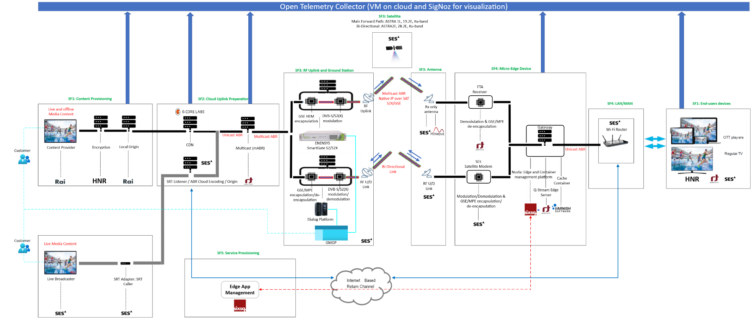

Figure 1: Conceptual diagram of SES DTH Testbed
The main components of the SES DTH testbed are described in Table 4

Table 4: Main components of SES DTH Testbed
System Function | Component | Type (HW/SW) | Responsible partner
SF1 | Encoder | HW | RAI
SF1 | Origin Server | HW | RAI
SF1 | License Server | SW | HNR
SF1 | CDN | HW+SW | G-Core
SF2 | Multicast-ABR Server | SW | FTA
SF3 | GSE-HEM Encapsulator | HW | SES
SF3 | DVB Modulator | HW | SES
SF3 | RF Uplink | HW | SES
SF3 | Satellite | HW | SES
SF3 | Rx Antenna | HW | SES and MinWave
SF4 | Receiver | HW+SW | FTA and SES
SF4 | mABR Edge Gateway Server | SW | FTA
SF4 | Cache | SW | Varnish
SF4/SF5 | Edge Devices and Apps Orchestrator | SW | SixSq
SF1 | Mobile Player App | SW | HNR and FTA
SF1 | UE for running Mobile and Web App | HW | SES
ALL SFs | Open Telemetry | SW | SES

3.2.2 EBU DTH testbed
Figure 2 below shows the EBU DTH testbed as part of the overall 5G-EMERGE distribution chain.
In the current phase, the satellite segment includes:
- One Egatel Dish roof top antenna (74 cm diameter) with Outdoor Unit (ODU) and Indoor Unit (IDU).
- One commercially available small dish (33 cm diameter) with Egatel ODU and IDU.
- Minwave foldable antenna with Egatel ODU and IDU.
- Satellite bidirectional capacity on Eutelsat HB13G (13°E).

The Egatel IDU uses MPE for the IP packet encapsulation.

On the source side, the Enensys Smartgate supports also MPE for the forward link. The same demonstration made in Phase 1 MS4 by the EBU can be done using the receiving equipment above.

As in Phase 1, the return channel by satellite has a limited bit rate, up to 140 kbits/s. With this limitation, it can be used for:
- DRM Control data, for example to do the Logon procedure of the Egatel box.
- Metadata from the Edge to the Recommendation system.
  - Requests for long tail content (other than the content pushed by the Recommendation system to the mABR Gateway).

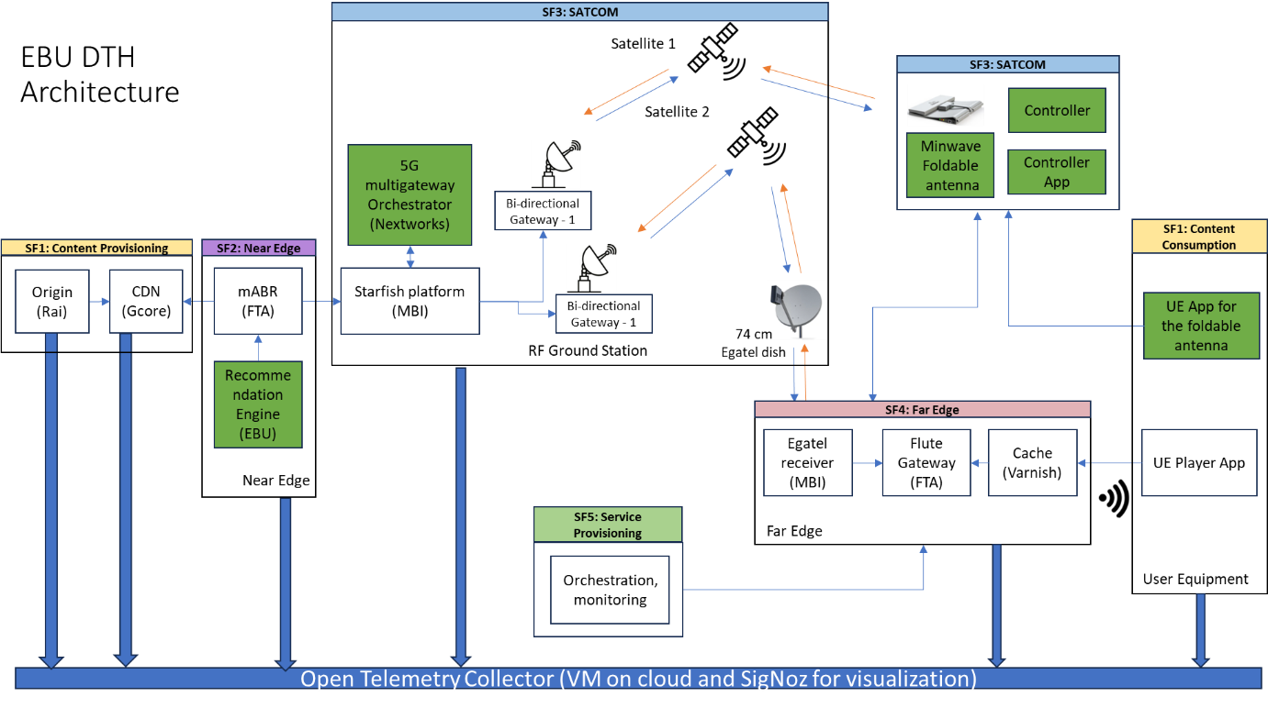
Figure 2: Diagram of the full configuration of the 5G-EMERGE satellite bidirectional platform used by the EBU testbed for Phase 2, including the foldable antenna (Minwave), the 5G multigateway Orchestrator (Nextworks) and the Open Telemetry (SES)

The main components of the EBU DTH testbed are described in Table 5.

Table 5: Main components of EBU DTH Testbed
System Function | Component | Type (HW/SW) | Responsible partner
SF1 | Encoder | HW | RAI
SF1 | Origin Server | HW | RAI
SF1 | License Server | SW | TBD
SF1 | Mobile player app | SW | TBD
SF1 | CDN | HW+SW | G-Core
SF2 | Multicast Server | SW | FTA
SF3 | Starfish Platform including | HW+SW | MBI
SF3 | 5G multigateway Orchestrator | SW | NXW
SF3 | MPE encapsulator | HW | MBI
SF3 | DVB modulator | HW | MBI
SF3 | RF Uplink | HW | MBI
SF3 | Return link frontend | HW | MBI
SF3 | Return link demodulator | HW | MBI
SF3 | Hub Linux servers including FTA Proxy | SW | MBI and FTA
SF3 | MBI Linux Firewall | SW | MBI
SF3 | Satellite | HW | Eutelsat
SF3 | Rx/Tx antenna | HW | MBI
SF4 | Edge Receiver | HW+SW | Egatel
SF4 | Antenna | HW | Minwave
SF4 | Antenna | HW | Technicat
SF4 | mABR Gateway | SW | FTA
SF4 | Cache | SW | Varnish
SF4/SF5 | Edge Devices and Apps Orchestrator | SW | SixSq
SF2 | Recommendation system | SW | EBU
All | Telemetry solution | SW | SES

3.3 Validation methodology

3.3.1 Functional testing methodology

The functional tests of the SES and EBU DTH testbed will follow the methodology defined in the Technical Note (TN) 2.3 Development Requirements (5G-EMERGE Phase 1 Technical Note , 2024) as well as in the deliverable Test Plan, Procedures and Report (TPPR) (5G-EMERGE Phase 1 Deliverable, 2024) of the Phase 1 of 5G-EMERGE.

3.3.2 Operational testing methodology

Operational tests will be conducted on the SES and EBU DTH testbed to:

- Assess the performance of the 5G-EMERGE system in different conditions.
- Collect metrics.
- Compare the 5G-EMERGE system with other classical content delivery systems such as terrestrial broadband.
- Conduct loading performance tests.

We would like to highlight that in Phase 1 of 5G-EMERGE, we noticed that end-to-end tests permitted to detect issues on the system using data collected and aggregated from the player. However, it was not enough as we were facing difficulties in the troubleshooting.

Hence, collecting telemetry data at every step of the 5G-EMERGE chain to understand better the behaviour of the system, with higher granularity is important. When multiple components provided by different vendors/actors are active in the chain, a jointly defined Open Telemetry protocol to aggregate comparative operational data is essential. Collecting data at every step of the 5G-EMERGE chain is necessary to understand and troubleshoot the problems.

An Open Telemetry installation guide has been described and can be found with more details in the Technical Note 3.1.5/3.23 Test Report of SES and EBU DTH Testbeds (Note).

Furthermore, EBU will use an in-house developed player based on Web App. It collects operational and user data. This Web App will be integrated in the telemetry platform provided by SES.

3.3.3 Test cases

The following test cases have been defined for the SES and EBU DTH testbeds:

MinWave - WP3.1.1

Test Case 1
Title: | In chamber and ab validation of flat panel antenna for DTH applications
Responsible Partner: | MinWave
Preconditions: | Pre1: | Design flat panel antenna according to the requirements
 | Pre2: | Implementation of the flat panel antenna
Description: | The goal of these tests is to validate the first revision of the flat panel antenna according to the project requirements and evaluating KPIs in terms of the antenna pattern, steering capabilities, beamwidth, sensitivity, and the calculations on G/T
Test Steps: | S1: | Functional tests in the lab for block level analysis, DC bias tests, microcontroller tests, and controlling all active components
 | S2: | The anechoic chamber tests for i) calibration of the antenna and ii) extracting the 2D radiation patterns in azimuth and elevation, iii) evaluating the performance of the antenna for azimuth steering, and iv) the sensitivity test, iv) test with modem, v) test with Antenna Control Unit (ACU)
Associated KPI: | - Directivity (>31dBi)  - Gain drop (<0.7dB/20degree)  - SLL>10dB
Actual Result: | - D=32dBi  - Gain drop=0.5/20degree

Test Case 2
Title: | In field validation of flat panel antenna for DTH applications in Lausanne and at SES test bed
Responsible Partner: | MinWave
Preconditions: | Pre1: | In lab and anechoic chamber validation of the antenna
 | Pre2: | Test of antenna with Low-Noise Block converter (LNB) and modem and ACU
Description:
Test Steps: | S1: | Use Geostationary Earth Orbit (GEO) satellite to validate the downlink parameters  Testing the steering and self-pointing feature of the antenna
 | S2: | If possible: evaluate the performance of the antenna in various conditions (weather, modulation rate of satellite transponder)
Associated KPI: | - SNR, Signal to Noise Ratio (>6dB for 54dBW Sat EIRP, QPSK modcod)  - G/T>3.5dB  - Field of view (40degree)
Actual Result: | N/A at this moment

FTA - WP3.1.2

Test Case 1
Title: | Live video streaming service reception, distribution and interoperability at home
Responsible Partner: | FTA
Preconditions: | Pre1 | Design and development of the DTH Gateway hardware and software according to its Product Requirements and Technical Specifications
 | Pre2 | Preparations of free-to-air live and VOD content and streams
 | Pre3 | Preparation of playout devices and player apps
 | Pre4 | Functional 5G-EMERGE near edge platform with satellite broadcast capacity on satellite
Description: | Reception of live and VOD mABR and NIP streams over a High-Definition Multimedia Interface (HDMI) output, navigation through DVB-I based Service Lists, download and playback of VOD content to/from local storage and streaming the above content to connected playout devices to test interoperability over a home-like Local Access Network (LAN)
Test Steps: | S1 | Far edge setup:  - Prepare content – live streams and VOD streams and make them available for streaming over the G-Core platform  - Ingest the content into the mABR/NIP Server to generate mABR/NIP streams and DVB-I metadata and output the streams to a DVB-S2X modulator via a proxy server
 | S2 | DTH receiver:  - Align a DTH dish antenna to 19.2E and connect the DTH Gateway and configure it to receive the mABR/NIP streams from the designated transponder  - Connect the DTH Gateway to a TV over HDMI and to a home-like LAN with connected playout devices  - Navigate through the DVB-I Service Lists, meta data of the streaming service, download and watch VOD content as an end user.
Associated KPI: | - Bootup time (<40s)  - Zapping time (<2s on same transponder; <10s between two different transponders on average)  - Decoding latency (<1s from the play start request on the client device)  - Number of connected playout devices (>3)  - Interoperability rate (>75% of Android 8 and iOS devices for AVC, >50% for HEVC)
Actual Result: | N/A at this moment

Test Case 2
Title: | Scaling test
Responsible Partner: | FTA
Preconditions: | Pre1 | Preparation of high bitrate content – live and VOD streams
 | Pre2 | For lab tests: Preparation of high bitrate DVB-S2/S2X signals with high symbol rates, high Modulation and Coding (ModCod), higher bandwidth, multiple carriers, multiple mABR/NIP-based services
 | Pre3 | For live test: same as Pre2 but over a live satellite capacity
Description: | Test the performance of the DTH Gateway under scaling satellite capacity conditions to simulate real-life deployments, understand the throughput limits that a DTH Gateway can support, validate the DTH Gateway functionality and performance in the presence of multiple mABR/NIP services on broadcast
Test Steps: | S1 | Set a testbed with a single mABR/NIP stream, a single transponder and scale up symbol rate, ModCod and bandwidth. Test reception and playback over HDMI and LAN streaming to playout devices
 | S2 | Scale up the number of mABR/NIP streams. Test reception and playback over HDMI and LAN streaming to playout devices
 | S3 | Scale up the number transponders. Test reception and playback over HDMI and LAN streaming to playout devices
Associated KPI: | - Zapping time between different transponders and different mABR/NIP streams (<10s)  - Max. symbol rate (60MS/s)  - Max. Bitrate (180Mbps)  - Decoding latency (<200ms)  - Number of connected playout devices (>3)  - Ability of the DTH Gateway to handle multiple mABR/NIP streams (Yes, 2 in case of dual tuner)
Actual Result: | N/A at this moment

SES - WP3.1.3

Test Case 1
Title: | Secure Real-time Transport (SRT) Sourced Contribution of Live Broadcast TV signals to the mABR Server and subsequent satellite transmission to the Client
Responsible Partner: | SES
Preconditions: | Pre1: | Tool needs to be fully developed and tested
 | Pre2: | Broadcast Quality TV Signals need to be made available via Serial Digital Interface (SDI) or HDMI
Description: | This test case is designed to test the complete end-to-end chain utilising the newly developed tool for ingesting live TV signals into the mABR infrastructure established in phase 1 of the project. Rather than rely on commercial encoders, this tool provides all the functionality for broadcasters to encode their live signals in the cloud, maintaining the initial quality and perfectly matching the encoding parameters to the requirements for state-of-the-art ABR transmissions
Test Steps: | S1: | Setup the network infrastructure for testing
 | S2: | Using actual Live Video Signals follow the signal path throughout the chain and validate delivery at the Client
Associated KPI: | - Broadcast Quality maintained from SRT source to Client Player  - Content Playable in both HLS and DASH
Actual Result: | The results were presented in the MS1 demo from SES and they will be reported in the final version of this document

Test Case 2
Title: | Real-time Transport Protocol (RTP) Sourced Contribution of Live Broadcast TV signals to the mABR Server and subsequent satellite transmission to the Client
Responsible Partner: | SES
Preconditions: | Pre1: | Tool needs to be fully developed and tested
 | Pre2: | Broadcast Quality TV Signals need to be made available via Multicast RTP
Description: | This test case is designed to test the complete end-to-end chain utilising the newly developed tool for ingesting live TV signals into the mABR infrastructure established in phase 1 of the project. Rather than rely on commercial encoders, this tool provides all the functionality for broadcasters to encode their live signals in the cloud, maintaining the initial quality and perfectly matching the encoding parameters to the requirements for state-of-the-art ABR transmissions
Test Steps: | S1: | Setup the network infrastructure for testing
 | S2: | Using actual Live Video Signals follow the signal path throughout the chain and validate delivery at the Client
Associated KPI: | - Broadcast Quality Video maintained from RTP source to Client Player throughout the 5G-EMERGE chain  - Content Playable in both HLS and DASH
Actual Result: | The results were presented in the MS1 demo from SES and they will be reported in the final version of this document

SES - WP3.1.4

Test Case 1
Title: | Request of Video Service Through a bi-directional satellite link via GMOP (Global Mission Operation Platform)
Responsible Partner: | SES
Preconditions: | Pre1: | GMOP fully developed
 | Pre2: | Broadcast TV signal, ISP connectivity
Description: | This test case is designed to demonstrate the request, activation monitoring and control of video + data transmission services through a bi-directional satellite link via the GMOP Graphical user Interface (GUI)
Test Steps: | S1:
 | S2:
Associated KPI: | - User request processing time < 15 min  - Video and Data Simultaneous transport with no or few events and high video quality (High Definition)
Actual Result: | N/A at this moment

Test Case 2
Title: | Request of Video service through a linear broadcasting satellite transmission via the GMOP (Global Mission Operations Platform)
Responsible Partner: | SES
Preconditions: | Pre1: | GMOP fully developed
 | Pre2: | Broadcast TV signal
Description: | This test case is designed to demonstrate the request, activation monitoring and control of Vide transmission services through a linear satellite broadcasting via the GMOP GUI
Test Steps: | S1:
 | S2:
Associated KPI: | - User request processing time < 15 min  - Video transport with no or few events and high video quality (High Definition)
Actual Result: | N/A at this moment

SES - WP3.1.5
Test Case 1
Title: | Verification of integration of player with 5G-EMERGE test setup
Responsible Partner: | SES
Preconditions: | Pre1: | Player integration into an Android/IOs application by FTA
Description: | The new player must be thoroughly tested to verify the functional replacement of the Nagra player:  - Correct playback of Live Video and Video on Demand  - Possibility to add DRM protection  - Off-line playback test  - Analytics collection verification and visualization
Test Steps: | S1: | Setup of 5G-EMERGE far-edge infrastructure and install application on mobile device
 | S2: | Using the mobile device start testing mentioned features. For the verification of the analytics collection, access to an analytics platform must be provided (preferably Open Telemetry)
Associated KPI: | Content received by far edge server being accessible to player and playback initiation in defined quality
Actual Result: | The first preliminary results are presented in Section 3.4 of this document

Test Case 2
Title: | Verification of traceability of http GET requests from deployed Open Telemetry clients on the Open Telemetry collector
Responsible Partner: | SES, FTA, Rai
Preconditions: | Pre1: | FTA deployed and configured Open Telemetry clients on mABR, Far-Edge (Q stream) Server and Mobile application (option)
Description: | Verify that the http GET requests are captured and traced by the Open Telemetry collector running on an SES VM on Azure. The Open Telemetry client modules must be installed – at least – in the mABR and Q Stream server (FTA)
Test Steps: | S1: | On a browser, from a whitelisted public IP, open URL of SES deployed server, on port 3301
 | S2: | Verify that in the "Trace" tab of the Signoz platform, traces from FTA are present and chained
Associated KPI: | 24/7 monitor and traceability of signal chain
Actual Result: | The first preliminary results are presented in Section 3.4 of this document

Test Case 3
Title: | Directly test average start-up times across methods
Responsible Partner: | SES
Preconditions: | Pre1: | Player capable of measuring start-up time
 | Pre2: | Test stream available both on satellite (Edge) and broadband connection (CDN)
Description: | Inputs:  - Time measurements from user request initiation to video playback start across CDN, Edge, etc.  - Controlled tests under consistent network conditions  Outputs:  - Average startup delay (seconds) for each method  - Comparative dataset of responsiveness across methods
Test Steps: | S1: | Measure start-up time with Player connected via Edge
 | S2: | Measure start-up time with Player connected via CDN
Associated KPI: | Start up time via Edge <= Start up time via CDN
Actual Result: | The first preliminary results are presented in Section 3.4 of this document

Test Case 4
Title: | Compare buffering frequency under different methods
Responsible Partner: | SES
Preconditions: | Pre1: | Player capable of measuring buffering events (playback interruptions) over longer playback periods
 | Pre2: | Test stream available both on satellite (Edge) and broadband connection (CDN)
Description: | Inputs:  - Playback logs recording frequency of buffering events per stream  - Method identifiers (CDN, Edge, etc.)  Outputs:  - Average buffering frequency per session across methods  - Comparative quality dataset ranking methods by smoothness of playback
Test Steps: | S1: | Start playback from Edge for long period. Measure player interruptions in specific timeframe
 | S2: | Start playback from CDN for long period. Measure player interruptions in specific timeframe
Associated KPI: | Rebuffering events Edge <= Rebuffering events CDN for e.g., 30min
Actual Result: | The first preliminary results are presented in Section 3.4 of this document

Test Case 5
Title: | Track frequency of resolution switches under different delivery
Responsible Partner: | SES
Preconditions: | Pre1: | Player capable of measuring resolution switch events
 | Pre2: | Test stream available both on satellite (Edge) and broadband connection (CDN)
Description: | Inputs:  - Playback logs recording resolution/bitrate changes during sessions  - Distribution method identifiers (CDN, Edge, etc.)  - Session metadata (network conditions, location)  Outputs:  - Frequency of resolution switches per stream across delivery methods  - Comparative dataset of playback stability
Test Steps: | S1: | Start playback from Edge. Measure resolution switches in specific timeframe
 | S2: | Start playback from CDN. Measure resolution switches in specific timeframe
Associated KPI: | No change resolution for Edge for e.g., 30min/1h of viewing  Change resolution events Edge <= change resolution events CDN
Actual Result: | The first preliminary results are presented in Section 3.4 of this document

Test Case 6
Title: | Track downtime as resilience indicator
Responsible Partner: | SES
Preconditions: | Pre1: | Monitor all uplink components with Open Telemetry (Content provider, mABR) for error events in stream signal chain
 | Pre2: | Monitor downlink components with Open Telemetry (GW) for error events in stream signal chain
Description: | Inputs:  - Continuous monitoring of service availability across distribution methods  - Logs of outage events, duration, and cause  Outputs:  - Percentage of uptime vs downtime across methods  - Frequency and severity of downtime incidents
Test Steps: | S1: | Deploy Open Telemetry on Content provider, mABR and GW
 | S2: | Measure error events in time-window to calculate frequency of error events
Associated KPI: | No Downtime for Edge / No downtime for CDN for e.g., 30min/1h of viewing
Actual Result: | The first preliminary results are presented in Section 3.4 of this document

MinWave - WP3.2.1
Test Case 1
Title: | Field tests of foldable reflector antenna (nomadic) at EBU testbed and in Lausanne office of MinWave
Responsible Partner: | MinWave
Preconditions: | Pre1: | Revision 2 of the foldable antenna to be implemented
 | Pre2: | In lab validation of the implemented (Ver.1 and Ver.2)
Description: | Validate the performance of implemented antenna with GEO satellites for downlink and uplink. We will test the antenna in various conditions to test the SNR and data rate for RX and Effective Isotropic Radiated Power (EIRP) test for TX. Also, the steering and beamforming algorithm.
Test Steps: | S1: | In field tests to validate the performance of receiver antenna
 | S2: | In field tests to validate the performance of transmitter antenna
Associated KPI: | Link budget parameters for downlink and uplink including the data rates, SNR and EIRP SNR>7dB, Received return signal at Gateway with SF:64 or 256
Actual Result: | The forward link tests are done at MinWave location and also at EBU testbed in Geneva. The SNR is measured 7.8-8dB. Demodulation and video stram with various QPSK FECs.  The orchestration tests are done at MBI for forward link, return link and we have measured end to end parameters. REST API, switching of the gateway and autopointing functionalities are successful.  The return link tests are done at Lausanne, Geneva and Pisa with Lower SNR =3-4dB.

Test Case 2
Title: | Conformance tests of foldable reflector antenna (nomadic)
Responsible Partner: | MinWave
Preconditions: | Pre1: | In house validation of the antenna
 | Pre2: | In third party test facilities
Description: | Qualify the foldable reflector antenna according to the required standards. The standard outlines essential requirements to ensure that terminal does not cause harmful interference and operates efficiently within the allocated frequency bands
Test Steps: | S1: | Implement test setup for validation of the antenna following conformance standard procedures with in-house anechoic chamber
 | S2: | Validate the antenna in a certified chamber
 | S3: | Procedures to verify compliance with technical specifications
Associated KPI: | Conformance certificate from certified authority,  Pattern Mask, EIRP <37dBW
Actual Result: | The EIRP is acceptable for eutelsat evaluation team

MBI - WP3.2.2
Test Case 1
Title: | Detection of far-edge updated location
Responsible Partner: | MBI
Preconditions: | Pre1 | Satellite terminal including foldable reflector antenna is fully operational
 | Pre2 | Bidirectional satellite connectivity is up and running
Description: | Verify that, once geographically relocated, the far edge provides the near edge with the updated set of coordinates describing its new position. The HUB provides to the monitoring platform, upon request, the updated set of coordinates
Test Steps: | S1 | A new geographic location of the far edge is emulated according to a nomadic behaviour
 | S2 | The far edge provides the near edge with the updated set of coordinates describing its new position
 | S3: | The satellite HUB provides to the monitoring platform the updated set of coordinates
Associated KPI: | Bidirectional satellite connectivity, signal-to-noise ratio ratio >-2dB on the fwd link before switching on the new beam (required minimum for reception of QPSK ¼ signalling)
Actual Result: | Preliminary test confirm successful logon of the nomadic terminal on the STARFISH Platform (both lab and real satellite link).

Test Case 2
Title: | 5G-orchestrated Satellite Gateway-switch
Responsible Partner: | MBI
Preconditions: | Pre1 | Satellite terminal including foldable reflector antenna are fully operational
 | Pre2 | Bidirectional satellite connectivity is up and running
Description: | Verify that the orchestrator successfully triggers a gateway switch when required. The near edge delivers the updated parameters to the far edge, producing the related messages to the auto-pointing antenna and the satellite terminal
Test Steps: | S1 | The orchestrator receives the updated position of the far edge and triggers a gateway switch, if required
 | S2 | The near edge delivers the updated parameters to the far edge, producing the related messages to the auto-pointing antenna and the satellite terminal
Associated KPI: | Bidirectional satellite connectivity, signal-to-noise ratio > 5dB on the fwd link after switching on the new beam
Actual Result: | Preliminary test for HUB-managed remote reconfiguration of the nomadic terminal (satellite terminal and antenna controller) have been performed in lab environment.

EBU - WP3.2.3
Test Case 1
Title: | Playout of content received through the roof top Egatel antenna, with sending telemetry data
Responsible Partner: | EBU
Preconditions: | Pre1: | User Equipment App integrated into the SES telemetry platform
 | Pre2: | The end-to-end distribution chain is up and running with at least one content available
Description: | This test is required to verify the correct reception with the new satellite segment and to check the implementation of the telemetry solution
Test Steps: | S1: | Setup of 5G-EMERGE far-edge infrastructure, including the module related to the telemetry solution
 | S2: | Start playout session and show analytics collection accessed through the implemented telemetry solution
Associated KPI: | - Content received on the User App in the defined quality  - Analytics received from the telemetry system and visualised
Actual Result: | The Live HLS “Rai-Crits” channel as well as the VoD “5GBroadcast” content are played out correctly with the three resolutions on the EBU Web player using the three available antennas (Egatel 74 cm, Technisat 33 cm and Minwave foldable antenna) and metrics are sent out and received on the Signoz local instance.

Test Case 2
Title: | Integration of FTA Mobile App on mobile device, playout and analytics
Responsible Partner: | EBU
Preconditions: | Pre1: | FTA Mobile App implemented on a mobile device integrated into the SES telemetry platform
 | Pre2: | The end-to-end distribution chain is up and running with at least one content available
Description: | This test is required to verify reception on a mobile device with provision of analytics
Test Steps: | S1: | Setup of 5G-EMERGE far-edge infrastructure, including the module related to the telemetry solution
 | S2: | Using the Mobile App, start playout session and show analytics collection accessed through the implemented telemetry solution
Associated KPI: | - Content received on the Mobile App in the defined quality  - Analytics received from the telemetry system and visualised
Actual Result: | The Live HLS “RAI-Crits” channel as well as the VoD “5GBroadcast” content are played out correctly with the three resolutions: 4.5 Mbps ->1920x1080 (Full HD), 2 Mbps -> 1280x720p25 (HDTV), and 1 Mbps -> 720x480p25 (SD) on the FTA Mobile App using the three available antennas (Egatel 74 cm, Technisat 33 cm and Minwave foldable antenna) and metrics are sent out and received on the Signoz local instance.

Test Case 3
Title: | Average startup time
Responsible Partner: | EBU
Preconditions: | Pre1: | FTA Player App can access the Streams delivered by the Far Edge
 | Pre2: | FTA Player App can publish the relevant data
Description: | This end-to-end/performance test aims at measuring the quality of experience of receiving a stream
Test Steps: | S1: | The Player requests the stream
 | S2: | Measure the start time of the Playout
Associated KVI | Quality
Associated KPI: | Start-up delay
Actual Result: | 369 ms (for 31 playout starts in 5 minutes) with the Minwave antenna  270 ms (for 10 playout starts in 5 minutes) with the TechniSat 33 cm antenna

Test Case 4
Title: | Average buffering frequency
Responsible Partner: | EBU
Preconditions: | Pre1: | FTA Player App can access the Streams delivered by the Far Edge
 | Pre2: | FTA Player App can publish the relevant data
Description: | This end-to-end/performance test aims at qualifying the network quality
Test Steps: | S1: | The playout starts and displays a stream in one of the available resolutions
 | S2: | Leave the stream playing during [30 minutes]
Associated KVI | Quality
Associated KPI: | Buffering Ratio / Rebuffering Events
Actual Result: | Total buffering duration:  19163 ms during 30 minutes with the Minwave antenna  0 ms during 30 minutes with the TechniSat 33 cm antenna

Test Case 5
Title: | Frequency of resolution switches
Responsible Partner: | EBU
Preconditions: | Pre1: | FTA Player App can access the Streams delivered the Far Edge
 | Pre2: | FTA Player App can publish the relevant data
Description: | This end-to-end/performance test aims at checking that the player switches between different resolutions
Test Steps: | S1: | The playout starts and displays a stream in one of the available resolutions
 | S2: | Leave the stream playing during [30 hours]
Associated KVI | Quality
Associated KPI: | Bitrate Stability / QoE
Actual Result: | Number of Resolution Switches:  86 during 30 minutes with the Minwave antenna  0 during 30 minutes with the TechniSat 33 cm antenna

Test Case 6
Title: | Percentage of uptime vs downtime
Responsible Partner: | EBU
Preconditions: | Pre1: | FTA Player App can access the Streams delivered by the Far Edge
 | Pre2: | FTA Player App can publish the relevant data
Description: | This end-to-end/performance test aims at qualifying the availability of the stream.
Test Steps: | S1: | The playout starts and displays a stream in one of the available resolutions
 | S2: | Leave the stream playing during [24 hours]
Associated KVI | Resilience
Associated KPI: | Availability (Uptime %)
Actual Result: | Downtime duration:  19163 ms during 30 minutes (1 %) with the Minwave antenna  0 ms with the TechniSat 33 cm antenna

3.4 Key results
In this Section 3.4, the results of the test cases identified in Section 3.3 are summarized. We need to highlight that in this second version only some preliminary results for some test cases are presented, while the full results for all the test cases will be provided in the 3rd and final version of this document.

3.4.1 Results of Test Cases of WP3.1.1
The flat panel antenna is tested for Test Case1 of WP3.1.1. All results are reported in TN3.1.1.2 of MS2 deliveries. in summary:
- Antenna modules and subarray are tested. The gain =12dBi with Matching >10dB showed successful results
- The functional test on full array are done. The radiation pattern measured. Directivity D=32dBi and beamwidth<4degree.
- Beam steering is successful for –20 degree to 20degree with Gain drop <0.7dBi/ 20degree

3.4.2 Results of Test Cases of WP3.1.2
The results are not applicable at this moment, but they will be reported in the 3rd and final version of this document.

3.4.3 Results of Test Cases of WP3.1.3
The results were presented in the demo of SES during the MS1, but they will be reported in the 3rd and final version of this document.

3.4.4 Results of Test Cases defined in WP3.1.4
The results are not applicable at this moment, but they will be reported in the 3rd and final version of this document. SES is planning to conduct and finalize the tests by May 2026.

3.4.5 Results of Test Cases defined in WP3.1.5
In this 2nd version of the document some preliminary results of the tests in the SES Testbed will be presented.
As have been mentioned, the Remote GW deployed in the SES Testbed is sharing telemetry data to the OTel collector deployed on an SES VM on the cloud. The Remote GW responds to HTTP requests that players connected in the same LAN of the SES test bed are making.
As we can see from Figure 3, the Remote GW was responding with 404 error messages for many player requests, a-periodically. In this graph, we can see that there are time clusters of error HTTP requests generated from the Remote GW and sent also to the OTel Collector in the SES VM in Azure.
The hypothesis that the remote connection between the mABR server and modulator was tested. On 5/12 the two (mABR server and modulator) where collocated and the errors dropped to zero.
So, it was proven that the remote connection was generating issues and then the issue was solved.

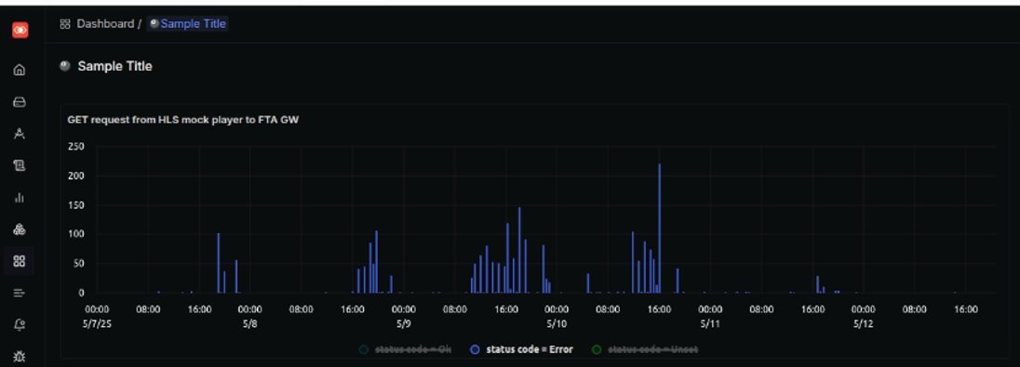

Figure 3: Telemetry data via the OTel collector deployed on an SES VM on the cloud
We also monitored the Remote GW traces shared to the OTel collector. After the collocation of the server another solid block of HTTP error was found, as then one depicted in Figure 4, between 20 and 22 of May 2025.

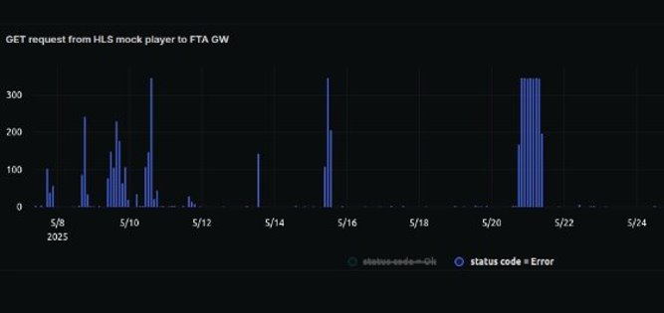

Figure 4: Remote GW traces shared to the OTel collector
The fixed number of HTTP errors per unit of time indicated a persistent error. After debugging together with FTA a minor bug on the mABR server was identified and corrected. The bug was related to the behavior of the mABR server when it received HTTP error responses from the content servers.
In the beginning, such a response was causing a stop in the live streams of the mABR servers. This bug, after identification was resolved very fast by the FTA team.
Furthermore, we also monitored the HTTP responses of the content server at RAI. An OTel client Nginx server has been deployed as to push all traces to the OTel Collector located on the SES VM in Azure. Occasionally, when we monitored some HTTP errors at the Remote GW (low number ~ 2-3 per 5 min), we noticed that the number of HTTP success responses per unit of time at the content server at RAI was dropping. This can be clearly seen in Figure 5.

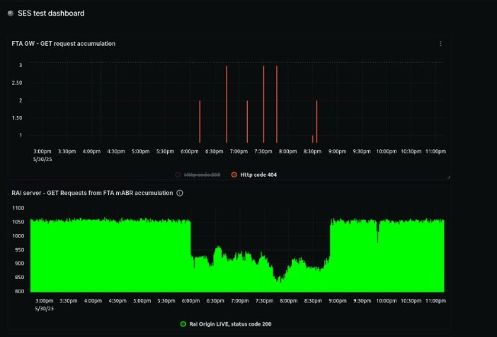

Figure 5: Monitoring the HTTP responses of the content server at RAI
The expected behaviour would be to have a relatively constant number of successful (code 200) HTTP requests at RAI at any time interval selection.

Unfortunately, the above behaviour can indicate one of two:
- mABR server not making the necessary HTTP requests to the RAI server (possible but unlikely).
- Congestion between RAI content server and mABR server so that no request is arriving at the content server in specific time intervals.
To verify the source of the error, the mABR server needs to share HTTP status codes to the OTel server deployed on the SES VM.

WP3.1.5 – Test Case 1 – Player Integration Verification

A basic test to verify the integration of the FTA player took place on the SES test bed. After the FTA player was installed on a test android phone (One Plus) the Remote GW was found and all the content on the satellite was available on the Player App, as shown in Figure 6.
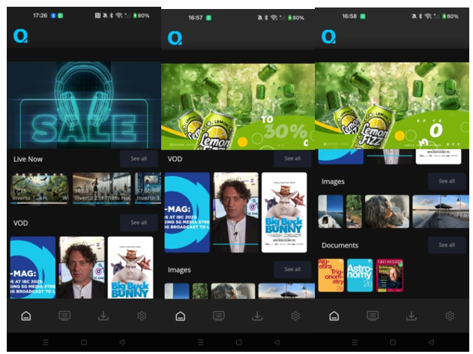

Figure 6: Content on the satellite available on the Player App provided by FTA

WP3.1.5 – Test Case 2 – HTTP Get Traceability
While the FTA player App was streaming any video from Remote GW, the latter keeps sharing traces monitoring data with the deployed OTel collector on the SES VM on Azure. We can now see clearly, in Figure 7, the traces from the HTTP requests of the APP to Remote GW.
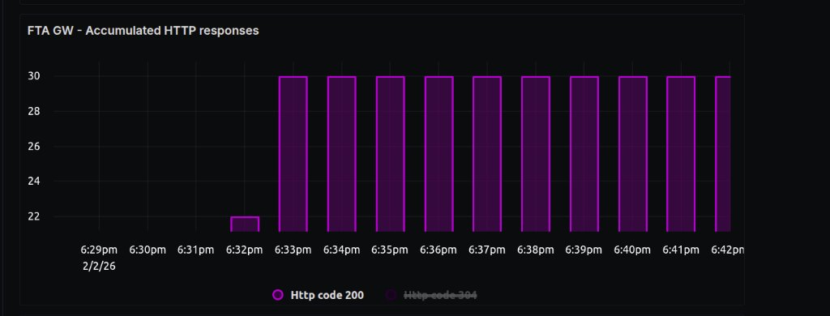
Figure 7: HTTP Get traceability
The HTTP code 200 is the result of a successful answer of the remote GW to a request from the App.

WP3.1.5 – Test Case 3 – Start-up Time Measurement
The FTA player app can share to an OTel Collector regarding the user experience of player user. One parameter monitored is the start-up. In this test a stream available on Remote GW was started from the App.
The App was sharing the time necessary to start the video and it can be seen in Figure 8.
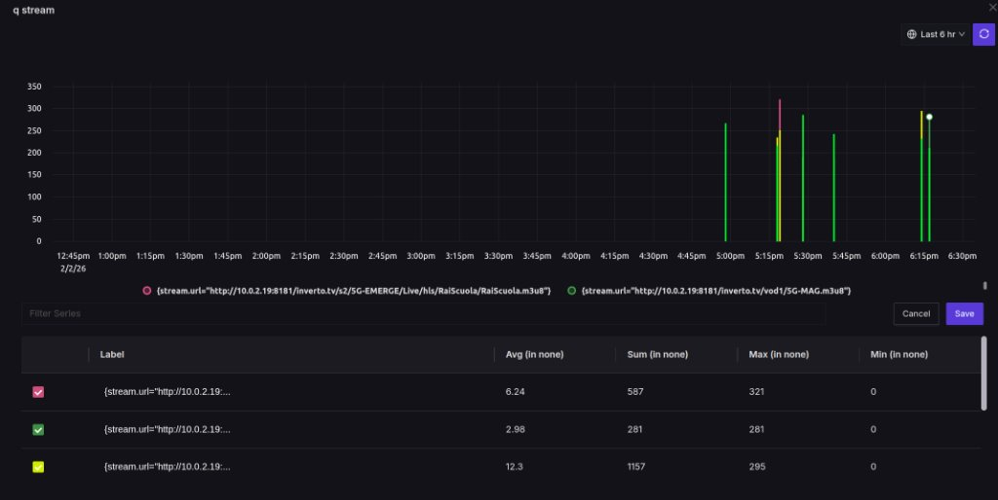
Figure 8: Start-up time measurement
The maximum time measured for about 10 videos start up events was around 321 msec. This test was limited to streams only from the satellite path. This test must be extended and compared to the results between streams from the satellite and CDN paths.

WP3.1.5 – Test Case 4 – End Buffering Duration
The FTA app can also share monitoring data regarding the buffering duration of the streams viewed. In the current setup the buffering duration was monitored for the satellite path streams.
As can be seen in Figure 9 the max buffering time for multiple streams has been 309msec. This result must be compared to the CDN buffering time.
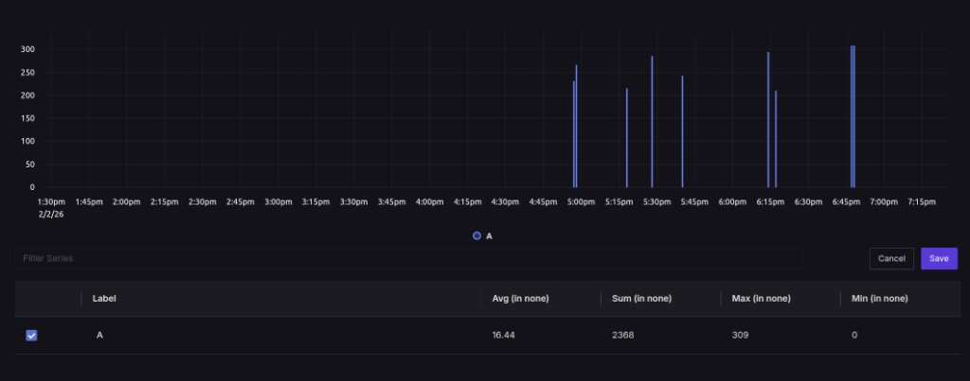
Figure 9: End buffering duration

WP3.1.5 – Test Case 5 – Video Resolution Changes

The App also monitors and communicates the viewing resolution to the OTel server. The number of lines and columns can be found in Figure 10 for multiple streams.

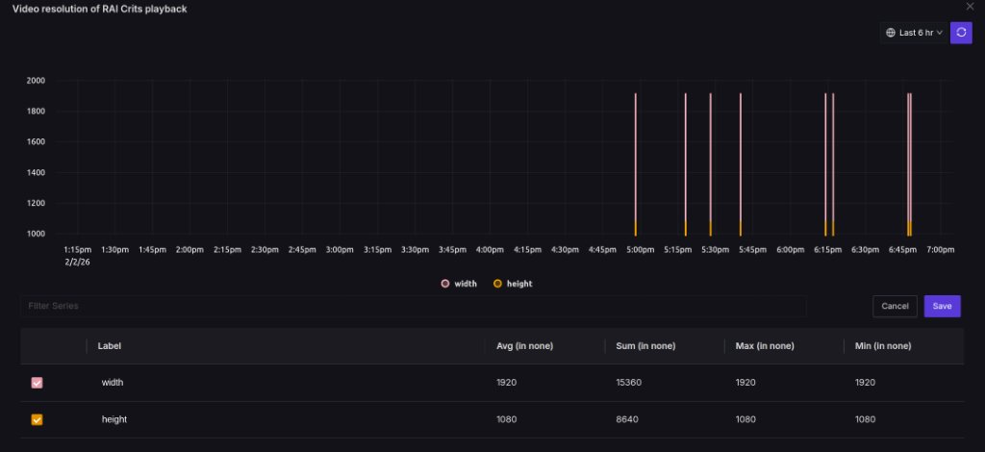

Figure 10: Video resolution changes
As we can see, the resolution has been constant 1920 x 1080 for all started streams. Furthermore, the resolution has been stable for all viewing time. The same test must take place via CDN.

WP3.1.5 – Test Case 6 – Error Playback Counting
The player App can also share results regarding possible errors during playback of streams. As we can see in Figure 11, two playback errors were captured.
Error monitoring can be very helpful for stability measurements and basic user experience understanding.
The same measurement has to be repeated for long period of viewing and for both satellite and CDN streams.

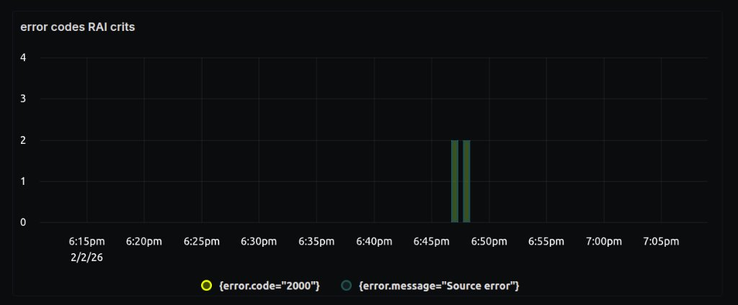

Figure 11: Error playback counting

3.4.6 Results of Test Cases defined in WP3.2.1
The reflector based MinWave Nomadic antenna is tested for Test case 1 and test case 2. In MS2 delivery report TN3.2.1.2 the full tests results are reported in detail including:
- RF antenna tests on new antenna modules: Matching (>10dB), Isolation (>30dB) and coupling (>17dB)
- RF functional board tests are done on antenna with added gain of each meta-antenna >4dB
- The antenna directivity of phase array feed without reflector in the chamber =23dBi (with reflector expected 30dBi)
- The forward link tests are done at MinWave location in Lausanne and at EBU testbed in Geneva. The measured SNR was 7.8-8dB.
- The orchestration tests are done at MBI for forward link, return link and end to end parameters are measured.
- MinWave REST API, switching of the gateway and auto pointing functionalities are successful at MBI test bed.
- The return link tests are done in Lausanne, Geneva and Pisa with Lower SNR =3-4dB of RX (forwarlink) due to the isolation issue of antenna.
- EIRP of antenna is measured and reported to Eutelsat for evaluation. EIRP pattern is approved.

3.4.7 Results of Test Cases defined in WP3.2.2
Preliminary tests have been conducted with the nomadic terminal (MinWave foldable antenna integrating an Egatel SmartLNB satellite terminal) operating with the STARFISH Platform. Preliminary results confirm:
- the capability to complete a successful logon of the nomadic terminal on the STARFISH Platform using the Hypercube Smartphone App connected via WiFi to the satellite terminal. The App will be used to provide the STARFISH HUB backend with the latitude and longitude of the nomadic terminal. This information will be used by the 5G Network Orchestrator to determine the recommended beam for the current location.
- the nomadic terminal (satellite terminal and antenna controller) has been remotely reconfigured via manual REST command invoked at HUB side.

3.4.8 Results of Test Cases defined in WP3.2.3
The preliminary results reported in the Test Cases above related to WP3.2.3 show that
- The end-to-end solution proposed by 5G-Emerge works
- Different antennas can be used, including the Foldable antenna with reflector and Phased array developed by Minwave for the 5G-Emerge project. The various performances of the antennas require finding a solution to optimize the usage of satellite resources
- The Mobile App player developed by FTA works well. It extracts and send metrics for performance assessment
- The Minwave antenna associated with the special Egatel terminal show degraded QoS indicators (Buffering, downtime) compared to a fixed antenna with similar performance. This issue will be further investigated
The results and tests above concern only the forward link. Work on the Return Links will be provided later in the project.

4. Test and validation plan for Strand 4: Direct to vehicle
The work in Strand 4 is divided into two main activities, each centred around specific test platforms, with a focus on the development of features and sub-features for the Direct-to-Vehicle (DTV) use case scenario.
- The first test platform is the Viasat DTV testbed. This testbed is centred around the development of a low-cost flat panel phased array antenna in Ka-band for mobility (TERESA) and its integration into the 5G-EMERGE environment. The low-cost antenna prototype developed by Viasat will be integrated with a modem that holds the orchestration functions from MBI. The terminal will be operated onto SES network using ASTRA GEO satellite in order to broadcast content from RAI, orchestrated by MBI.
- The second test platform is the LINKS Turin DTV testbed. The main goal of this testbed is the testing of the phased array antenna designed in Phase 1 by LINKS and its integration in an end-to-end demonstrator for content redistribution inside a moving vehicle. The antenna has been designed for GEO satellite reception in the Ku-band.
In the next subsections, the following activities will be reported for both testbeds:
  - High-level description of the test plan
  - Testbed and setup
  - Validation methodology
  - Key results.

4.1 Viasat - DTV testbed

4.1.1 High-level description of the test plan
The test flow of the TERESA terminal can be divided into five phases as described in Figure 12 below. TERESA terminal (which is currently under development) will go through 5 main phases/steps for its validation. Phases/steps 1 to 4 are related to the validation of the terminal itself (RF tests, HW tests, etc) while phase/step 5 is related to the integration of this terminal into the 5G-EMERGE ecosystem (e.g., receiving live TV stream from GEO satellite in display it on monitor inside the vehicle).

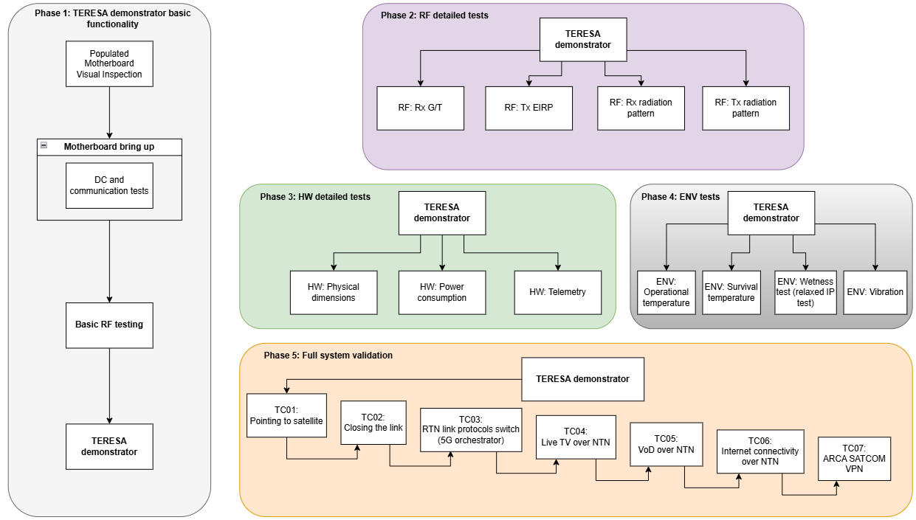
Figure 12: TERESA test flow

4.1.2 Testbed and setup

The Functional block diagram of the Testbed is shown in Figure 13.

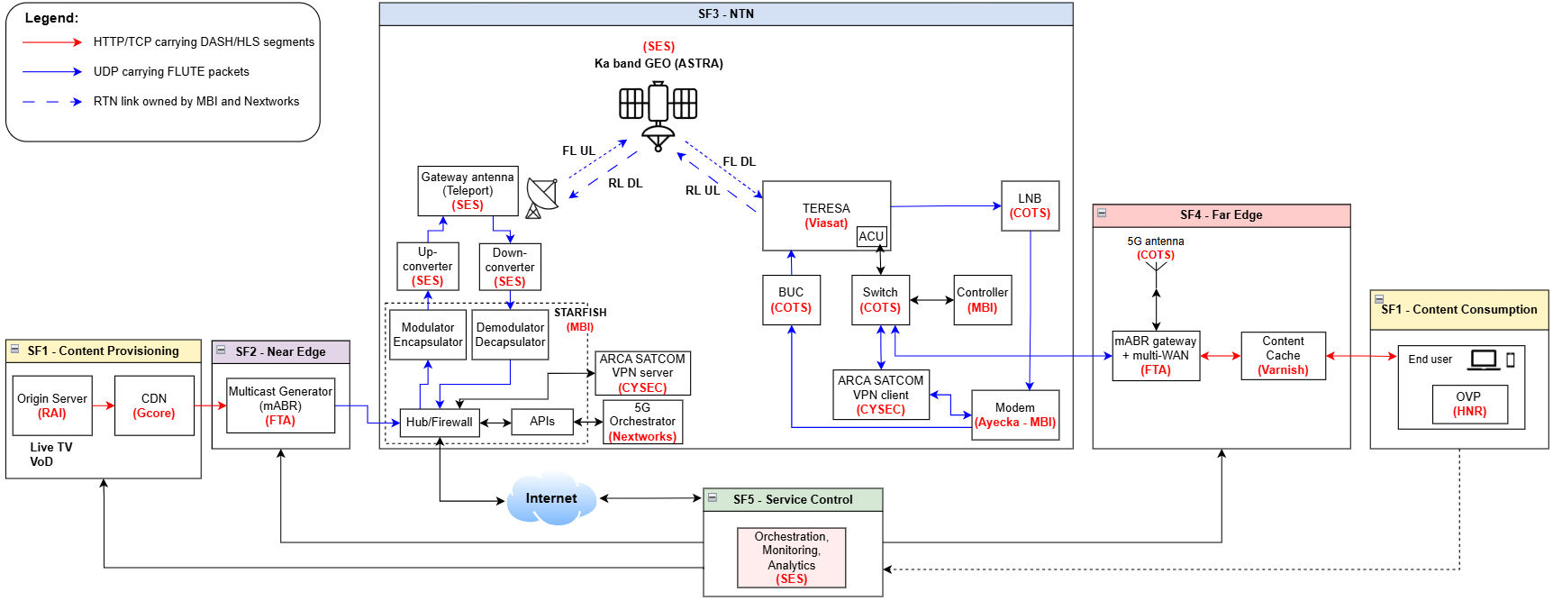

Figure 13: Viasat - DTV testbed functional bloc diagram

4.1.3 Validation methodology

  - On top of the following test cases that focus on quantitative measurements, qualitative feedback will also be collected from test users. This feedback will include QoS metrics such as Wi-Fi connection quality, speed, ease of access, robustness as well as stream resolution.

Stages 1 to 4 are related to TERESA antenna validation before implementing it into 5G-EMERGE ecosystem. Since it is at antenna component level, no KPI is involved in these phases.

Stage 5 is related to the validation of the TERESA antenna within the 5G-EMERGE ecosystem. The corresponding KPIs are listed at the end of each test case from phase 5.

4.1.3.1 Stage 1 (antenna preliminary testing)

High level plan | Basic functionality | Notes
Objective | Test the basic functionalities of the terminal
Note on Req. Tested
Pass/Fail Criteria
Test Setup | Terminal in SNFS
Procedure | - Perform a visual inspection of the populated motherboards  - Perform the bring-up of the motherboards  - Perform basic DC and communications tests  - Perform basic RF testing
Expected Deliverable
Expected Results | The motherboards have no visual defects, they are correctly power supplied, they can be controlled and monitored and they pass basic RF testing

4.1.3.2 Stage 2 (antenna preliminary testing)
High level plan | Rx G/T | Notes
Objective | Measure the terminal G/T for a set of beam states
Note on Req. Tested
Pass/Fail Criteria | Terminal has G/T higher or equal to 10dB/K across the Rx band for scan angles from 0° to 60°
Test Setup | Terminal in SNFS | Requires RF power level calibration
Procedure | For a given set of configurations:  - Scan directions (θ = 0, 45, 60; φ = 0, 30, 90) TBC  - Beam set frequencies: 17.7 to 20.2GHz every 500 MHz TBC  - RFIC bias: at least 3 modes TBC  - Polarization: single TBC  - Nominal second stage setting  For each configuration:  - Input power: Find input power corresponding to OP1dB, OP3dB and 10 dB back-off from P3dB or perform a power sweep TBC  - Measure active antenna gain for each configuration and input power.  - Measure active antenna noise temperature for each configuration and input power.  - Deduce G/T from active antenna gain and noise temperature.
Expected Deliverable | G/T variation over input power level and antenna configurations.
Expected Results | Terminal shall have G/T higher or equal to 10dB/K for scan angles from 0° to 60°

High level plan | Tx EIRP | Notes
Objective | Measure the terminal EIRP for a set of beam states.
Note on Req. Tested
Pass/Fail Criteria | The terminal has a minimum EIRP of at least 51dBW over the scan range when averaged over up to 80MHz of instantaneous bandwidth, at any operating frequency within transmit frequency band and 25°C ambient temperature.  The terminal has a minimum EIRPSD of at least 32dBW/MHz over the scan range while being compliant with regulatory constraints.
Test Setup | Terminal in SNFS | Requires RF power level calibration
Procedure | For a given set of configurations:  - Scan directions (θ = 0, 45, 60; φ = 0, 30, 90) TBC  - Beam set frequencies: 27.5 to 30 GHz every 500 MHz TBC  - RFIC bias: at least 3 modes TBC  - Polarization: single TBC  - Nominal second stage setting  For each configuration:  - Input power: Find input power corresponding to OP1dB, OP3dB and 10 dB back-off from P3dB or perform a power sweep TBC  - Measure active antenna gain for each configuration and input power.  - Deduce EIRP from active antenna gain and input power.
Expected Deliverable | EIRP variation over input power level and antenna configurations.  EIRPSD | EIRPSD = EIRP - 10log(BW) [dB/MHz]
Expected Results | EIRP > 51dBW over 80MHz  Mask>EIRPSD>32dBW/MHz

High level plan | Rx radiation pattern | Notes
Objective | Measure the Rx aperture radiation pattern, including realized gain, for a set of beam states.
Note on Req. Tested
Pass/Fail Criteria | Rx XPD > 18dB  Rx pointing error < 0.2° (3σ)
Test Setup | Terminal in SNFS
Procedure | For a given set of configurations or beam plan, including the following settings:  - Scan directions (θ = 0, 45, 60; φ = 0, 30, 90) TBC  - Beam set frequencies: 17.7 to 20.2GHz every 500 MHz TBC  - RFIC bias: nominal TBC  - Polarization: both TBC  - Nominal second stage setting  - Input power: TBC  For each configuration measure the Rx radiation pattern (for a bandwidth around the beam set frequency)
Expected Deliverable | Rx aperture parameters measured including:  - Antenna gain and directivity  - Cross-polar discrimination (XPD)  - Pointing error | XPD = co-pol gain/cross-pol gain, in the main beam direction
Expected Results | Rx XPD > 18dB  Rx pointing error < 0.2° (3σ)

High level plan | Tx radiation pattern | Notes
Objective | Measure the Tx aperture radiation pattern, including realized gain, for a set of beam states.
Note on Req. Tested
Pass/Fail Criteria | N/A
Test Setup | Terminal in SNFS
Procedure | For a given set of configurations or beam plan, including the following settings:  - Scan directions (θ = 0, 45, 60; φ = 0, 30, 90) TBC  - Beam set frequencies: 27.5 to 30 GHz every 500 MHz TBC  - RFIC bias: nominal TBC  - Polarization: both TBC  - Nominal second stage setting  - Input power: TBC  For each configuration measure the radiation Tx pattern (for a bandwidth around the beam set frequency)
Expected Deliverable | Tx aperture parameters measured including:  - Antenna gain and directivity  - Cross-polar discrimination (XPD)  - Pointing error | XPD = co-pol gain/cross-pol gain, in the main beam direction
Expected Results | Tx XPD > 20dB  Tx pointing error < 0.2° (3σ)

4.1.3.3 Stage 3 (antenna preliminary testing)
High level plan | Physical dimensions | Notes
Objective | Measure the terminal size and mass
Req. Tested | Terminal size  Terminal mass
Pass/Fail Criteria | Terminal mass measurement is lower than 30kg.  Terminal size measurement is lower than:  - Footprint: 8100cm²  - Height: 10cm
Test Setup | Terminal including heatsink.  Scale with gram-accuracy, ruler/caliper
Procedure | - Weight all terminal subassemblies up to the final assembly  - Measure the assembled terminal outer-dimensions (box measurement) with mm accuracy TBC | For difficult to weight component, a large measurement interval is acceptable
Expected Deliverable | Mass breakdown of the terminal BOM
Expected Results | Terminal mass < 30kg  Terminal footprint< 8100cm²  Terminal height < 10cm

High level plan | Power consumption | Notes
Objective | Demonstrate the terminal operates properly at its nominal power supply level and characterize its power consumption for different duty cycle values.
Note on Req. Tested | PSU nominal voltage is 24VDC.
Pass/Fail Criteria | Terminal power consumption is lower than 700W (TBC) at 100% duty cycle and 300W at 12.5% duty cycle.
Test Setup | Terminal is in a shielded anechoic environment.
Procedure | Measure DC power consumption across different operating modes:  - power consumption of the terminal (at external PSU, as well as from internal voltage/current sensors)  - across the different terminal operating modes (at 12.5% and 100% duty cycle and RFIC bias settings). TBD RF input power level
Expected Deliverable | - Power consumption of each voltage regulator stages vs operating mode, to create a consumption breakdown per subsystems  - Compare consumption breakdown with subsystems standalone measurements
Expected Results | Terminal operates at 24VDC +/- TBC.  The terminal power consumption shall be lower than 700W (TBC) at 100% duty cycle and 300W at 12.5% duty cycle.

4.1.3.4 Stage 4 (antenna preliminary testing)
High level plan | Operational temperature | Notes
Objective | Validate the terminal operational temperature range
Note on Req. Tested | Applicable standards and parameters for the test: ISO 16750-4: 2010 items 5.1.1.2 and 5.1.2.2.
Pass/Fail Criteria | The terminal meets all the performance requirements over the operating temperature ranging from -25°C to +55°C ambient temperature. | Failure mode is electrical malfunction caused by extreme  temperature, e.g. the freezing of capacitors with liquid electrolyte.
Test Setup | - Terminal in SNFS for pre/post stimuli measurements.  - Thermal chamber for simulating extreme operating temperature.  - Terminal placed outside for performing OTA test.
Procedure | - Do pre-test metric measurements (list TBC):  - RF input match  - In SNFS: Near-Field transmission measurement (exercising TTDU functions and beams at different frequencies, verify HPA output power telemetry TBC)  - Run terminal POST/IBIT  - Do first OTA test  - In thermal chamber: Do temperature test as described in the notes and monitor current, voltage and temperature (PoL, heatsink, CPU, etc)  - Do second OTA test. Assert no difference with first OTA test.  - Do post-test metric measurements. Assert no difference with pre-test.  - Open terminal and do visual inspection. | Test mode:  Terminal is exposed to Tmin/Tmax temperature environment for a duration of 24h/96h and it shall keep running (powered on, PoL on, etc) but obviously not connected. It shall not be turned off during this operational temperature test. Current, voltage and temperature (PoL, CPU, heatsink, etc) are monitored over the whole test duration. Then, the terminal is put in normal operation environment (OTA) and should be able to connect to satellite. All the performance requirements shall be met.  Perform the test in accordance with IEC 60068-2-1, Test A, at the minimum operating temperature, Tmin=-25°C, for a duration of 24 h. The operating mode of the DUT is 3.2, as defined in ISO 16750-1.  Perform the test in accordance with IEC 60068-2-2, Test B, at the maximum operating temperature, Tmax=+55°C, for a duration of 96 h. Use operating mode 3.2, as defined in ISO 16750-1.  Operating mode 3.2 = systems/components with electric operation and control in typical operating mode.
Expected Deliverable | Terminal operational temperature range
Expected Results | No change in measurements before/after

High level plan | Survival temperature | Notes
Objective | Validate the terminal survival temperature range
Note on Req. Tested | Applicable standards and parameters for the test: ISO 16750-4: 2010 items 5.1.1.1 and 5.1.2.1.
Pass/Fail Criteria | The terminal meets all the performance requirements after being exposed to survival temperature ranging from -40°C to +85°C ambient temperature. | Failure mode is electrical malfunction caused by extreme  temperature, e.g. the freezing of capacitors with liquid electrolyte.
Test Setup | - Terminal in SNFS for pre/post stimuli measurements.  - Thermal chamber for simulating extreme survival temperature.  - Terminal placed outside for performing OTA test.
Procedure | - Do pre-test metric measurements (list TBC):  - RF input match  - In SNFS: Near-Field transmission measurement (exercising TTDU functions and beams at different frequencies, verify HPA output power telemetry TBC)  - Run terminal POST/IBIT  - Do first OTA test  - In thermal chamber: Do temperature test as described in the notes and monitor current, voltage and temperature (PoL, heatsink, CPU, etc) until the terminal automatically turns off.  - Do second OTA test. Assert no difference with first OTA test.  - Do post-test metric measurements. Assert no difference with pre-test.  - Open terminal and do visual inspection. | Test mode:  Terminal is exposed to Tmin/Tmax temperature environment for a duration of 24h/96h. Terminal shall automatically shut down when its internal temperature reaches TBD °C. Then, the terminal is put in normal operation environment (OTA) and shall be able to connect to satellite. All the performance requirements shall still be met.  Perform the test in accordance with IEC 60068-2-1, Test A, at a temperature of −40 °C for a duration of 24 h unless otherwise specified in the DUT specification. The operating mode of the DUT is 1.1, as defined in ISO 16750-1.  Perform the test in accordance with IEC 60068-2-2, Test B, at a temperature of +85 °C for a duration of 48 h unless otherwise specified in the DUT specification. The operating mode of the DUT is 1.1, as defined in ISO 16750-1.  Operating mode 1.1 = no voltage is applied to DUT. Not connected to wiring harness.
Expected Deliverable | Terminal survival temperature range
Expected Results | No change in measurements before/after

High level plan | Wetness test (IP test relaxed) | Notes
Objective | Validate that there is not water ingress inside the antenna enclosure after wetness test.
Note on Req. Tested | Not IP66 test but only wetness test (relaxed) since the terminal shall only reach TRL 5.
Pass/Fail Criteria | No water ingress inside the antenna enclosure.
Test Setup | Terminal in shower.
Procedure | - Apply water absorbing color changing paper all around the o-ring inside of the antenna enclosure  - Cover with tape connector openings on both sides (in/out)  - Mount Radome  - Put terminal in shower  - 2 minutes of shower from 1m height perpendicularly to radome. Shower whole antenna  - 1 minute of shower from 1m height. Shower under an angle from all around the antenna  - 1 minute of shower under an angle from close distance to the antenna all around antenna
Expected Deliverable | No water traces appeared on the observed surfaces. Paper did not change color. Water did not enter controlled area.
Expected Results | Waterproofness test is successful.

High level plan | Vibration | Notes
Objective | Assess terminal susceptibility to vibrations (mechanical integrity and RF performance).
Note on Req. Tested | Applicable standards and parameters for the test: - SAE J1455: 2012 item 4.10, figure 10 or ISO 16750-3: 2012 item 4.1.2.7, table 1 code "F".
Pass/Fail Criteria | The terminal shall meet all performance requirements while being subjected to the following random vibration profile.  No mechanical defects. | Vibration on sprung masses is random vibration induced by rough-road driving. The main failure to be identified by this test is breakage due to fatigue.
Test Setup | - Terminal on vibration table.  - SNFS chamber for pre/post-test measurements.  - OTA site for pre/post-test measurements.
Procedure | - Do pre-test metric measurements (list TBD)  - includes terminal POST/IBIT  - includes RF calibration  - For each 3 axis of vibration  - With the terminal in nominal operation mode (reduced duty cycle such as not to require active cooling)  - Perform a pre-stimuli resonant frequency search  - Apply the Acceleration Power Spectral Density curve (see notes), for 4h  - TBD if loopback testing during excitation, or only during vibe pauses  - Monitor the terminal alarms, assert no errors  - Perform a post-stimuli resonant frequency search  - Do post-test metric measurements. Assert no difference.  - Inspect terminal for any mechanical defects. TBD if should be done after each axis if resonant frequency search show differences | Perform the test in accordance with IEC 60068-2-64, random vibration, using a test duration of 4h for each plane of the DUT.
Expected Deliverable | - Observed resonant frequencies and amplification factors prior and after vibe  - Inspection of interconnects and PWAs post vibe  - Assessment of vibration impact on terminal performance and calibration
Expected Results | - No change in resonant frequencies after the test  - No observed RF performance degradation

4.1.3.5 Stage 5 (validation of antenna within 5G-EMERGE ecosystem)
High level plan | TC01: Pointing to satellite | Notes
Objective | Validate the pointing capability of TERESA terminal (Rx only)
Prerequisites | Rx RF performance tests.
Note on Req. Tested | The first iteration of this test case will be carried out in a static environment. Then, it will be tested on the move.
Pass/Fail Criteria | Modem is lock on the FWD Rx signal and ready to demodulate. This will imply that:  - the Rx beam of TERESA antenna is well pointed to ASTRA GEO satellite.  - the Es/No is high enough with respect to the FWD link MODCOD used.
Test Setup | - On Viasat side:  - TERESA antenna  - LNB (Low noise block down converter)  - Ayecka modem  - MBI controller  - 10MHz reference  - PSUs (Power supply units)  - SA (Spectrum analyzer)  - Cart or van  - On SES side:  - ASTRA GEO transceiving FWD link carrier  - Gateway antenna  - On MBI side:  - Starfish platform | For static iteration: TERESA terminal can be mounted either on a cart or on the roof of the van.  For iteration on the move: TERESA terminal is mounted on the roof of the van.
Procedure | - Bring Viasat setup in OTA (over-the-air) environment.  - Turn on the system.  - Set the LNB to the proper LO frequency and amplification gain.  - Fill in the file "conf.ini" inside the MBI controller with the right values to point to ASTRA GEO satellite (Polarization, bandwidth, center frequency, LNB LO frequency and satellite longitude). Then, run the controller.  - Check with SA connected at the LNB output that the FWD link signal is well received.  - Replace the SA by the Ayecka modem and check if E_{s}/N₀ (or any SNR equivalent data) is high enough with respect to FWD link MODCOD used.  - Check if the modem is locked to FWD link modulated signal.  - In Overview tab:  - "DVB Carrier" is locked  - "DVB Es/N0 [dB]" value is updating  - In Connectivity tab:  - Es/N0 is high enough with respect to FWD link MODCOD used  - BER≠1 (BER=0 or BER>1 means that the modem is demodulating)
Expected Deliverable | - FL Rx data meet expectations: Power levels, center frequency, BW, roll-off, Rs, SNR at modem, MODCOD and Rb  - Signal strength computed from SA screen: SNR [dB] =((S+N)/N) - 1)  - Es/N0 value indicated by the modem GUI and compare it to the SNR value computed before: Es/N0=SNR*B/Rs | - S+N [dBm] being the higher level on the SA within the correct bandwidth around the correct center frequency. N [dBm] being the noise floor on the SA.  - B=FWD bandwidth [MHz] and Rs=FWD symbol rate [Msps].
Expected Results | Ayecka modem is lock on FWD Rx signal and demodulating too.
Associated KVI | Quality
Associated KPI | Throughput, Bitrate Stability / QoE

High level plan | TC02: Closing the link | Notes
Objective | Validate the pointing capability of TERESA terminal (Rx and Tx).
Prerequisites | - Rx and Tx RF performance tests.  - TC01: Pointing to satellite
Note on Req. Tested | The first iteration of this test case will be carried out in a static environment. Then, it will be tested on the move.
Pass/Fail Criteria | - RTN Tx signal is received by the SES gateway and demodulated by the Starfish platform with the proper signal parameters (Center frequency, bandwidth, symbol rate and MODCOD) and power level. This will imply that both Rx and Tx beams of TERESA antenna are aligned and well pointed to ASTRA satellite.  - ACM (adaptive coding and modulation) is properly working. This will imply that the link is stable independently of the signal quality that could be affected by changing weather conditions. The MODCOD is dynamically adapted with respect to the Es/N0 values (both for FWD and RTN links). | ACM is controlled by both modems (Ayecka and Starfish).
Test Setup | - On Viasat side:  - TERESA antenna  - LNB (Low noise block down converter) and BUC (block up converter)  - Ayecka modem  - MBI controller  - 10MHz reference  - PSUs (Power supply units)  - SA (Spectrum analyzer)  - Cart or van  - On SES side:  - ASTRA GEO transceiving FWD and RTN link carriers  - Gateway antenna  - On MBI side:  - Starfish platform | For static iteration: TERESA terminal can be mounted either on a cart or on the roof of the van.  For iteration on the move: TERESA terminal is mounted on the roof of the van.
Procedure | - Start from the last step of the procedure detailed in TC01: Pointing to satellite.  - Connect and power on the Tx part of the terminal  - In modem configuration tab, make sure it set it to maintenance mode.  - In modem transmitter tab, set the:  - Modulation to CW  - Frequency  - Power backoff  - Turn on HPA status  - Turn on Tx status  - Set BUC LO frequency and amplification gain to minimum.  - Check that 10MHz reference led is green and then unmute BUC (Unmute status).  - Check output signal with SA:  - frequency  - power level  - Turn off BUC (Mute) and connect its output to TERESA Tx port.  - Check on TERESA that:  - Motor position angles are still correct and fixed  - Tx aperture PoLs are on  - Call SES PMOC and turn on BUC when he tells we can transmit.  - Turn on BUC and increase progressively its gain (decrease back-off) until PMOC monitors the contracted EIRP4 at the satellite transponder level.  - Perform cross-polarization check if asked by PMOC, then stop the phone call with them if everything is good..  - Connect BUC output to TERESA Tx port.  - Ask to MBI:  - if they see the RTN link CW from their Starfish platform  - what is their Rx power level of the CW  - what is the Rx frequency of the CW, and conclude on ASTRA GEO drift [kHz]  - In FSIM DVB tab of the modem, enable PID filters, it will extract the F-SIM specific signalling parameters from the FWD link and used to generate the RTN link signal.  - Check in modem overview tab that:  - DVB carrier is still Locked  - NCR locked passes from Unlocked to Locked  - Set modem to "Operational" configuration (will allow to set automatically the Tx frequency based on the signaling tables received over the FWD link, Tx frequency needs to be set in the GUI only for maintenance mode)  - Check with MBI if they receive the RTN link modulated signal (FSIM protocol should be set by MBI)  - Check in modem overview tab that:  - the F-Sim Hub is green  - the LogOn state passed from Idle, to Acquisition, to LogOn and finally to Tx Ready (TxReady = link is closed)  - Check with MBI if their ACM is working.
Expected Deliverable | RL Tx data meet expectations: Power levels, center frequency, BW, roll-off, Rs, MODCOD, Rb, latency (RTT), frequency drift. | Power levels can be monitored either at the BUC output by Viasat or at ASTRA GEO level by SES or at Starfish platform by MBI
Expected Results | FSIM RTN link signal is received by Starfish platform.
Associated KVI | Quality
Associated KPI | Throughput, Bitrate Stability / QoE

High level plan | TC03: Return link protocols switch (5G orchestrator) | Notes
Objective | Validate the 5G orchestrator supporting the RTN link protocols switch
Prerequisites | - TC01: Pointing to satellite  - TC02: Closing the link
Note on Req. Tested | The first iteration of this test case will be carried out in a static environment. Then, it will be tested on the move.
Pass/Fail Criteria | - Both RTN link protocols are operational and provide the expected throughputs.  - RTN link protocol can be switched from FSIM to DVB-RCS and vice versa.
Test Setup | - On Viasat side:  - TERESA antenna  - LNB (Low noise block down converter) and BUC (block up converter)  - Ayecka modem  - MBI controller  - 10MHz reference  - PSUs (Power supply units)  - Cart or van  - On SES side:  - ASTRA GEO transceiving FWD and RTN link carriers  - Gateway antenna  - On MBI side:  - Starfish platform  - On Nextworks side:  - 5G orchestrator connected to STARFISH APIs | For static iteration: TERESA terminal can be mounted either on a cart or on the roof of the van.  For iteration on the move: TERESA terminal is mounted on the roof of the van.
Procedure | - Start from the last step of the procedure detailed in TC02: Closing the link.  - Check the RTN link protocol switch is working:  - The terminal performs a logon and is configured to transmit with FSIM.  - The Network Orchestrator notifies the hub the need of a RTN link protocol switch based on a request from the Exposure Gateway, triggered by a QoD request from an application.  - The Starfish HUB instructs the terminal to switch to DVB-RCS2 and updates RTN link parameters (e.g. tx frequency, symbol rate).  - The terminal updates its configuration and performs transmission with the new protocol.  - Verify successful demodulation of DVB-RCS2 signal.  - Previous steps are repeated to test roll-back to FSIM RTN link protocol.  - Measure the overall amount of time between the user request and the actual switch  - Measure RTN link throughput (by running iperf tests) for both FSIM and DVB-RCS protocols.  - Now that both FWD and RTN links are activated, measure the ping RTT for both RTN link protocols.  - Compare all the expected deliverables with the measured value | Switch can be triggered by:  - specific user request (by simply running a script from the user side)  - user switching from audio call (low throughput) to video call (higher throughput) directly notifying to 5G orchestrator that RL throughput reached its upper limit
Expected Deliverable | - RL throughputs for both FSIM and DVB-RCS protocols  - Latency (ping RTT) for the FWD link + RTN link FSIM and FWD link + RTN link DVB-RCS
Expected Results | Both return link solutions are operational on orchestrator/user demands | The overall switch procedure may require a few tens of seconds.
Associated KVI | Quality
Associated KPI | Throughput, Bitrate Stability / QoE, switch time

High level plan | TC04: Live TV over NTN | Notes
Objective | Validate the reception, decoding and demodulation of the linear stream (live TV, multicast) at the expected resolution
Prerequisites | - TC01: Pointing to satellite  - TC02: Closing the link  - TC03: RTN link protocols switch (5G orchestrator)
Note on Req. Tested | The first iteration of this test case will be carried out in a static environment. Then, it will be tested on the move.
Pass/Fail Criteria | Live TV content is displayed on monitor inside the van. | Several resolutions of the audiovisual content can be accepted. A lower Rx SNR will induce a lower FWD MODCOD that will decrease the throughput and thus the resolution of the content.
Test Setup | - On Viasat side:  - TERESA antenna  - LNB (Low noise block down converter)  - Ayecka modem  - MBI controller  - 10MHz reference  - PSU (Power supply unit)  - Cart or van  - On SES side:  - ASTRA GEO transceiving FWD link carrier  - Gateway antenna  - On MBI side:  - Starfish platform  - On Nextworks side:  - 5G orchestrator connected to STARFISH APIs  - On Rai side:  - Generation of linear content (live TV) from Origin server  - On FTA side:  - mABR server  - mABR client  - On HNR side:  - Online Video Platform | For static iteration: TERESA terminal can be mounted either on a cart or on the roof of the van.  For iteration on the move: TERESA terminal is mounted on the roof of the van.
Procedure | - Start from the last step of the procedure detailed in TC03: Return link protocols switch.  - Origin server (RAI) will generate the TV live stream  - mABR server (FTA) will transform this stream into multicast content at the near edge  - Starfish platform (MBI) will modulate, encode and transmit it to the available ASTRA satellite  - Viasat terminal (Viasat and MBI) will receive, decode and demodulate it  - mABR gateway (FTA) will transform the data back to unicast  - TV live stream will be displayed by the video player (HNR)  - Check if resolution is in line with Rx E_{s}/N₀ and throughput. | Live TV from Rai Origin server has the following available video resolutions (+200 kbit/s for audio and some margin):  - 1920x1080p25, AVC, bit-rate 4.5 Mbit/s  - 1280x720p25, AVC, bit-rate 2 Mbit/s  - 720x406p25, AVC, bit-rate 1 Mbit/s
Expected Deliverable | Rx E_{s}/N_{0,} throughput and linear content resolution | FWD link throughput of 4.7Mbps should be enough for 1080p resolution
Expected Results | Live TV content is displayed on monitor inside the van.
Associated KVI | Quality
Associated KPI | Throughput, Bitrate Stability / QoE

High level plan | TC05: VoD over NTN | Notes
Objective | Validate the reception, decoding and demodulation of the VoD content (multicast) either from Origin server or from content cache
Prerequisites | - TC01: Pointing to satellite  - TC02: Closing the link  - TC03: RTN link protocols switch (5G orchestrator)
Note on Req. Tested | The first iteration of this test case will be carried out in a static environment. Then, it will be tested on the move.
Pass/Fail Criteria | VoD content is displayed on monitor inside the van. | Several resolutions of the VoD content can be accepted. A lower Rx SNR will induce a lower FWD MODCOD that will decrease the throughput and thus the resolution of the content.
Test Setup | - On Viasat side:  - TERESA antenna  - LNB (Low noise block down converter)  - Ayecka modem  - MBI controller  - 10MHz reference  - PSU (Power supply unit)  - Cart or van  - On SES side:  - ASTRA GEO transceiving FWD link carrier  - Gateway antenna  - On MBI side:  - Starfish platform  - On Nextworks side:  - 5G orchestrator connected to STARFISH APIs  - On Rai side:  - VoD content available from Origin server  - On FTA side:  - mABR server  - mABR client  - On HNR side:  - Online Video Platform  - On Gcore side:  - CDN  - On Varnish side:  - Content cache | For static iteration: TERESA terminal can be mounted either on a cart or on the roof of the van.  For iteration on the move: TERESA terminal is mounted on the roof of the van.
Procedure | - Start from the last step of the procedure detailed in TC03: Return link protocols switch.  - End user request specific VoD content  - Content is fetched in near edge cache, if not found, then see next point  - Request reach Origin server (RAI) over RTN link  - VoD content is sent to mABR server (FTA) that will transform this stream into multicast content at the near edge  - Starfish platform (MBI) will modulate, encode and transmit it to the available ASTRA satellite  - Viasat terminal (Viasat and MBI) will receive, decode and demodulate it  - mABR gateway (FTA) will transform the data back to unicast  - Data will be sent to content cache (Gcore)  - VoD content will be displayed by the video player (HNR)  - Check if resolution is in line with Rx E_{s}/N₀ and throughput. | VoD content from Rai Origin server and and Gcore CDN has the following available video resolutions (+200 kbit/s for audio and some margin):  - 1920x1080p25, AVC, bit-rate 4.5 Mbit/s  - 1280x720p25, AVC, bit-rate 2 Mbit/s  - 720x406p25, AVC, bit-rate 1 Mbit/s
Expected Deliverable | Rx E_{s}/N_{0,} throughput and VoD content resolution | FWD link throughput of 4.7Mbps should be enough for 1080p resolution
Expected Results | VoD content is displayed on monitor inside the van.
Associated KVI | Quality
Associated KPI | Throughput, Bitrate Stability / QoE

High level plan | TC06: Internet connectivity over NTN | Notes
Objective | Validate the internet connectivity from the end used vehicle.
Prerequisites | - TC01: Pointing to satellite  - TC02: Closing the link  - TC03: RTN link protocols switch (5G orchestrator)
Note on Req. Tested | The first iteration of this test case will be carried out in a static environment. Then, it will be tested on the move.
Pass/Fail Criteria | - STARFISH platform is connected to internet and end user can access web content from the near edge vehicle.
Test Setup | - On Viasat side:  - TERESA antenna  - LNB (Low noise block down converter) and BUC (block up converter)  - Ayecka modem  - MBI controller  - 10MHz reference  - PSUs (Power supply units)  - Van  - On SES side:  - ASTRA GEO transceiving FWD and RTN link carriers  - Gateway antenna  - On MBI side:  - Starfish platform  - On Nextworks side:  - 5G orchestrator connected to STARFISH | For static iteration: TERESA terminal can be mounted either on a cart or on the roof of the van.  For iteration on the move: TERESA terminal is mounted on the roof of the van.
Procedure | - Start from the last step of the procedure detailed in TC03: Return link protocols switch.  - Connect end user device to the smart gateway access point.  - Perform speed tests and iperf tests to evaluate connectivity.
Expected Deliverable | Speed test and iperf outputs
Expected Results | End user can connect to Internet from the vehicle.
Associated KVI | Quality
Associated KPI | Throughput, Bitrate Stability / QoE

High level plan | TC07: ARCA SATCOM VPN | Notes
Objective | Integrate ARCA SATCOM VPN from CYESC into Viasat DTV testbed to improve data security and throughputs.
Prerequisites | - TC01: Pointing to satellite  - TC02: Closing the link  - TC03: RTN link protocols switch (5G orchestrator)  - TC04: Live TV over NTN  - TC05: VoD over NTN  - TC06: Internet connectivity over NTN
Note on Req. Tested | The first iteration of this test case will be carried out in a static environment. Then, it will be tested on the move.
Pass/Fail Criteria | - VPN client and server are successfully set:  - Data are encrypted  - Throughput is improved
Test Setup | - On Viasat side:  - TERESA antenna  - LNB (Low noise block down converter) and BUC (block up converter)  - Ayecka modem  - MBI controller  - 10MHz reference  - PSUs (Power supply units)  - Van  - On SES side:  - ASTRA GEO transceiving FWD and RTN link carriers  - Gateway antenna  - On MBI side:  - Starfish platform  - On Nextworks side:  - 5G orchestrator connected to STARFISH APIs  - On Rai side:  - VoD content available from Origin server  - On FTA side:  - mABR server  - mABR client  - On HNR side:  - Online Video Platform  - On Gcore side:  - CDN  - On Varnish side:  - Content cache  - On CYSEC side:  - VPN server  - VPN client | For static iteration: TERESA terminal can be mounted either on a cart or on the roof of the van.  For iteration on the move: TERESA terminal is mounted on the roof of the van.
Procedure | - Start from the last step of the procedure detailed in TC06: Internet connectivity over NTN.  - Connect end user device to the smart gateway access point.  - Perform speed tests and iperf TCP tests to evaluate connectivity with VPN enabled.  - Check with CYSEC data encryption  - Repeat also live TV and VoD tests with VPN enabled
Expected Deliverable | Speed test and iperf TCP outputs
Expected Results | End user can connect to Internet from the vehicle.
Associated KVI | Quality, Security
Associated KPI | Throughput, Bitrate Stability / QoE  Additional security and performance KPIs:  - KPI1 - Encrypted communication coverage: Ensure confidentiality of satellite communications.  - Metric: Percentage of SATCOM traffic transmitted through encrypted VPN tunnels  - Target: 100% of data traffic encrypted  - KPI2 - Secure tunnel establishment: Ensure only authenticated endpoints can establish the VPN.  - Metric: Successful authentication of VPN endpoints during tunnel establishment  - Target: 100% authenticated tunnel establishment  - KPI3 - Integrity protection of transmitted data: Prevent modification or injection of packets within the communication channel.  - Metric: Percentage of transmitted packets protected by authenticated encryption  - Target: 100% integrity protection  - KPI4 - Security monitoring and logging: Provide visibility into the security status of VPN communications.  - Metric: Availability of real-time monitoring and logging of VPN sessions  - Target: Full monitoring of tunnel status and security events  - KPI5 - Throughput preservation over GEO link: Maintain high data throughput despite encryption overhead.  - Metric: Ratio of achievable throughput with ARCA SATCOM compared to a plain connection over the same GEO link  - Target: ≥ 70% of baseline throughput.  - KPI6 - Resilience to packet loss: Maintain stable performance over high-latency and lossy GEO links  - Metric: Throughput degradation under controlled packet loss conditions (e.g., 10%).  - Target: ≤ 30% throughput degradation under 10% packet loss.  - KPI7 - Secure tunnel establishment time: Ensure fast initialization of encrypted tunnels despite long RTT.  - Metric: Time required to establish a secure VPN tunnel over a GEO link.  - Target: ≤ 2 RTT for tunnel establishment.

4.1.4 Key results

Between MS1 and MS2, some test cases have already been validated with Spark antenna (TERESA still under development):
- TC01: Pointing to satellite
  - Fully validated
- TC02: Closing the link
  - Fully validated
- TC03: RTN link protocols switch
  - Manually validated
  - Automatic switch triggered by 5G orchestrator will be tested during next testing slot
- TC04: Live TV over NTN
  - Simplified multicast stream validated
  - Live TV will be tested during next testing slot
- TC05: VoD over NTN
  - will be tested during next testing slot
- TC06: Internet connectivity over NTN
  - will be tested during next testing slot
- TC07: ARCA satcom VPN (CYSEC, TBC)
  - will be tested during next testing slot
Next testing slot means the next time we have ASTRA GEO satellite available. This needs to be planned with SES.

Summary table of the first four test cases achieved:
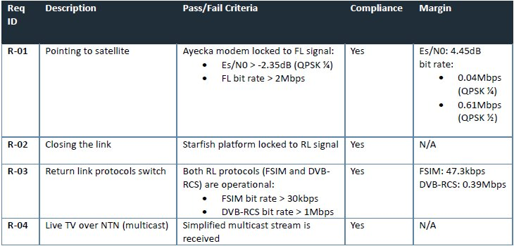
Table 6 : Viasat DTV first results

More results for FWD link throughputs (7MHz bandwidth):
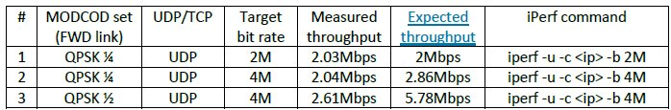
Table 7: FWD link throughput (7MHz bandwidth)
Note that the expected throughput mentioned in the table is the raw bit rate at layer 1.
While the measured throughput with iperf is at UDP layer and it is always reduced by headers and framing overhead.​
Target bitrate is the requested bit rate to iperf, that is intentionally higher than the maximum expected bitrate in order to push iperf to the maximum achievable over the link.
12MHz bandwidth should be allocated for the final demo in order to reach 4.7Mbps that is required for 1080p resolution.

More results for RTN link throughputs (5MHz bandwidth):
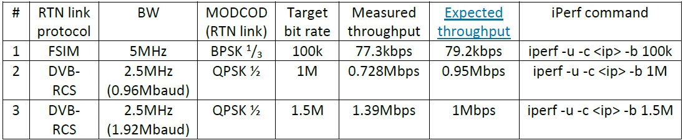
Table 8: RTN link throughput (5MHz bandwidth)
Same note as for FWD link throughputs, expected throughput refers to physical layer, while measured one is taking into account framing overhead.​
For instance, 1.4Mbps is the maximum achievable at UDP layer for DVB-RCS with 1920kBaud, and 0.7Mbps is the maximum for 0.96 Mbaud.

4.2 Links Turin DTV testbed

4.2.1 High-level description of the test plan

Different tests are envisioned in Phase 2, starting from the preliminary verification of the antenna behaviour in the LINKS laboratories to the full system validation in an outdoor mobile scenario. The following Figure 14 reports a block diagram of the test flow.

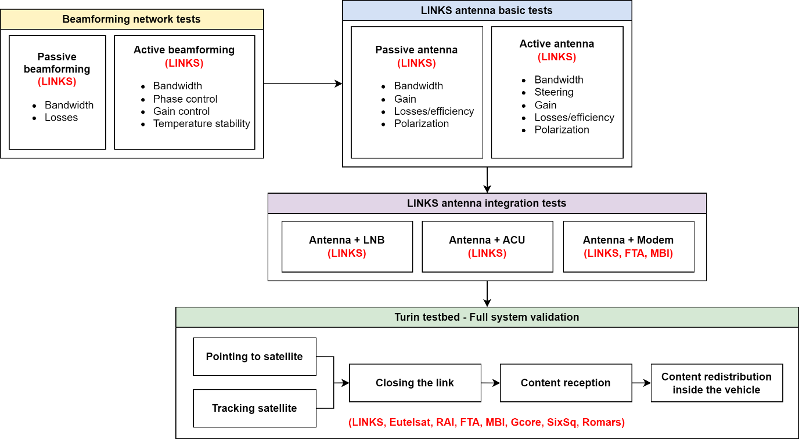

Figure 14: Block diagram reporting the test flow.

4.2.2 Testbed and setup

The Functional bloc diagram of the Testbed is shown in Figure 15.
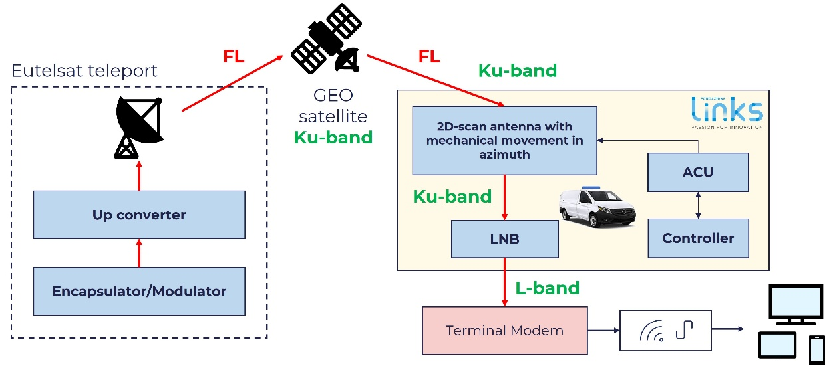
Figure 15: Block diagram of the LINKS Turin DTV testbed

Table 9: Main components of the LINKS Turin DTV testbed
System Function | Component | Type (HW/SW) | Responsible partner
SF1 | Content provider | SW | RAI
SF2 | Multicast generator | SW | FTA
SF3 | Encapsulator/Modulator | HW+SW | Eutelsat/MBI
SF3 | Uplink antenna (Teleport) | HW | Eutelsat
SF3 | Satellite – GEO (Ku-band) | HW | Eutelsat
SF3 | RX antenna | HW | LINKS
SF3 | ACU + Controller | HW+SW | LINKS
SF3 | LNB | HW | LINKS
SF3 | Modem terminal | HW+SW | FTA
SF4 | LAN Access Network | HW+SW | LINKS/RAI
SF4 | 5G-N3IWF technology (TBC) | SW | Romars

The main components of the LINKS Turin testbed are reported in Table 9.
The end-to-end tests are envisioned in the second year of Phase 2 (2026). Currently, work is focused on all integration tasks and preliminary testing aimed at finalizing the antenna system.
The discussions regarding the implementation of the end-to-end tests with all the involved partners officially started in October 2025, alongside the start of WP 4.2.3 (“Integration, validation, and demonstration”).

4.2.3 Validation methodology
The validation of the proposed antenna and its application in the 5G-EMERGE vehicular scenario will be performed through the tests outlined in Figure 5 and described below.
4.2.3.1 Beamforming and antenna tests
The tests concerning the passive and active electronic boards and the antenna are organized as follows according to the block diagram reported in Figure 18: Block diagram of the LINKS Turin DTV testbed.
- Passive beamforming network tests: two passive beamforming networks were fabricated to test the antenna: one is formed by several outputs in order to test each row of the phased-array separately; the other one collects all rows together and allows us to perform the tests on the entire array in a broadside configuration. During the passive beamforming network tests, the two combiners will be tested without the antenna, to check the electrical connections, the impedance matching and to evaluate the losses. The tests are performed in the electronic laboratory at LINKS.
- Active beamforming network tests: these tests involve the active control board with the phase shifters. The goal is to check the electrical connections, the impedance matching, the correct functioning of the phase shifters and to evaluate the losses. The tests are performed in the electronic laboratory at LINKS.
- Passive antenna tests: during these tests the phased antenna array is connected to the passive combiners to test each row of the phased-array separately and the entire array in a broadside configuration. All RF tests are performed in LINKS and Politecnico di Torino facilities.
- Active antenna tests: after performing the tests with the passive beamforming network, the active board is connected to the RX antenna, and the tests made with the passive beamforming network are repeated to test the steerable capabilities of the realized phased array antenna.
A more detailed description of the tests already performed is reported in the document “5G-EMERGE_Phase2_WOR_WP4.2”. Table 10 provides a list of the tests already completed.
Table 10: Beamforming and antenna tests performed/scheduled
Test ID | Title and associated KPIs | Status | Pass/fail
T-PBFN-BW-01 | Passive beamforming: bandwidth | DONE – MAR 2025 | Pass
T-PBFN-IL-01 | Passive beamforming: losses | DONE – MAR 2025 | Pass
T-ABFN-BW-01 | Active beamforming: bandwidth | DONE – APR 2025 | Pass
T-ABFN-PC-01 | Active beamforming: phase control | DONE – APR 2025 | Pass
T-ABFN-GC-01 | Active beamforming: gain control | DONE – APR 2025 | Pass
T-ABFN-TS-01 | Active beamforming: temperature stability | SCHEDULED | –
T-PANT-BW-01 | Passive antenna: bandwidth | DONE – MAR 2025  REP – SEP 2025 | Fail*
T-PANT-G-01 | Passive antenna: gain | DONE – JUL 2025  REP – SEP 2025 | Fail*
T-PANT-EFF-01 | Passive antenna: losses/efficiency | DONE – JUL 2025  REP – SEP 2025 | Fail
T-PANT-POL-01 | Passive antenna: polarization | DONE – MAR 2025  REP – SEP 2025 | Pass
T-AANT-BW-01 | Active antenna: bandwidth | DONE – JUL 2025  REP – SEP 2025 | Pass
T-AANT-STER-01 | Active antenna: steering | DONE – JUL 2025  REP – SEP 2025 | Pass
T-AANT-G-01 | Active antenna: gain | DONE – JUL 2025  REP – SEP 2025 | Fail*
T-AANT-EFF-01 | Active antenna: losses/efficiency | DONE – JUL 2025  REP – SEP 2025 | Fail
T-AANT-POL-01 | Active antenna: polarization | DONE – JUL 2025  REP – SEP 2025 | Pass

Most of the tests have been repeated (REP) in September 2025 to ensure the repeatability and stability of the results. The tests concerning the estimation of the bandwidth and the gain for the passive and the active antenna are marked as Fail in Table 7, since the criterium RL>10 dB is not satisfied over the entire Ku bandwidth due to manufacturing issues in the realized prototype. However, this limitation does not hinder the development of the demonstrator and of the end-to-end tests, since the antenna ensures acceptable performance throughout most of the bandwidth. For the antenna efficiency tests, the measured efficiency results lower than 60% (Pass criterium). This is probably related to fabrication inaccuracies that are currently under investigation.
The KPIs addressed by the tests reported in Table 7 are the gain-to-noise-temperature (G/T), the antenna efficiency, the scanning range and the cross-polarization. These parameters provide a direct measure of the antenna’s performance, radiation quality, and operational effectiveness.

4.2.3.2 Integration tests
To finalize the complete antenna system, the antenna must be interfaced with the LNB, the properly developed ACU and the modem terminal. Different test cases are properly defined to test the integration of the antenna, the LNB, the ACU, the controller, and the modem terminal (see Table 8).
We have confirmed the possibility of integrating the Inverto airstream LiveTM Gateway within the far edge framework, utilizing it instead of the Egatel modem. A description of the test procedure adopted by MBI to validate this integration is reported in the document “5G-EMERGE_Phase2_WOR_WP4.2”.
The Inverto airstream LiveTM Gateway provided by FTA seems to be a good candidate for the considered testbed. FTA has already provided the FW version 1.26.17, with the bridge mode and the REST interface, for interfacing with the controller. Currently, the modem provided by FTA is at the LINKS laboratories, where the integration tests with the antenna and the control unit will be performed.
Table 11: Integration tests scheduled
Test ID | Title | Status | Pass/fail
T-INT-ANT-STER-01 | Assembled antenna: steering capabilities | IN PROGRESS | –
T-INT-FUN-LNB-01 | Subsystem: LNB functionality | IN PROGRESS | –
T-INT-FUN-IMU-01 | Subsystem: IMU functionality | IN PROGRESS | –
T-INT-FUN-GPS-01 | Subsystem: GPS functionality | IN PROGRESS | –
T-INT-FUN-MCU-01 | Subsystem: MCU functionality | IN PROGRESS | –
T-INT-POINT-01 | Pointing algorithm capabilities | IN PROGRESS | –
T-INT-MODEM-01 | FTA modem: integration | IN PROGRESS | –

4.2.3.3 Full system validation
Concerning the full system validation, a precise list of the test cases is not available yet. However, the test cases will be structured to encompass the following tests:
- Validating the pointing capabilities of the RX antenna system in a static realistic outdoor scenario.
  - Validating the reception, decoding and demodulation of a simple text message transmitted through the Eutelsat satellite in a static realistic outdoor scenario.
  - Validating the tracking capabilities of the RX antenna system in a mobile scenario (antenna mounted on a moving vehicle).
  - Validating the reception, decoding and demodulation of a simple text message transmitted through the Eutelsat satellite in a mobile scenario.
  - Validating the reception, decoding and demodulation of media content transmitted through the Eutelsat satellite in a mobile scenario.
  - Validation of the re-redistribution of the media content to the passengers’ personal devices.
A preliminary evaluation of the throughput has been performed at the beginning of Phase 2 in collaboration with Eutelsat (see the document “5G-EMERGE_Phase2_WOR_WP4.2” for details). The throughput achievable with the current version of the fabricated antenna seems to be sufficient for the purposes of the demonstrator. However, a more precise computation of the link budget will be performed using the measured antenna gain profile (T-AANT-G-01 in Table 7).
KVIs
The KVIs related to the end-to-end tests are not identified at this stage, as these tests will be defined after the MS2. At that time, the test procedures, conditions, and evaluation criteria will be specified in detail to ensure a comprehensive assessment of the system performance across the considered operational scenarios.

4.2.4 Key results
The key results achieved so far can be briefly summarized as follows:
- The passive beamforming networks fabricated to test the antenna work as expected.
- The active beamforming network works as expected.
- The antenna shows an operational bandwidth lower than expected due to manufacturing issues. This does not hinder the development of the demonstrator, just limiting the antenna's use to frequencies sufficiently far from the bounds of the Ku-band (see the document “5G-EMERGE_Phase2_WOR_WP4.2” for details).
- Tests on the passive and active antenna have been repeated in the anechoic chamber during different test campaigns, confirming the behaviour of the fabricated prototype.
- A very good accordance between simulations and measurements has been achieved for the proposed antenna, in terms of directivity, polarization and steering capabilities.
- Preliminary tests on the modem terminal revealed that the airstream LiveTM Gateway can be used in the considered testbed.

5 Test and validation plan for Strand 5: Direct to edge

5.1 WP5.1 - EBU DTE Testbed

5.1.1 High level description of the EBU DTE Testbed

The functional bloc diagram of the EBU DTE Testbed is shown in Figure 16.

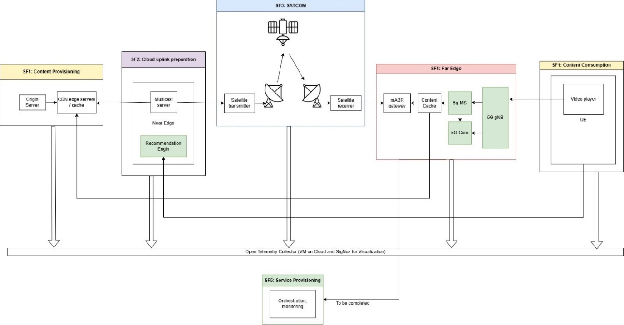
Figure 16: Functional block diagram of EBU DTE Testbed

Figure 17 illustrates the possible integration of the EBU DTE Far Edge into a 5G Mobile Network infrastructure.

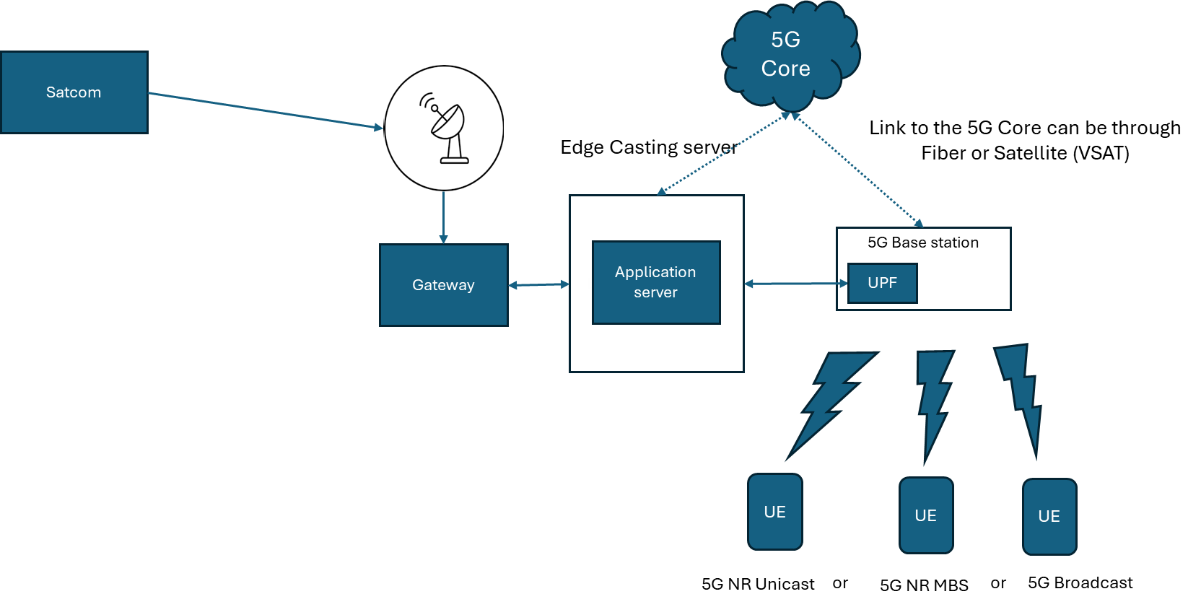
Figure 17: Simplified diagram of possible integration of the EBU DTE Far Edge into a 5G Mobile Network infrastructure

5.1.2 WP5.1 planned tests

The key points of the test plan for the EBU DTE testbed in phase 2 are as follows:

- 5G Media Streaming (on Unicast):
  - Functional end-to-end tests:
    - Reception on a Client
    - Reception on the Mobile FTA App – Pre-condition: FTA Player operational with 5G Unicast
  - Functional components tests:
    - Publishing user data following 5G-MAG specs – Pre-condition: FTA Player App publishes the relevant data
  - Performance end-to-end tests:
    - Directly test average startup times across methods – Precondition: FTA Player App can access the Streams delivered by the Application Server and can publish the relevant data
    - Compare buffering frequency under different methods - Precondition: FTA Player App can access the Streams delivered by the Application Server and can publish the relevant data
    - Track frequency of resolution switches under different delivery - Precondition: FTA Player App can access the Streams delivered by the Application Server and can publish the relevant data
    - Track downtime as resilience indicator - Precondition: FTA Player App can access the Streams delivered by the Application Server and can publish the relevant data

- 5G MBS:
  - Subject to availability of 5G NR MBS components from external sources (External entities following their own development time plan)
  - Component functional tests only. Integration test, communication between components. Progressive with missing components becoming available (See details further below, status at per September 2025).
  - Providing Logs, no need for telemetry
  - Component functional tests, using API calls:
    - MBSTF
    - MB-UPF
    - MB-SMF
    - AF/AS with MBSTF
    - Verification that 5G MBS gNodeB transmits on the selected frequency a unidirectional signal.
    - UE

5G MBS component availability and development status:
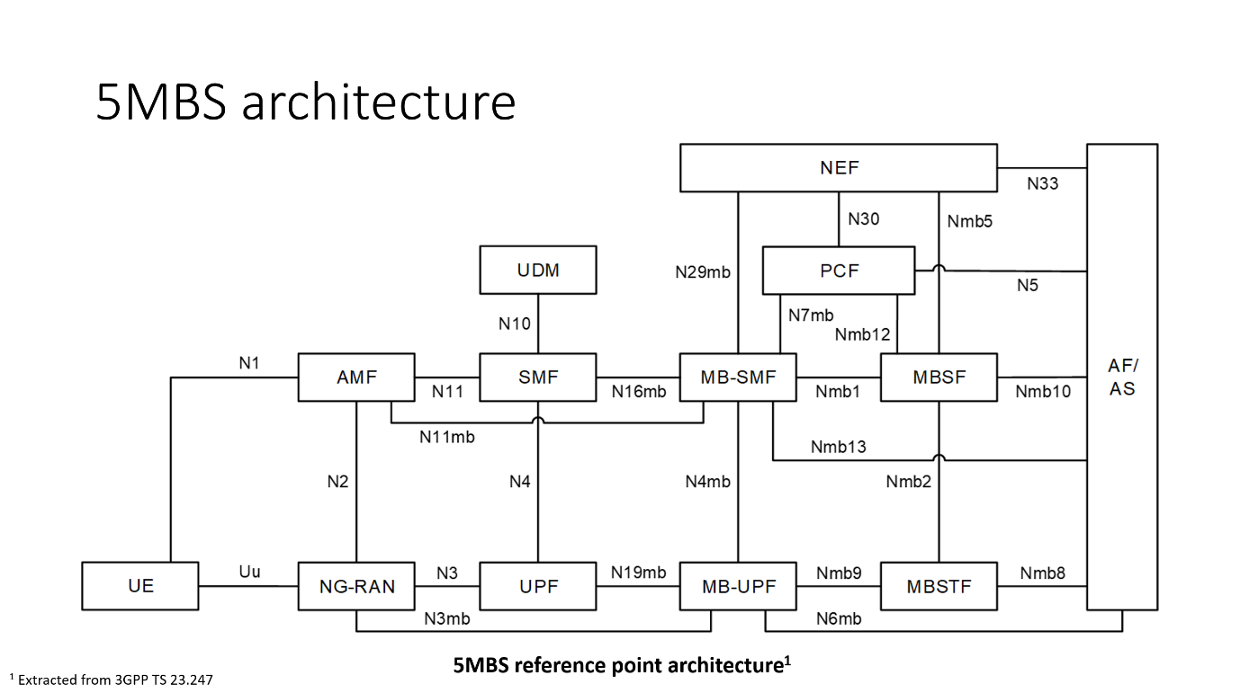

 |  |  |  | Status as per September 2025
Component | Name | Role | Required for EBU DTE testbed ? | (Fully) Available in 5G-MAG Reference Tools or in 5GCore ? | Under development in UPV for 5G-MAG ? | Under development in other members for 5G-MAG ?
AF/AS | Application Function/  Application Server | External application that requests and controls multicast/broadcast services | Yes | (No) Partial |  | Yes
NEF | Network Exposure Function | Exposes network capabilities securely to external applications | No | N/A | N/A | N/A
PCF | Policy Control Function | Provides policy rules for multicast/broadcast services | No | N/A | N/A | N/A
MBSF | Multicast/  Broadcast Session Function | Controls multicast/broadcast session lifecycle | Yes | No |  | Yes
MBSTF | Multicast/  Broadcast Service Transport Function | Responsible for service transport for multicast/broadcast | Yes | Yes
MB-UPF | Multicast/  Broadcast UPF | Handles multicast/broadcast data delivery | Yes | (No) Partial | Yes | Yes
MB-SMF | Multicast/  Broadcast SMF | Specialized version of SMF for multicast/broadcast | Yes | (No) Partial | Yes
UPF | User Plane Function | Routes and forwards unicast user data packets | Yes | Yes
SMF | Session Management Function | Manages session establishment, modification, and release for unicast services | Yes | Yes
UDM | Unified Data Management | Stores and manages subscriber data | No | Yes
AMF | Access and Mobility Management Function | Manages registration, mobility, and connection management for the UE | Yes | Yes
NG-RAN | Next Generation Radio Access Network | Handles radio communications and connects the UE to the core network | Yes | Yes (MBS under development) | Yes
UE | User Equipment | Represents the end-user device receiving unicast or multicast/broadcast data | Yes | Yes (MBS under development) | Yes

Table 12 shows the big phases of planned test of the EBU DTE Testbed

Table 12: Planned tests of the EBU DTE Testbed
Test name | Methodology | Tools | KPIs | When | Comments | WP
Integration of 5G media Streaming | Test reception of 5G Emerge content from Far Edge on 5G NR UE through a real unicast 5G NR transmission | - EBU Far Edge  - 5G Radio Board (Software Defined Radio)  - 5G MAG reference tools implementing 5G Media Streaming | - Established connection between 5G NR UE and 5G NR gNB  - Playout of 5G Emerge content on the UE | Q1’25 | Has been demonstrated at MWC 2025 | 5.1.1 and 5.1.2
First Integration of recommendation system, telemetry and user playout application | Test the recording of user data in the PEACH databases and metrics on the Telemetry platform | - EBU PEACH Recommendation system  - Open Telemetry (with SES)  - FTA Player App | Established connection between the Far Edge and the metrics platforms (PEACH and Telemetry) |  | Not realised due to the repurposing of the DTE testbed architecture for the integration of 5G MBS components | 5.1.2, 2.1, 2.4.6 and 3.2.3
Integration of 5G MBS | Observation of logs from different components | - EBU Far Edge  - 5G MAG reference tools related to 5G MBS, as available. | Correct integration of 5G-Media Streaming with 5G MBS components | Q3’26 | To be shown at MS3 in October 2026 | 5.1.1 and 5.1.2
Support to Deployment and Orchestration | Using the Nuvla Platform to deploy Media Streaming on the Far Edge | - Nuvla  - 5G-MAG Media Streaming | - Deployment time  - 100% of Monitoring indicators are green | Q2’26 | To be shown at MS3 in October 2026 | 5.1.2, 2.3 (

5.1.3 WP5.1 test cases

This section contains some test cases identified so far. They should be completed moving forward.

Test Case 1
Title: | Connecting a 5G User Equipment (smartphone, Tablet, ..) to the Far Edge
Responsible Partner: | EBU
Preconditions: | Pre1: | Far Edge up and 5G Core and gNodeB up and running
 | Pre2: | UE SIM card registered into the 5G Core and UE connected to the 5G Network
Description: | This Component/functional test is required to verify that the UE can access the Far Edge through the gNodeB, using media Streaming and Unicast
Test Steps: | S1: | Send requests to the Far Edge components
 | S2: | Check the Logs of the different Far Edge components
Associated KPI: | Availability of the physical connection
Actual Result: | Passed

Test Case 2
Title: | Playing content on the FTA mobile application from the Edge
Responsible Partner: | EBU
Preconditions: | Pre1: | FTA Player App can access the Streams delivered by the Application Server
 | Pre2: | FTA Player App can publish the relevant data
Description: | This end-to-end/functional test is required to verify reception on a mobile device from DTE with provision of analytics, using Media Streaming and Unicast
Test Steps: | S1: | Play Live content from the Far Edge
 | S2: | Check analytics dashboard
Associated KPI: | Availability of the service
Actual Result:

Test Case 3
Title: | Reception of user data on the telemetry platform
Responsible Partner: | EBU
Preconditions: | Pre1: | FTA Player App can access the Streams delivered by the Application Server
 | Pre2: | FTA Player App can publish the relevant data
Description: | This component/functional test is required to verify reception of user data by the telemetry platform, using Media Streaming and Unicast
Test Steps: | S1: | Start the FTA player
 | S2: | Verify the presence of user data on the telemetry platform
Associated KPI: | Verify the reception of the telemetry data
Actual Result:

Test Case 4
Title: | Average startup time
Responsible Partner: | EBU
Preconditions: | Pre1: | FTA Player App can access the Streams delivered by the Application Server
 | Pre2: | FTA Player App can publish the relevant data
Description: | This end-to-end/performance test aims at measuring the quality of experience of receiving a stream using Media Streaming and 5G Unicast
Test Steps: | S1: | The Player requests the stream
 | S2: | Measure the start time of the Playout
Associated KPI: | Start-up delay
Actual Result:

Test Case 5
Title: | Average buffering frequency
Responsible Partner: | EBU
Preconditions: | Pre1: | FTA Player App can access the Streams delivered by the Application Server
 | Pre2: | FTA Player App can publish the relevant data
Description: | This end-to-end/performance test aims at qualifying the network quality, using Media Streaming and 5G Unicast
Test Steps: | S1: | The playout starts and displays a stream in one of the available resolutions
 | S2: | Leave the stream playing during [30 minutes]
Associated KPI: | Buffering Ratio / Rebuffering Events
Actual Result:

Test Case 6
Title: | Frequency of resolution switches
Responsible Partner: | EBU
Preconditions: | Pre1: | FTA Player App can access the Streams delivered by the Application Server
 | Pre2: | FTA Player App can publish the relevant data
Description: | This end-to-end/performance test aims at checking that the player switches between different resolutions, using Media Streaming and 5G Unicast, when the quality of the network changes.
Test Steps: | S1: | The playout starts and displays a stream in one of the available resolutions
 | S2: | Leave the stream playing during [30 hours], while modifying the transmit power and moving the UE in space.
Associated KPI: | Bitrate Stability / QoE
Actual Result:

Test Case 7
Title: | Percentage of uptime vs downtime
Responsible Partner: | EBU
Preconditions: | Pre1: | FTA Player App can access the Streams delivered by the Application Server
 | Pre2: | FTA Player App can publish the relevant data
Description: | This end-to-end/performance test aims at qualifying the availability of the stream, using Media Streaming and 5G Unicast
Test Steps: | S1: | The playout starts and displays a stream in one of the available resolutions
 | S2: | Leave the stream playing during [24 hours]
Associated KPI: | Availability (Uptime %)
Actual Result:

Test Case 8
Title: | MBS individual component test: MBSTF  Create a streaming MBS Distribution Session for pull operation on the DASH manifest
Responsible Partner: | EBU
Preconditions: | Pre1: | Tool to capture network packets (Wireshark)
 | Pre2: | MBSTF component up and running
Description: | This tests the STREAMING distribution mode for PULLed DASH manifest file (MPD). This executes the following highlighted steps from MBS User Service provisioning using the command line to perform the actions that the MBSF would otherwise perform.
Test Steps: | S1: | Create a jason request to pull a DASH distribution session
 | S2: | Adapt MB-UPF tunnel configuration
 | S3: | API call to push the session to the MBSTF
 | S4: | Capture the packets of the response
Associated KPI: | MBSTF works properly
Actual Result:

Test Case 9
Title: | MBS individual component test: MB-SMF: create a Nmb9 ingress tunnel
Responsible Partner: | EBU
Preconditions: | Pre1: | MBSF and MB-SMF up & running
 | Pre2:
Description: | This tests the communication between MB-SMF and MB-UPF
Test Steps: | S1: | Create a MBS Session from MBSF to MB-SMF
 | S2: | Create a Nmb9 ingress tunnel from MB-SMF component
Associated KPI: | MB-SMF works properly
Actual Result:

Test Case 10
Title: | MBS individual component test: MB-UPF
Responsible Partner: | EBU
Preconditions: | Pre1: | Test Case 9 succeed
 | Pre2: | MB-UPF and gNB up & running
Description: | This tests the transport of FLUTE packets from MB-UPF to the gNb
Test Steps: | S1: | Set up Multicast/Broadcast service
 | S2: | Create a Nmb9 ingress tunnel
 | S3: | Send DASH manifest or segment in FLUTE format to Mb-UPF
 | S4: | Check if multicast FLUTE packets are sent to the gNb
Associated KPI: | MB-UPF works properly
Actual Result:

Test Case 11
Title: | MBS individual component test: AF/AS with MBSTF
Responsible Partner: | EBU
Preconditions: | Pre1: | MBSF has created a MBS Session through MB-SMF and MB-UPF (test case 9 & 10)
 | Pre2: | MBSF has created a Distributed Session to MBSTF
Description: | This tests how MBSTF pulls segments from AF/AS
Test Steps: | S1: | AF/AS sends a DASH manifest to MBSTF
 | S2: | MBSTF gets a first segment to AF/AS
 | S3: | MBSTG pulls next segments to AF/AS
Associated KPI: | AF/AS with MBSTF works properly
Actual Result:

Test Case 12
Title: | MBS individual component test: AF/AS with gNodeB
Responsible Partner: | EBU
Preconditions: | Pre1: | Test case 8, 9,10&11
 | Pre2:
Description: | This tests the segments sent to the gNb from the AS
Test Steps: | S1: | Create a MBS User Session by creating a Distributed session ain ingress tunnel
 | S2: | Send a Dash manifest from the AS
 | S3: | Segments are sent through the gNB in FLUTE format
Associated KPI: | AF/AS with gNodeB works properly
Actual Result:

5.2 WP5.2 Arctic Space (WIP) DTE Testbed
Figure 18 shows the Phase 2 planned architecture of the Arctic Space DTE Testbed

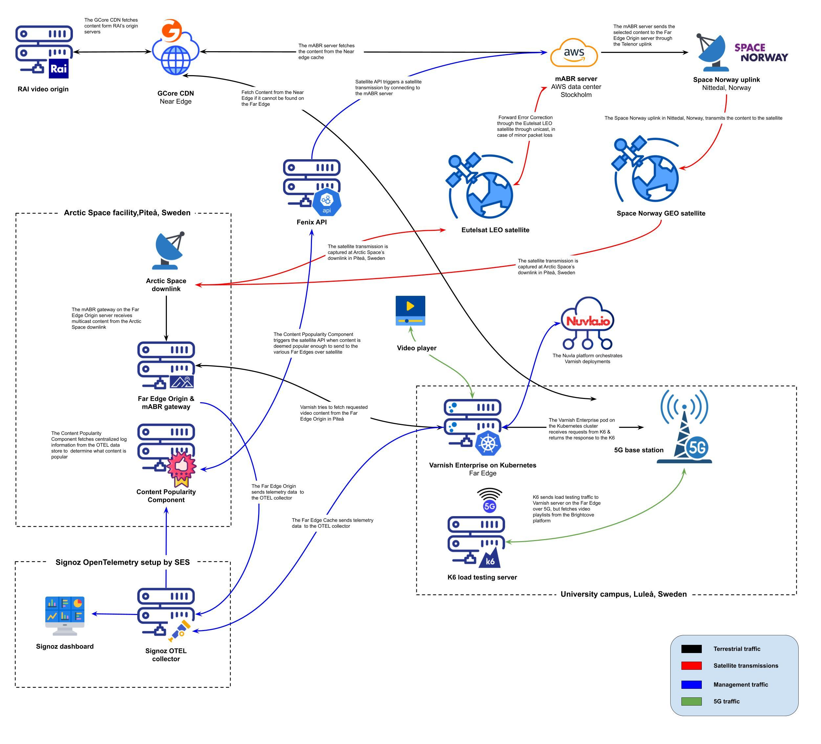

Figure 18: Planned architecture for Phase 2 - DTE Arctic Space
Local Caching (5G Campus Network) content is first retrieved from Varnish Cache on campus premises via a 5G network to minimize latency. If the content is unavailable it is retrieved from the Far Edge origin server, which contains content that was transmitted via the satellite. The content that is unavailable is requested via the Near Edge over terrestrial internet.
If the requested content is not available on the Far Edge origin server and is deemed popular enough based on aggregated consumption metrics (through the Content Popularity Component), it triggers the transmission of the unavailable content over GEO satellite via multicast or using Eutelsat LEO constellation.
The LEO link also provides the possibility to retrieve repair packets in case of packet loss through multicasting over GEO satellite. To stress test the system and measure metrics the K6 load testing server is used, this data is transmitted to the dashboard on the far edge.

5.2.1 High-level description of the Test Plan (WIP)

5.2.1.1 WP 5.2.1 - End-To-End testbed for DTE Micro Data Center use case
Throughput measurement verify that the mABR Server and Gateway can meet the expected throughput levels. FAIL/PASS.
Load & Stress Testing evaluate the system performance under high load and measure metrics.
Packet loss measurement & Recovery Measure the packet loss percentage over the network and verify that the loss can either be recovered via FEC with fallback on recover via unicast transmission over LEO. FAIL/PASS
API-Based Transmission develop and verify that API for transmission over GEO / LEO through the mABR server is working as expected. FAIL/PASS
Caching efficiency measures latency & throughput improvements when requested content is cached on the Far Edge, versus uncached content hosted on the Far Edge origin server, versus content that needs to be pulled from the Near Edge.
The primary KPIs monitored during the performance evaluation include CPU utilization, memory utilization, throughput, and latency metrics such as Time to first byte (TTFB) and Time to last byte (TTLB). These indicators collectively provide a comprehensive view of system responsiveness, resource efficiency, and data delivery performance under load.

5.2.1.2 WP 5.2.2 - Near Edge and Far Edge development
New features and innovations are being introduced with entering phase 2, which will need testing. While individual components will be tested separately, integration tests are expected to provide more valuable insights due to these phase 2 innovations. Section 4.2 provides a detailed overview of the test plan for the Arctic Space Test Bed, which is a Direct-To-Edge use case.
They include:
1. Satellite transmission tests.
2. Satellite transmissions API tests.
3. Cache efficiency tests.
4. Content popularity component tests.
5. Brightcove Video player & platform tests.
6. Far Edge benchmarks over 5G.
7. Component orchestration tests.
8. Integration tests.
The tests are described in 4.2.2.

5.2.1.3 WP 5.2.3
To verify that the system is working as expected the test plan from parts from WP 5.2.1 and 5.2.2 can be used to verify the components separately and for the final integrated plan. With live data stream in a real-world scenario and failure recovery. Measuring the system performance of this scenario.
End-To-End Testing
- Linear Stream performance tests E2E
Linear Video Stream ingested from RAI source processed using FENIX protocol, transmitted over GEO link. Measure the different KPIs such as timing in each step of the chain and latency how far behind the player receives segments.
- Cache miss E2E
Content that is not stored in cache, measure how long it takes until this is available in cache from the first request by requesting content to be populated via API
- Pre-cached content over 5G:
Measure the throughput / performance of precached content over 5G network

5.2.2 Test bed and setup (WIP)
5.2.2.1 WP 5.2.1 - End-To-End testbed for DTE Micro Data Center use case
API Implementation Test
To allow fast and effortless integration of our file transmission software Arctic Space is creating API calls which can be used by Consortium Partners or third parties to integrate and connect to our solution.
For phase 2 this is particularly relevant for Varnish as their caching solution will call our software on demand with their content popularity component to transmit files to where they are needed.
Each API call shall be tested for functionality.
GEO Satellite Transmission Test
Our testbed is using Space Norway's satellite THOR-7 as our current GEO satellite for multicasting.
First tests include the transmission from their teleport in Nittedal through the GEO satellite to our Far-Edge facility in Piteå Sweden where we will receive the signal and validate the functionality and bitrate. Some smaller files will be transferred to check for functionality of the GEO transmission.
The second step includes testing of the maximum bandwidth available. For this we will push as much content over the satellite and see at which data rate the satellite connection will get to its limits. The data rate is then forwarded to Varnish.
5G Connectivity Test
We will update the testbed of the 5G network. New access points and software compared to Phase 1 will be provided by our partner University, Luleå Technical University.
Tests are similar to tests in Phase 1 where we connect a device e.g. a laptop to a 5G access point and see if we can connect through the 5G network to our device. The laptop runs the K6 load testing client to simulate end user by requesting video content during the test.
End-to-End Test
The primary end-to-end test to be performed aims to verify that both HLS and VOD content can be transmitted reliably over satellite link in multiple quality levels or bitrates. This includes confirming that content segments are correctly received, at the Far Edge, and subsequently served to the end user over 5G without major playback interruptions on the video player. PASS/FAIL.

Test Case 01 | mABR Throughput Performance Test
Title: | Throughput Verification of mABR Server and Gateway
Responsible Partner: | Arctic Space Technologies
Preconditions: | Pre1: mABR Server and Gateway deployed and accessible
 | Pre2: Test environment simulating streaming load available
Description: | Verify mABR server and gateway meet expected throughput levels
Test Steps: | S1: Simulate multiple streams through the mABR server
 | S2: Measure total throughput and verify against expected levels
Associated KPI: | Measured throughput (Mbps), PASS/FAIL
Actual Result:

Test Case 02 | Load & Stress Evaluation Test
Title: | System Performance Under Load
Responsible Partner: | Arctic Space Technologies
Preconditions: | Pre1: Streaming system and mABR server deployed
 | Pre2: Load simulation tools available
Description: | Evaluate performance metrics under high load/stress
Test Steps: | S1: Increase concurrent stream requests to system
 | S2: Monitor performance metrics)
Associated KPI: | Latency (ms), TTFB, Throughput, CPU Utilization, Memory utilization
Actual Result:

Test Case 03 | Packet Loss Recovery Verification
Title: | Packet Loss and Recovery Measurement
Responsible Partner: | Arctic Space Technologies
Preconditions: | Pre1: Network conditions controlled to induce packet loss
 | Pre2: FEC and unicast fallback mechanisms configured
Description: | Measure packet loss and validate recovery via FEC/unicast fallback
Test Steps: | S1: Induce controlled packet loss
 | S2: Observe FEC and unicast recovery responses
 | S3: Evaluate loss recovery effectiveness
Associated KPI: | Packet loss rate (%), Recovery success (PASS/FAIL)
Actual Result:

Test Case 04 | API-Based GEO Transmission Test
Title: | GEO Satellite Transmission via API
Responsible Partner: | Arctic Space Technologies
Preconditions: | Pre1: mABR Server operational
 | Pre2: GEO transmission API implemented and functional
Description: | Develop and verify API for satellite transmission over GEO via mABR
Test Steps: | S1: Initiate transmission using API
 | S2: Confirm data reaches destination via GEO path
 | S3: Validate system logs and transmission success
Associated KPI: | Transmission status (PASS/FAIL), API response success
Actual Result:

Test Case 05 | 5G Network Connectivity and File Transfer Test
Title: | 5G Device Connectivity Verification
Responsible Partner: | Arctic Space Technologies
Preconditions: | Pre1: Updated 5G access points installed
 | Pre2: Device configured and ready to connect
Description: | Test 5G network connectivity and file transmission via 5G access point.
Test Steps: | S1: Connect device to 5G network and ping
 | S2: Initiate file transfer to validate data flow
Associated KPI: | Connection success (PASS/FAIL), File transfer rate (Mbps), TTFB, TTLB,
Actual Result:

Test Case 6 | End-to-End Integration Verification Test
Title: | System-Wide End-to-End Workflow Validation
Responsible Partner: | Arctic Space Technologies, Varnish Software, RAI
Preconditions: | Pre1: All components integrated (API, satellite, caching)
 | Pre2: Content popularity component operational
Description: | Simulate full data flow: popularity detection to satellite transmission and edge delivery.
 | Verify that both HLS and VOD content can be transmitted reliably over the satellite link in multiple quality levels or bitrates.
 | Ensure that content segments are correctly received at the Far Edge and subsequently served to the end user over 5G without major playback interruptions.
Test Steps: | S1: Trigger content popularity
 | S2: Confirm triggered file transmission through satellite
 | S3: Validate playback from Far Edge
Associated KPI: | Workflow completion (PASS/FAIL), Latency (ms), QoE score
Actual Result: | PASS/FAIL

5.2.2.2 WP 5.2.2 - Near Edge and Far Edge development

1. Satellite transmission tests
Arctic Space is allowed to use a Space Norway satellite, with upstream is in Nittedal (Norway), downstream is captured at Arctic Space’s facilities in Piteå (Sweden).
According to our information, we have access to a capacity of 10 Mbps on the satellite. Arctic Space will run specific tests to max out that capacity.
The test results will give us the opportunity to define how many streams we can transmit via the satellite in parallel, and which bit rate representations of those videos can be transmitted.
There will be a distinction between live streams and VOD content.
First Arctic Space will run standalone tests sending as many video segments as possible over the satellite to determine the available bandwidth. In a second stage, more targeted throughput tests will be performed using the video catalogue that RAI provides.

2. Satellite transmission API tests
Satellite transmissions at the Arctic Space test bed are currently triggered manually. Arctic Space is in the process of developing a REST API to integrate satellite transmissions into a component that is responsible for determining the popularity of video titles.
Apart from functional testing to trigger satellite transmissions and get bandwidth usage information during active transmissions, performance & efficiency tests will also be performed on the API. We will use the test results of the satellite transmission tests and try to achieve the same levels of efficiency through the API.

3. Cache efficiency tests
A big part of the success of the 5G Emerge Consortium Project hinges on the efficiency of caches. By caching content on the Far Edge, less content is transmitted over terrestrial internet or GEO/LEO satellites. Bandwidth conservation is the primary goal here.
Testing whether cached content still causes data transmissions to the Far Edge Origin server on the Near Edge is pretty much a PASS/FAIL situation and can be very easily tested.
The real value of the cache efficiency tests is not just quality of service by conserving bandwidth but also reducing network latency due to the proximity of the Far Edge to the consuming client. This is a quality of experience test.
These tests are not PASS/FAIL tests but need to show faster loading times for cached versus uncached content. Because we operate in a proof-of-concept environment and not a real-world environment, the efficiency improvement will be noticeable, but not earthshattering.
During the integration tests we can increase the concurrency and add more stress to the systems, which will paint a clearer picture of the efficiency of the cache.

4. Content popularity component tests
The Content Popularity Component that is being designed and developed by Varnish Software uses custom logs captured by the Far Edge caches to determine what content is popular.
The information that is captured from these logs will be centralized and aggregates content popularity across Far Edges. The right tests need to be drawn up, to determine how accurate the log centralization is and how accurate the statistical algorithms are that will come up with a list of popular content.
Signoz & OTel will be used to centralize, query & visualize content popularity information. The component that will be developed to make decisions on content popularity, will execute statistical algorithms on the extracted from Signoz Telemetry database to extract the most popular content.
While the centralized content popularity information can be considered the input, and the satellite transmission the output, the content popularity component provides the processing.
The necessary tests need to be designed to artificially boost the popularity of a specific title through requests to the Far Edge. If enough of these calls are made, the component will trigger a satellite transmission containing multiple bit rate representations of that title. We will test if the relevant video files for this title end up on the Far Edge and how long it takes for these files to be transmitted.
Live streams need to be tested more rigorously, because they are latency sensitive.
The Content Popularity Component will have a set of configuration parameters that influence how much content is transmitted to the satellite, with which frequency and how long the backoff period is in between transmissions. Selecting the number of titles to transmit in parallel and the selection of bit rates will depend on the outcome of the Satellite transmission API tests.

5. Video player & platform tests
The video player we are using is the standard video.js player. This is a well-regarded and well-tested video player. Varnish Software’s & Arctic Space’s goal is not to test the video player as such, but to perform an integration test of our test bed. Our current tests focus on the delivery of the video footage and assume that a successful HTTP response within an acceptable time frame is sufficient. While we know that the video streams can be consumed by a variety of video players, it makes sense to perform end-to-end tests that include a real video player. Running these tests in an automated way requires the use of a tool that can process Javascript, because video.js is a Javascript-based video player. That’s why we’ll run some of the integrations tests using Puppeteer. Puppeteer is a Javascript library that has an API to run headless HTTP requests within a browser. This would allow us to trigger requests from the video player, let the video player play some footage, and analyze client-side metrics from the video player within Puppeteer to determine whether the test was successful.

6. Far Edge benchmarks over 5G
In Phase 1 we concluded that automated test performance did not meet our expectations. We noticed latency when we scaled up the concurrency of our tests.
We are in communication with engineers from Telia who manage the 5G base station in Luleå (Sweden). Our goal is to optimize our test scripts to improve our test performance.

7. Component orchestration tests
As more components are added, and partner testbeds share orchestration becomes critical. We provide Kubernetes Helm charts such that we can scale deployments and spin up new nodes quickly using consistent, repeatable configs.
Instead of 1 satellite, we could potentially test with 2 satellites. Instead of one 5G base station, we could have multiple. This will only work if we can automate the deployment through helm charts. The necessary tests will have to be created to test these extra deployments.

8. Integration tests
While testing the individual components is important, proving the value of our test bed and the entire 5G-Emerge project can only be done through an all-in-one integration test.
This test will start with empty caches and will request video content over 5G using automated testing tools. Various tests will be run to fill up the caches and improve the Quality of Experience through the caches.
In these tests we will boost the popularity of certain video titles and test how the Content Popularity Component will notice this sudden increase in popularity. Ultimately this will trigger a satellite transmission to the Far Edge and we will run tests to see how the performance of our video delivery improves as more content is being served from the Far Edge instead of the Near Edge.

Tests procedures:
Test Case 7 | Satellite Bandwidth Capacity Test
Title: | Multistream Bandwidth Determination over GEO
Responsible Partner: | Arctic Space Technologies
Preconditions: | Pre1: Satellite connectivity established (THOR-7)
 | Pre2: Nittedal teleport and Piteå reception station operational
Description: | Test bandwidth capacity by transmitting as many video streams as possible.
Test Steps: | S1: Transmit multiple video streams via satellite
 | S2: Record throughput and number of parallel streams
Associated KPI: | Maximum throughput (Mbps), Number of parallel streams
Actual Result:

Test Case 8 | RAI Catalogue Throughput Test
Title: | Targeted Bandwidth Test with Video Catalogue
Responsible Partner: | Arctic Space Technologies
Preconditions: | Pre1: RAI video catalogue accessible
 | Pre2: GEO satellite connectivity operational
Description: | Measure satellite throughput using standard video catalogue items.
Test Steps: | S1: Transmit content from RAI catalogue
 | S2: Record bitrates and stream completion
Associated KPI: | Average bitrate (Mbps), Transfer success rate (%)
Actual Result:

Test Case 9 | Satellite Transmission API Functional Test
Title: | REST API Validation for Transmission Control
Responsible Partner: | Arctic Space Technologies
Preconditions: | Pre1: REST API implemented
 | Pre2: Manual transmission benchmark available
Description: | Ensure API triggers satellite transmission correctly and efficiently
Test Steps: | S1: Trigger transmission via API
 | S2: Validate correct operation and compare to manual baseline
Associated KPI: | Trigger success rate (%), Efficiency match (PASS/FAIL)
Actual Result:

Test Case 10 | Content Popularity Accuracy Test
Title: | Popularity Component Evaluation
Responsible Partner: | Varnish Software
Preconditions: | Pre1: Signoz & OTEL collector operational
 | Pre2: Log generation and collection enabled
Description: | Validate accuracy of content popularity estimation from edge logs
Test Steps: | S1: Trigger edge requests to influence popularity
 | S2: Confirm if algorithm ranks content accurately
Associated KPI: | Accuracy rate (%), Latency to detection (ms)
Actual Result:

Test Case 11 | HNR Player Integration and Caching Test (optional)
Title: | CDN Integration and Playback Testing
Responsible Partner: | HNR, Varnish Software
Preconditions: | Pre1: HNR player integrated with Far Edge CDN
 | Pre2: Playlist generation through HNR
Description: | Validate playback, API proxy integration, and Varnish caching performance
Test Steps: | S1: Play video via HNR player
 | S2: Enable API proxy, evaluate playlist delivery via Varnish
Associated KPI: | Playback rate (%), Proxy cache hit rate (%)
Actual Result:
Note: Testcase 11 depends on HNR solution as replacement for Brightcove, this test will be performed depending on the HNR solution.
Test Case 12 | Far Edge 5G Concurrency & Latency Optimization
Title: | 5G Network Performance Improvement
Responsible Partner: | Arctic Space Technologies, Varnish Software
Preconditions: | Pre1: LTU 5G base station operational
 | Pre2: Phase 1 test data available
Description: | Improve concurrency and latency using optimized test scripts
Test Steps: | S1: Re-run Phase 1 tests with new scripts
 | S2: Measure response time and stability
Associated KPI: | Latency reduction (%), Max concurrent sessions
Actual Result:

5.2.2.3 WP 5.2.3 - Integration, Validation and Demonstration (incl. Integration of Strand 2 scalability tests)
Within this work package we will test the integration, validate the system and produce a demonstrator showing the capabilities of the deployable edge unit with hybrid satellite and terrestrial network and caching functionality. Metric tests and automatic report generation are planned to be integrated.

Test Case 13 | Deployment Integration
Title: | Integrated System Validation
Responsible Partner: | Arctic Space Technologies
Preconditions: | Pre1: Available helm charts.
Description: | Validate that the FENIX TX multicast service and FENIX RX clients can be deployed rapidly using Helm charts, and that content can be received successfully after new fresh instance is deployed.
Test Steps: | S1: Deploy fresh instance via Helm Charts
 | S2: Verify content can be received from the newly deployed instances
Associated KPI: | Status PASS/FAIL
Actual Result:

Test Case 14 | End-to-End Performance Simulation
Title: | Integrated System Validation
Responsible Partner: | Arctic Space Technologies, Varnish Software
Preconditions: | Pre1: All system components operational
 | Pre2: Empty cache state initialized
Description: | Run system-wide tests simulating user demand, triggering satellite delivery and caching improvements
Test Steps: | S1: Simulate user traffic over 5G
 | S2: Boost popularity of titles
 | S3: Verify satellite-triggered transmission and edge caching
Associated KPI: | Cache hit rate (%), QoE score, Latency (ms), TTFB, TTLB
Actual Result:

Test Case 15 | End-to-End test
Title: | Linear performance tests
Responsible Partner: | Arctic Space Technologies, Varnish Software
Preconditions: | Pre1: All system components operational
Description: | Trigger linear content over GEO satellite and measure the delay / time it takes at each step and how long it takes before reaches the Video player and end user can get served the content over 5G,
Test Steps: | S1: User requests to play live stream from 5G network.
 | S2: Trigger api to start the transmission chain and Capture metrics in each step.
 | S3: Measure the metrics
Associated KPI: | Throughput(bps), Bytes transmitted, TTFB,TTLB,
Actual Result:

Test Case 16 | End-to-End test
Title: | Cache miss
Responsible Partner: | Arctic Space Technologies, Varnish Software
Preconditions: | Pre1: All system components operational
Description: | Content that is not stored in cache, measure how long it takes until this is available in cache from the first request by requesting content to be populated via API
Test Steps: | S1: Fetch content that is not available in the cache (cache miss)
 | S2: Measure the metrics until the content is populated in the cache
Associated KPI: | Throughput(bps), Bytes transmitted, TTFB, TTLB
Actual Result:

Test Case 17 | End-to-End test
Title: | Cached content over 5G,
Responsible Partner: | Arctic Space Technologies, Varnish Software
Preconditions: | Pre1: All system components operational
Description: | Measure the throughput / performance of precached content over 5G network
Test Steps: | S1: Fill Cache,
 | S2: Simulate users requesting the content over 5G network.
Associated KPI: | Throughput(bps), Bytes transmitted, TTFB, TTLB, Latency (ms)
Actual Result:
The matrix below executes test cases 18–20 across three client locations with increasing network distance from the Varnish cache (Luleå-5G, Luleå-terrestrial, Belgium-terrestrial). Each cell reports TTFB, TTLB, bytes, and throughput(bps).
Test case NO: / Network | 5G Network Luleå | Terresterial Luleå | Terresterial Belgum (laptop)
15 | TTFB, TTLB, Throughput, Bytes | TTFB, TTLB, Throughput, Bytes | TTFB, TTLB, Throughput, Bytes
16 | TTFB, TTLB, Throughput, Bytes | TTFB, TTLB, Throughput, Bytes | TTFB, TTLB, Throughput, Bytes
17 | TTFB, TTLB, Throughput, Bytes | TTFB, TTLB, Throughput, Bytes | TTFB, TTLB, Throughput, Bytes

Test Case 18 | End-to-End test
Title: | Response times across diffrent geographies
Responsible Partner: | Arctic Space Technologies, Varnish Software
Preconditions: | Pre1: All system components operational
Description: | Run a couple of tests from different locations to measure TTFB & TTLB/ Use the university laptop in Luleå  Send a couple of requests from a system in Piteå  Spin up an AWS machine in Stockholm and send requests from there  Run a test from computer in Belgium  Each of these steps increases the geographical distance between client & Varnish
Test Steps: | S1: Fetch content from cache in Luleå Unviersity, Laptop 5G
 | S2: Fetch content from cache in Arctic Space facillity Piteå
 | S3: Fetch content from cache in AWS and send request from there,
 | S4: Fetch content from cache from Laptop in Belgium
Associated KPI: | TTFB,TTLB for each test scenario.
Actual Result:

Test Case 19 | End-to-End test
Title: | Quantify wasted resources if streams are abandoned early
Responsible Partner: | Arctic Space Technologies, Varnish Software
Preconditions: | Pre1: All system components operational
 | Pre2: 5G network working
 | Pre3: Terrestrial Network 5G laptop
Description: | We can test how many segments get fetched when we start the video player & stop it immediately on an empty cache (includes Far Edge or Near Edge requests) We can test how many segments get fetched when we start the video player & stop it immediately on cached content (no Far Edge or Near Edge requests) We can manipulate the threshold so that satellite transmission also kicks in and uses even more resources.
Test Steps: | S1: Start player & stop video player see amount of segmets that gets fetched.
 | S2: Repeat for the different scenarios (cache hit, cache miss, trigger satellite transmission )
 | S3: Messure the amount of wasted bytes in each scenario.
Associated KPI: | Wasted bytes for each scenario
Actual Result:

Test Case 20 | End-to-End test
Title: | Measure load effect on failure rates under stress tests
Responsible Partner: | Arctic Space Technologies, Varnish Software
Preconditions: | Pre1: All system components operational
 | Pre2: Teresstrial network on campus laptop.
Description: | Measure load effect on failure rates under stress tests Using terrestrial internet to send a number concurrent requests to Varnish and measure TTFB & throughput. The goal is to prove that Varnish remains stable under highload.
Test Steps: | S1: Simulate high amount of users and generate high traffic over terrestrial network to Varnish cache.
 | S2: Verify that Varnish is stable and can handle the high load.
Associated KPI: | Throughput(bps), TTFB
Actual Result:

Test Case 21 | End-to-End test
Title: | Track frequency of resolution switches under different delivery
Responsible Partner: | Arctic Space Technologies, Varnish Software
Preconditions: | Pre1: All system components operational
 | Pre2: 5G network working
 | Pre2: Terrestrial internet on 5G laptop.
Description: | During playback sessions we will monitor resolution changes together with their timestamps. This allows us to correlate when and why the player adapts quality (e.g., during cache hit vs. cache miss scenarios, over 5G vs. terrestrial internet).
Test Steps: | S1: simulate playback and trigger for cache miss
 | S2: -||- cache hit
 | S3: Capure nr of resolution switches as the video player during playback.
Associated KPI: | Nr of resolution changes
Actual Result:

Test Case 22 | End-to-End test
Title: | Directly test average startup time across metods
Responsible Partner: | Arctic Space Technologies, Varnish Software
Preconditions: | Pre1: All system components operational
 | Pre2: 5G network working
 | Pre2: Terrestrial internet on 5G laptop.
Description: | This scenario evaluates how quickly playback begins under different delivery conditions. Measure Time To First Frame (TTFF), Time To Last Byte (TTLB), and throughput across: Cache miss (Far Edge origin not found, Near Edge fallback) Cache hit Cache miss with low threshold (satellite transmission triggered, comparing Far Edge vs Near Edge access) Tests are run over both 5G and terrestrial internet. Using video.js with Puppeteer, we capture timestamps for firstplay, play, and playing events to measure true startup latency.
Test Steps: | S1: Cache MISS: clear Far-Edge cache; keep SAT trigger off/high.  Cache HIT: Far-Edge.  MISS + Low Threshold: set low SAT threshold to trigger transmission
S2: Caputure playback of video using video.js & puppeteer.
Caputure firstplay,play,playing
 | S3: Compute average startup time for the diffrent methods/scenarios.
Associated KPI: | Throughput(bps), Average startup time, TTFF (ms), TTFB, TTLB,
Actual Result:

5.3 WP5.3 Maritime testbed

5.3.1 Testing on a vessel
The testing results for the maritime testbed is illustrated in Figure 19, which displays the different test areas that will be conducted on the vessel. It is important to highlight that the attach test, Internet connectivity test, performance test, the PLMN restriction test, and DOT HO test, are all solely intended for the private network test. Test no. 6, which involves accessing multimedia content stored locally over the private network serves as the end-to-end test with all the 5G-EMERGE components present.
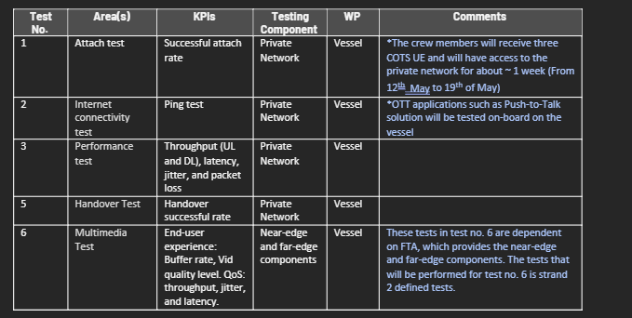

Figure 19: List of testing scenarios for the maritime testbed

P5G Network Test:
The testbed will be moved from the lab to a vessel, and to facilitate a seamless transfer, Telenor Maritime will verify that all components are operational upon deployment. These components include the RAN, CN, satellite link, and other dependencies utilized in the 5G-EMERGE ecosystem. This test will be a part of WP 5.3.3. Telenor Maritime will strategize in advance of this test to guarantee smooth deployment to the vessel. The reason for this stems from the technical and practical complexities associated in boarding a vessel, which includes notifying the vessel personnels and scheduling the installation.
Telenor Maritime will conduct connectivity and functional tests with COTS UE to verify the operational state of the network. This private 5G network consists of Ericsson RAN and Magma AGW. The KPIs of interest are successful attach time, latency, and packet loss. The primary goal of this test is to ensure that all the building blocks are fully operational on the vessel before integrating or introducing additional components from the 5G-EMERGE ecosystem.
To meet the success criteria of this test, the COTS UE using eSIM must successfully attach to the network, have access to the global Internet, and be able to maintain consistent network connectivity without experiencing any significant packet loss or jitter issues.

Satellite Transmission over VSAT:
Telenor Maritime collaborates with Space Norway (formerly known as Telenor Satellite), which will provide the VSAT infrastructure in Nittedal, Norway. From phase 1, there were two satellites: TVRO and bidirectional, the first for media distribution using the Airstream HW and bidirectional for general Internet connectivity (including communication with near-edge systems). In phase 2, the main components are re-used from phase 1, and the satellite communication architecture is further simplified by introducing multicast over VSAT instead of TVRO.
The satellite transmission over VSAT test ensures that the connectivity test with the MDM2150 modem on the vessel is successful. To ensure that this test is satisfied, the VSAT terminal should be able to receive multicast content over the Thor 7 satellite, where the data source is transmitted from the Nittedal teleport, and further distributed to the Nuvla VM where the Flute-GW and Varnish is running.

Content Delivery (End-to-End).
The goal of this content delivery test is to upload various video segments to the cloud and verify that the content can be received by the Near Edge GW on the hub side, subsequently processed and transmitted via satellite, and finally received by the VSAT terminal (MDM2150) on the vessel. Telenor Maritime will be using the latest Far Edge GW (v1.17.0), which will be managed by the Nuvla orchestrator.
This test will concentrate on individual components, initially receiving multicast content from the far edge GW and storing it using Varnish, followed by verifying that the content can be disseminated to various end users. Initially, Telenor Maritime will use the QSteam player developed by FTA, which will run on COTS UE.
Once the testbed is installed on board the vessel, Telenor Maritime will perform a variety of tests while multiple users are connected to the private 5G network. The key focus will be on the satellite link, network performance, and end-user experience, considering both the QoS and QoE.
Telenor Maritime intends to utilize APIs to gather metrics from the Ericsson BB, which will thereafter be transmitted to the Ericsson Network Manager and further redistributed to a statistical platform, providing a user-friendly approach to data collection and analysis. For the end-user experience, OTEL in tandem with SigNoz will be used to collect QoE metrics, such as error rate, stall rate, startup time, video bitrates, among others.
It should be highlighted that the actual test results of the selected tests on the vessel are described in the WOR document under Chapter 10.1 Planned Tests on the Selected Vessel.

5.3.2 Optimization of 5G orchestration functions
Three testing configurations will be used as shown in Figure 20, Figure 21 and Figure 22 according to what is being tested.
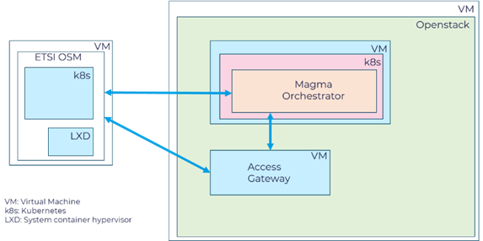
Figure 20: Test setup with only ETSI OSM orchestrator and 5G Magma core
The setup in Figure 20 will be used in the first part of the project. The setup in Figure 21 will be used in the first part of the project. This is the minimal setup required to develop solutions for the integration of the ETSI OSM orchestrator with the 5G Magma core, with different realizations of the Access Gateway.
The OSM orchestrator is deployed on a VM. During installation, OSM creates a Kubernetes cloud on this VM, as well as a LXD hypervisor. The main parts of the OSM orchestrator are deployed on the Kubernetes cloud. System containers are deployed on LXD in connection with Day 1 and 2 operations.
The ETSI OSM orchestrator is an open-source Management and Orchestration (MANO) stack aligned with ETSI NFV Information Models. OSM intends to provide a production-quality Management and Orchestration stack that meets operators' requirements for commercial deployments.
OpenStack is used as the cloud computing platform for the 5G Magma core. OpenStack is deployed in a VM on Telenor R&I’s iCora cloud and directly (on bare metal) on one of the desktop PCs.
The 5G Magma core consists of two components: the Magma orchestrator and the Access Gateway. The Magma orchestrator is a centralized controller for a set of Magma networks. The Magma orchestrator supports multiple functionalities, e.g. network entity configuration (networks, gateway, subscribers, policies, etc.).
The Magma orchestrator is installed on a Kubernetes cloud that runs in a VM deployed on OpenStack.
The Access Gateway is installed in a VM which is deployed on OpenStack. It provides network services and policy enforcement.

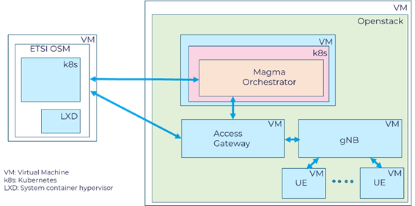
Figure 21: Test setup with ETSI OSM orchestrator, 5G Magma core, simulated gNB and simulated UEs
Figure 21 shows a test setup that will be used when developing or testing functionalities that require end-to-end connectivity with simulated gNB and UEs.

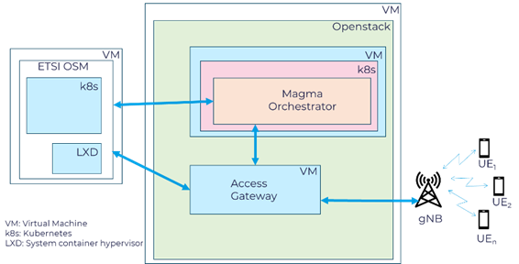

Figure 22: Test setup with ETSI OSM orchestrator, 5G Magma core, physical gNB and physical UEs
Figure 22 shows a test setup that will be used when developing or testing functionalities that require end-to-end connectivity with physical gNB and UEs.
It should be highlighted that the actual test results of the selected tests with the OSM are described in the WOR document under Chapter 6.2.5.

Planned tests
For optimization of the 5G orchestration functions the planned tests are shown in Table 13.
Table 13: Planned tests of the 5G orchestration functions
Test name | Methodology | Tools | KPIs | When | Testing setup | Comments | WP
Access GW deployment time | Measure time from command in OSM to AGW up and running | Own tool developed specifically for these tests | Deployment time | Q2’25 | 1 | To be done for different AGW solutions | 5.3.5, 5.3.6
Orc8r deployment time | Measure time from command in OSM to Orc8r up and running | Own tool developed specifically for these tests | Deployment time | Q2’25 | 1 |  | 5.3.5, 5.3.6
5G Magma core deployment time | Measure time from command in OSM to Magma core being ready for connection to gNB | Own tool developed specifically for these tests | Deployment time | Q2’25 | 1 | To be done for different AGW solutions and different AGW/Orc8r integration solutions | 5.3.5, 5.3.6
Deployment time for a new site | Measure time from command in OSM to the new site is up and running | Own tool developed specifically for these tests | Deployment time | Q3’25 | 1,2 | To be done with different number of existing sites | 5.3.5, 5.3.6
Multiple site software update deployment time | Measure time from command in OSM to the software being updated and system running in all sites | Own tool developed specifically for these tests | Deployment time | Q4’25 | 1,2 | To be done for different types of updates and different number of sites | 5.3.5, 5.3.6
5G system performance | Measure 5G-system performance, e.g. throughput and latency | Open-source tools and own tools developed specifically for these tests | Throughput, Latency and others | Q1’26 | 1,2,3 | To be done to test the effect of different improvements made to the 5G-RAN and 5G-core solutions | 5.3.5, 5.3.6, 5.3.7
Tests with components from Strand-2 | TBD | TBD | TBD | Q2’26 | 3 |  | 5.3.2, 5.3.8

5.3.3 WP5.3 test cases
This section gives the test case descriptions that are currently specified. More test cases will be added as they are specified.

Test Case 1
Title: | Attach Test
Test type: | Component test
Responsible Partner: | Telenor Maritime
Preconditions: | Pre1: COTS UEs are provisioned with eSIMs  Pre2: APN is correctly configured on the UE  Pre3: UEs can automatically search for the cell
Description: | Before performing other types of tests, it is important that the UE can connect to the private network on the vessel, demonstrating that the network is operational. This test will be demonstrated using different types of COTS UEs (Android & Apple) to ensure that it is supported.  The primary goal of this test is to verify that all system components are functioning properly before integrating or testing the rest of the components in the 5G-EMERGE ecosystem.  Two different criterions were considered for this test:  - UEs can see the nearby cell and connect to it successfully  - UEs can successfully attach to the network
Test Steps: | S1: Turn on the UE
 | S2: Verify that the UE can see the cell
 | S3: Verify that the UE can connect to the network by examining the CN logs for PDU session establishment and ensuring that the user has recieved an IP address.
Associated KPI: | Attach Successful Rate  Health check on the AGW (ensure that everything is OK with no alarms)
Actual Result: | See TN 5.3

Test Case 2
Title: | Internet Connectivity Test
Test type: | Component test
Responsible Partner: | Telenor Maritime
Preconditions: | Pre1: COTS UEs is able to succesfully connect to the network  Pre2: DNS server is setup correctly
Description: | The initial test entails doing a ping test to ensure that the user is able access the global Internet by pinging the Google Domian Name Server (DNS) server. The secondary assessment leverages an Over-the-Top (OTT) application while the user remains connected to the private network. The specified OTT application to be tested is a Push-to-Talk (PTT) service called NSC3 (which is hosted on prem) The primary objective of this dual testing protocol is to validate that the users can maintain continuous internet connectivity while simultaneously transmitting payload data, with the ping test demonstrating internet access capability and the PTT application showcasing payload transmission over the private network infrastructure.  Two different criterions were considered for this test:  - UEs can successfully ping the Google DNS server  - UEs can access the Media player application
Test Steps: | S1: Verify that the UE is attached to the network (by looking at the network status)
 | S2: Ping towards 8.8.8.8 (using ping application)
 | S3: Access the QStream player
Associated KPI: | Latency (in ms)
Actual Result: | See TN 5.3

Test Case 3
Title: | Performance Test
Test type: | Component test
Responsible Partner: | Telenor Maritime
Preconditions: | Pre1: COTS UEs can successfully connect to the private network  Pre2: COTS UEs UEs has access to the global Internet
Description: | Before performing the end-to-end test, it is important that the users can reach the global Internet over the private network and have sufficient indoor coverage. It is also important to ensure that the performance of the network is satisfactory with the current configuration both in stationery and mobility situations. The measurements should be taken while the user is moving from different areas (both public and private areas on the vessel)
Test Steps: | S1: Verify that the UE is attached to the network (by looking at the network status)
 | S2: Perform Speed Test (using an application) - performed for six iterations, with a five minute interval, resulting in a total test duration of thirty minutes
 | S3: Access the OTT application
 | S4: Test out mobility by moving to different areas (public and private) on the vessel and continously monitoring the signal strength on the UE
Associated KPI: | Throughput (UL, and DL), latency, jitter, and packet loss.
Actual Result: | See TN 5.3

Test Case 4
Title: | Multimedia Test
Test type: | End-to-end test
Responsible Partner: | Telenor Maritime
Preconditions: | Pre1: Ensure that the MDM2510 modem (on the vessel) is able to capture multicast content from Nittedal, Norway over VSAT  Pre2: Ensure that the users are connected to the private network  Pre3: Users can access the QStream player when connected to the network
Description: | The multimedia tests will be divided into two parts: component testing and the end-to-end test. This was done to make it possible to allow for a systematic evaluation of each component, ensuring proper functionality instead of testing all the components at once. The tests that will be conducted on the multimedia test are to validate that the user is able to watch content over the private network  The component test validates the multimedia content delivery capabilities of the Flute GW to ensure that the system works before performing the end-to-end test on the vessel. The purpose is to verify that the gateway can serve cached satellite content to multiple concurrent users over HTTP over unicast. The test was conducted using Grafana k6, an open-source load testing tool, to simulate 50 concurrent users requesting video content from the Flute GW.
Test Steps: | S1: Run the test script using K6
 | S2: Check the SigNoz dashboard and document the results. If successful, go to S3
 | S3: The UE can use the QStream player to discover the FTA GW and watch multimedia content over the network. In the background, verifying the metrics obtained from the media player and Flute-GW
Associated KPI: | KPIs captured from the media player and the Flute GW:  - Buffering time, video resolution, HTTP requests/response and latency metrics.  - Data received & sent
Actual Result: | See TN 5.3

For the Magma Integration with OSM, the following test cases has been defined:

Test Case 5
Title: | Deployment time for the Magma Orchestrator
Test type: | Component test
Responsible Partner: | Telenor
Preconditions: | Pre1: ETSI OSM running in a VM on a desktop PC  Pre2: OpenStack running on a second desktop PC  Pre2: Kubernetes cloud running in a VM that has been deployed on OpenStack
Description: | Measure how long it takes to deploy the Magma orchestrator (Orc8r) in an OpenStack cloud from an ETSI OSM orchestrator.  Two different criterions were considered for when the Orc8r was deployed:  - All pods up and running:  The test is stopped when all the pods of the Orc8r application is up and running in its Kubernetes cluster  - Orc8r fully deployed:  The test is stopped when the configuration of the pods has also been completed.
Test Steps: | S1: Execute command in the OSM client
 | S2: Monitor the Kubernetes cluster to determine when all pods of the Orc8r application is up and running.
 | S3: Monitor the Kubernetes cluster to determine when the pod that configure the NMS has completed.
Associated KPI: | Orc8r deployment time
Actual Result: | See TN 5.3

Test Case 6
Title: | Magma Access Gateway (AGW) Deployment Time
Test type: | Component test
Responsible Partner: | Telenor
Preconditions: | Pre1: ETSI OSM running in a VM on a desktop PC  Pre2: Kubernetes cloud and an OpenStack cloud running on a second desktop PC.
Description: | Measure how long it takes to deploy the Magma Access Gateway (AGW) in an OpenStack cloud from an ETSI OSM orchestrator.  Do the test for two different AGW implementations: “image based” and “install when deploying” implementations
Test Steps: | S1: Execute command in the OSM client
 | S2: Monitor the OSM client output and the OpenStack cloud to determine when the AGW VM is deployed
Associated KPI: | AGW deployment time
Actual Result: | See TN 5.3

Test Case 7
Title: | Deployment time for the Magma 5G Core
Test type: | Component test
Responsible Partner: | Telenor
Preconditions: | Pre1: ETSI OSM running in a VM on a desktop PC  Pre2: OpenStack running on a second desktop PC  Pre2: Kubernetes cloud running in a VM that has been deployed on OpenStack
Description: | Measure how long it takes to deploy the Magma 5G Core in an OpenStack cloud from an ETSI OSM orchestrator.  Do the test for two different AGW implementations: “image based” and “install when deploying” implementations
Test Steps: | S1: Install the AGW
 | S2: Install the Orc8r
 | S3: Connect the AGW to the Orc8r
Associated KPI: | Magma core deployment time
Actual Result: | See TN 5.3

Test Case 8
Title: | Deployment time for a new site – New gNBs
Test type: | Component test
Responsible Partner: | Telenor
Preconditions: | Pre1: ETSI OSM running in a VM on a desktop PC  Pre2: OpenStack running on a second desktop PC  Pre3: AGW VM deployed on OpenStack
Description: | The goal is to determine the time it takes to deploy a new gNB, and configure a new gNB and the Magma core (AGW) so that they are ready for UEs to connect the gNB and get its services through the Magma core.  The test completes when it is verified that the new gNB have connected to the AGW.
Test Steps: | S1: Get the Virtual Network Function (VNF) IDs from the gNB and AGW names
 | S2: Retrieve the required interface IP addresses from the gNB and AGW
 | S3: Create the gNB configuration file and start the gNB
 | S4: Verify that the gNB has connected correctly to the AGW by inspecting the gNB logs
Associated KPI: | New site deployment time - gNBs
Actual Result: | See TN 5.3

Test Case 9
Title: | Deployment time for a new site – New AGWs
Test type: | Component test
Responsible Partner: | Telenor
Preconditions: | Pre1: ETSI OSM running in a VM on a desktop PC  Pre2: OpenStack running on a second desktop PC
Description: | The goal is to determine the time it takes to deploy a new site in the form of a new AGW.  To verify correct operation of the AGW, a simulated gNB and UE (UERANSIM) is deployed as well. The test completes when it is verified that the gNB successfully connects to the AGW, and the “AGW UPF IP bug” is handled so that UEs can successfully connect to the AGW and get Internet connectivity.
Test Steps: | S1: Deploy a new AGW NS and a gNB NS on OpenStack
 | S2: Connect the gNB to the AGW and verify correct operation
 | S3: Connect a UE to the gNB, check for the “AGW UPF IP bug” and fix if required
Associated KPI: | New site deployment time - AGWs
Actual Result: | See TN 5.3

Test Case 10
Title: | Multi-site software update deployment time – Update AGWs
Test type: | Component test
Responsible Partner: | Telenor
Preconditions: | Pre1: ETSI OSM running in a VM on a desktop PC  Pre2: OpenStack running on a second desktop PC
Description: | The goal is to determine the time it takes to update the AGW software at multiple sites. The software update is done by replacing the existing AGW Network Service (NS) with a new AGW NS that has the updated software.  To verify correct operation of the AGW, a simulated gNB and UE (UERANSIM) is deployed as well. The test completes when it is verified that the gNB successfully connects to the AGW, and the “AGW UPF IP bug” is handled so that UEs can successfully connect to the AGW and get Internet connectivity.
Test Steps: | S1: Delete the existing AGW NS and the corresponding gNB NS
 | S2: Deploy a new AGW NS and a gNB NS on OpenStack
 | S3: Connect the gNB to the AGW and verify correct operation
 | S4: Connect a UE to the gNB, check for the “AGW UPF IP bug” and fix if required
Associated KPI: | Software update deployment time - AGWs
Actual Result: | See TN 5.3

5.3.4 Key results
See TN5.3 for description of testing methodology and testing results for both vessel tests and orchestration integration tests.

5.4 WP 5.4 5G Broadcast integration test bed

5.4.1 KPIs and tests
In order to properly assess:
  - Successful implementation of a prototype Protocol adapter at 5G Broadcast transmitting site,
  - Successful integration of 5G-EMERGE Far Edge with 5G Broadcast receiver,
  - Successful end-to-end laboratory integration,
the following additional KPIs are shown in Table 14 are considered.

Table 14: Considered KPIs and tests for the 5G Broadcast integration test bed
# | Test Title | Description | Test level | KPI | Quantitative KPIs | Nature of the test | Associated KVI | Status
5.4-1 | M1 Adapter Module integration at LTE-based 5G Terrestrial Broadcast transmitting site | Verify ability of the developed M1 Adapter Module to adapt the input FLUTE streams based on DVB-NIP to FLUTE streams based on 3GPP signalling and encapsulated in GTP-U protocol, providing error-free ingestion to the 5G Broadcast transmitter | Component | Ingestion errors/warnings on the 5G Broadcast transmitter dashboards |  | Functional | Quality | PlannedMS3
5.4-2 | M1 Adapter Module latency | Measure additional latency introduced by the Protocol adapter at 3GPP M1 interface. Target: additional latency significantly lower than ABR segment duration. | Component | Additional latency | Additional latency  (Target:  < 200 ms,  i.e., 10% of segment duration) | Performance | Quality | Completed MS2  PASS (detailed results in TN5.4)
5.4-3 | Control interface integration at LTE-Based 5G Terrestrial Broadcast transmitting site | Verify ability to deliver the correct signalling from the BM-SC to the eNB | Component | Acquisition of control plane information at 5G Broadcast transmitter |  | Functional | Reach | PlannedMS3
5.4-4 | HW and SW integration of 5G-EMERGE Far Edge with LTE-Based 5G Terrestrial Broadcast receiver | Verify ability to integrate a 5G Broadcast receiver instead of a satellite receiver for the Far-Edge reception | Component | Integration of 5G Broadcast receiver at Far Edge |  | Functional | Reach | PlannedMS3
5.4-5 | Service continuity on end-to-end 5G Broadcast integration | Laboratory demonstration of the correct functioning of the end-to-end chain, including satellite link, M1 Adapter Module at transmitter side and 5G Broadcast receiver at far edge side | End-to-end | A/V service continuity | Mean time between error events  (Target:  less than one error event per transmission hour in average) | Performance | Quality | PlannedMS3
5.4-6 | End-to-end additional latency | Measure additional end-to-end latency introduced by the 5G-EMERGE distribution (i.e., satellite feed and M1 Adaptation Module) with respect to a traditional IP distribution where the 5G Broadcast Core is directly connected with the eNodeBs via terrestrial IP network | End-to-end | End-to-end additional latency (one-way) | End-to-end additional latency  (Target:  < 500 ms) | Performance | Quality | PlannedMS3
5.4-7 | Maximum peak bit-rate | Measure the maximum allowed peak bit-rate at SAT reception to avoid saturation of the M1 adapter module and/or 5G Broadcast TX and, hence, to avoid video artifacts, freezes and UX issues | End-to-end | End-to-end peak bit-rate | Peak bit-rate  (Target:  > available bit-rate in 5G Broadcast minus 300 kbit/s) | Performance | Quality | PlannedMS3
5.4-8 | Allowed average bit-rate | Measure the maximum allowed average bit-rate at SAT reception to avoid saturation of the M1 adapter module and/or 5G Broadcast TX and, hence, to avoid video artifacts, freezes and UX issues | End-to-end | End-to-end peak bit-rate | Average bit-rate  (Target:  > 80% of peak bit-rate) | Performance | Quality | PlannedMS3

5.4.2 Test procedures

KPI 5.4-1 – M1 Adapter Module integration at LTE-based 5G Terrestrial Broadcast transmitting site
The test procedure to assess the correct integration of the developed M1 Adapter Module consist in evaluating its ability to adapt the input FLUTE streams received from the satellite using DVB-NIP to FLUTE streams based on 3GPP signaling and encapsulated in GTP-U protocol, providing error-free ingestion to the 5G Broadcast transmitter.
Unfortunately, commercial 5G Broadcast transmitters (as the one used in this testbed), usually do not expose detailed metrics and statistics about the input streams but they expose a simplified dashboard, which only signals the presence of errors or warning at the input, as the one shown in Figure 23. Moreover, warnings and errors at this stage are typically not dependent on a single metric/factor but, rather, by a multitude of them, for example:
- MBMS SYNC errors
- Presence of GTP-U packets in MBMS SYNC sequence
- GTP-U packet loss
- Input streams bit-rate exceeding the max bit-rate allowed by the target MCS of the modulator
For this reason, the test procedure for test 5.4-1, consist in monitoring the transmitter dashboard for a reasonable amount of time, making sure that no errors or warnings are signaled during this time frame. The target amount of time is typically in the range of 15-30 minutes per session, since almost all of the aforementioned error causes typically manifests themselves with very short periodicity (e.g.: MBMS SYNC sequence is about 40 s, Satellite bursts occur every 1-2 seconds, …).

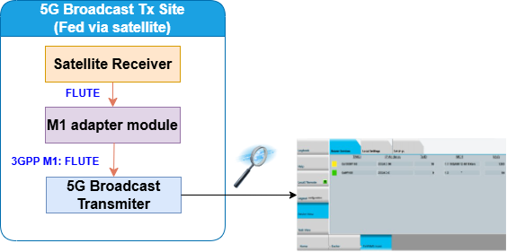

Figure 23: Test procedure for M1 Adapter Module integration at LTE-based 5G Terrestrial Broadcast transmitting site
KPI 5.4-2 – M1 Adapter Module latency
The test procedure for evaluation of the latency introduced by the M1 Adapter module at Tx side consists of an off-line measurement, based on IP traffic capture and subsequent analysis.
Input and output IP packets, i.e., input FLUTE multicast streams as received via satellite and corresponding output GTP-U multicast stream, are simultaneously captured on the PC running the M1 Adapter Module by means of Wireshark tool, as shown in Figure 24. Based on this capture, subsequent off-line analysis allows to match the corresponding input and output packets, calculating their timestamp difference (one-way latency).

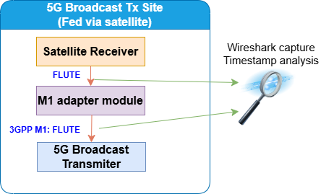
Figure 24: Test procedure for evaluation of M1 Adapter Module latency
Measured latency will be reported as histograms with at least 10 000 samples, indicating minimum, maximum, average values and percentile 95 and 99.9.
Note: Wireshark produces timestamps in nanosecond resolution, however such timestamps are received from the libpcap (or Npcap) library, which in turn gets them from the operating system kernel: this means that their accuracy depends on several factors and cannot be easily estimated. However, in this specific case a millisecond accuracy (or even ten milliseconds) can be considered sufficient when compared to ABR segment duration (e.g., 2 or 4 s).
Tests should be repeated without or with traffic shaping.

KPI 5.4-6 – End-to-end additional latency
End-to-end latency refers to the total latency introduced by the 5G-EMERGE chain, from audio/video encoder to playout device.
This KPI rather refers to the additional latency introduced by the 5G-EMERGE distribution (i.e., satellite feed and M1 Adaptation Module) with respect to a traditional distribution where the 5G Broadcast Core is directly connected with the eNodeBs via terrestrial IP network.
The test procedure consists in measuring the end-to-end latency in case of 5G Broadcast integration with 5G-EMERGE as described in the present document (path A in Figure 25) and in case of pure 5G Broadcast distribution (path B in Figure 25), and calculating their difference.
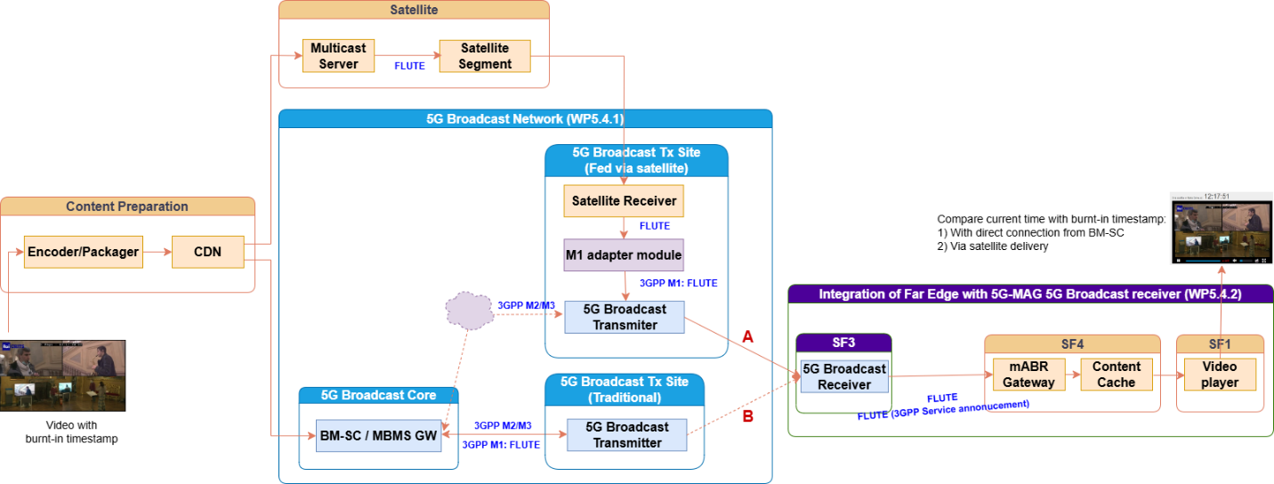
Figure 25: Test procedure for evaluation of the end-to-end additional latency
In order to allow evaluating the end-to-end latency, at the encoder side a timestamp is burnt in the video.
At the receiver side, the video player should also show current timestamp (e.g., the PC clock or a network service, e.g., https://time.is), allowing to estimate the end-to-end latency between the two timestamps. If the same procedure and the same client device are used for both paths A and B, the difference between the two measurements provides the additional end-to-end latency.
Note: The accuracy of this measurement is affected by the accuracy of the timestamp burnt in the video (i.e., video frame duration, e.g., 20 or 40 ms in case of 50p or 25p frame rate respectively) and by the stability of the video player buffer size among multiple sessions.

6 Test and validation plan for Strand 6: Direct to device

The verification work in Strand 6 is structured into multiple test platforms. Each testbed is dedicated to a specific subset, focusing either on validating the functionality of features or evaluating their performance and limitations. All subset testing is designed to ensure the verification of the Direct-to-Device (DTD) end-to-end solution, which is illustrated in high-level in the Figure 26. In addition to that several simulation environments offer theoretical insights into performance across various scenarios, providing valuable information and input for the verification conducted in the testbeds.
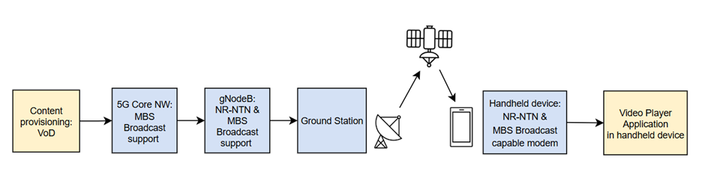
Figure 26: High-Level Block Diagram of the DTD end-to-end Testbed
The primary goal of DTD verification is to demonstrate the functionality of the new technology as a fully integrated end-to-end system, highlighting its capabilities and potential under diverse conditions. This process provides valuable insights into the capabilities of DTD technology from both service and use case perspectives, potentially enabling new opportunities for service providers.
In summary, four different testbeds are focusing on the following subtests:
- The first testbed (WP6.3) focuses on technology verification, replicating the NR NTN setup in a laboratory environment using Keysight test equipment and a MediaTek Android test phone with a 5G modem that supports both NR-NTN and MBS broadcast features. This setup is used to test and validate NR MBS over NR-NTN.
- The second testbed (WP6.4.2) utilize same configuration than the first one for technology verification but focusing now for NR-NTN performance testing.
- The third testbed (WP6.4.3) is focusing on performance testing, like WP6.4.2, but with the key difference that testing is executed wirelessly within an RF chamber.
- 5G MBS functionalities within the Core Network is verified in fourth testbed, as detailed in the following subsections regarding to WP6.3.11.
- The final testbed is for the Direct-to-Device end-to-end solution described in WP6.4.4, utilizing all components verified in earlier testbeds. It also includes a real satellite link, content provisioning, and an end-user video player application.
Detailed descriptions of the simulation environments and test subsets are provided in the following subsections. The upcoming subsections will cover the following activities for all testbeds:
  - High-level description of the test plan
  - Testbed and setup
  - Validation methodology
  - Key results.

To ensure a robust and objective evaluation of the project's technical achievements, a comprehensive set of KPIs was defined. The KPIs for each testbed were specifically chosen to reflect its unique validation scope, creating a layered testing strategy that progresses from low-level physical layer characterization to end-to-end service quality.
- Keysight Performance Testbed: Focused on physical layer demodulation performance in a conducted, controlled lab environment.
- Verkotan OTA Testbed: Focused on characterizing the terminal's antenna and radio performance over the air.
- DTD End-to-End Testbed: Focused on a combination of network-layer metrics and application-level KPIs, such as video quality and rebuffering events, to evaluate the complete user experience.

The following table provides a consolidated overview of the primary and secondary KPIs defined for each testbed.
Testbed / Category | KPI / Metric | Description / Focus Area
Keysight Performance Testbed
Primary KPI | PDSCH Block Error Rate (BLER) | Measures the physical layer error rate as a function of RSRP. This is the core metric for evaluating demodulation performance under various channel conditions.
Secondary KPIs | Data Rate (Throughput) | Measures the application-level data rate achieved over the NR-NTN radio link.
 | Throughput Stability | Evaluates the consistency of the data rate over time to assess the quality and quality of the radio link.
 | Connection Reliability / Robustness | Tracks the frequency and circumstances of unexpected connection loss events (Connection Drops).
 | Connection Establishment Time | Measures the time required to establish a stable NR-NTN connection from an initial state.
Verkotan OTA Testbed
NTN terminal radio link OTA performance | OTA data rate | Measures over-the-air data rate
 | OTA data rate variations | Assesses stability of OTA data rate
 | Connection drops | Tracks loss of connection events
 | Setup time of NTN connection | Time to establish NR-NTN connection
Verkotan OTA Testbed
NTN terminal RF OTA performance | EIS/TIS, EIRP/TRP | Measures receiver sensitivity and transmitter power
 | Radiation pattern (EIS, EIRP) | Characterizes antenna performance
 | TIS, TRP | Total isotropic sensitivity and radiated power
DTD End-to-End Testbed
Application Layer | Application Layer Throughput | Measures the effective data rate ("goodput") received by the video streaming application. This is the most direct indicator of user-perceived performance and is validated against the target bitrates for SD, HD, and 4K streams.
 | Video Quality | A subjective evaluation of the video playback, focused on identifying visual impairments such as artifacts, pixelation, or freezes.
 | Rebuffering Events | The number and total duration of stalls or buffering events during a test session, directly impacting the viewing experience.
 | Consumption Reporting | Verification that the User Equipment (UE) reports media consumption metrics back to the network as specified in 3GPP TS 26.501.
Modem/Network Layer | Block Error Rate (BLER) | Measures the percentage of transport blocks received with errors. This is a critical KPI for broadcast, as there are no HARQ retransmissions. The plan defines both an "Ideal Target" (< 1%) and an "Acceptable Threshold" (< 5%).
 | Physical Layer Throughput | Measures the raw data rate over the NR-NTN link at the modem level. This KPI is used to assess the fundamental performance and efficiency of the radio link.
 | Throughput Stability | Evaluates variations in the physical layer data rate over time to assess the stability and consistency of the satellite link.
 | NTN Connection Setup Time | Measures the time taken for the UE to establish the initial Radio Resource Control (RRC) connection over the NR-NTN link.
 | Service Continuity | Confirmation that the MBS session is not dropped during minor link fluctuations or temporary signal obstructions.

6.1 System Modelling and Simulations – WP 6.1

6.1.1 High-level description of the test plan
The objective of WP 6.1 is to develop and test versatile aspects of 5G MBS in NTN environment. The overall activity-chain of WP 6.1 is as follows:
- WP 6.1.1 concentrates on link/PHY level studies of NTN user link. They are able to provide quick analysis of the physical layer aspects, such as antenna performance, prior to deployment of the models or parameters to the test-beds in other Strand 6 WPs. Moreover, they provide input to the system-level simulations conducted by WP 6.1.2 and 6.1.3 as well as test-bed research in WP 6.1.4. Matlab-based software is utilized.
- WP 6.1.2 develops global-scale satellite constellations considering PHY parameters unified with WP 6.1.1. The constellations will be deployed in the protocol-level simulations in WP 6.1.3. Ansys Systems Tool Kit (STK) is used for designing the constellations. As such, the produced constellations may serve as useful reference for what is required from the satellite network to support the 5G-EMERGE service levels.
- WP 6.1.3 conducts 5G MBS protocol-level simulations reusing the PHY parameters from WP 6.1.1 and the constellations from WP 6.1.2. The NS-3 based ALIX simulator is used, which allows customized and highly-dynamic scenarios with respect to service, traffic and satellite network conditions. WP 6.1.3 may provide Strand 6 test-beds with insight on protocol performance (e.g. mobility operations, control plane issues etc.) and optimizations to e.g. related parameter values.
- WP 6.1.4 focuses on defining the channel emulation parameters and scenarios—including channel impairments—to be used in the tests conducted in WP 6.3 and WP 6.4.2, utilizing Keysight channel and network emulators and MediaTek user equipment (UE). Key parameters for channel emulation have been aligned with WP6.1.1, WP6.1.2, and WP6.1.3 to ensure comparability with the simulations performed in those work packages.

Based on the above, the sub-WPs may provide useful information for test-beds at various layers of the system. To enable delivery of reliable information, the sub-WPs deploy dedicated testing environments tailored for their own development process. As each sub-WP utilizes different software for development and focus on different parts of the 5G and MBS, there is no single test-environment or test-bed implemented in the WP but the sub-WPs conduct independent testing strategies. These strategies are described in the following sub-sections. More detailed explanations of the testing approaches can be found in Technical Notes of each sub-WP.

WP 6.1.1: Physical layer simulation – radio channel and communication link modelling
Two simulation tools are being developed. The first, based on analytical methods such as link budget analysis, is implemented in spreadsheets (Excel) to allow quick exploration of how design parameters—such as frequency bands, antenna characteristics, and satellite orbits—affect the feasibility and performance of direct-to-device communication, including its ability to provide the required throughput. The second is a more detailed MATLAB-based PHY-LL model of the complete transmitter–receiver chain, focusing on key metrics such as carrier-to-noise and signal-to-noise ratios, which directly influence bit error rates/block error rates and, in turn, throughput.

WP 6.1.2: NGSO constellation simulation – large scale system modelling
Constellation design is done with commercial Systems Tool Kit (STK) tool. The requirement for the NGSO constellations is global coverage at any time. This means that the user terminals have to be able to successfully receive transmissions whenever, wherever. The metric used to define the success is bit error rate (BER); it has to be below a certain max value, e.g., 10⁻⁶. Additionally, other metrics such as C/N or Eb/No can be also computed, as well as the same with the interference included (BER+I, C/(N+I), Eb/(No+Io)).

WP 6.1.3: 5G NTN technology simulations – smaller scale system modelling
ALIX system level simulator will be used for the small-scale simulations. It is based on open-source Network Simulator 3 (NS-3) platform which provides testing framework for the simulations. The project will apply Scrum processes and practices, and Continuous Integration (CI) practices will be employed within the Scrum framework. The CI process entails continuous testing of the software which will be automatically triggered upon each update in the common software repository.
Testing in WP 6.1.3 is fully software-based without emulation or real devices, where the testing strategy spans from per-function unit tests of the code base to broader system-level regression tests. The output of each test is reproducible, ensuring rigorous and consistent behavior of the simulator during the development phase. These tests are used to verify the requirements defined for the essential features developed for 5G MBS simulations.

WP 6.1.4: Channel emulation implementation, based on simulation results
High level description of channel emulation test scenarios has been implemented and defined in this work package. The tools and methods are defined, and preliminary implementations of the test scenarios is also done. Keysight Orbit and Channel Modelling tool SW will be used for basic functionalities of the test scenarios and additional features will be enabled by special scripts which will be enhanced/implemented in WP 6.3.10. The high-level test plan for testing the UE performance in emulated setup test bed is to utilize various test scenarios defined in deliverables of WP 6.1.4. and is further described in WP 6.3 and 6.4 sections below.

6.1.2 Validation methodology

WP 6.1.1:
Testing in WP6.1.1 is carried out without emulation or experimental measurements of real devices. Instead, the results are cross-validated against findings from the technical literature (particularly 3GPP) and academic research, by comparing the outputs of the two developed simulation tools with each other, with the results of other WP6.1 tasks, and, at a later stage, with experimental outcomes from WP6.3. For verification, a set of test cases and scenarios will be defined. These will include simple, easily tractable cases to ensure the correctness of the developed tools and to help detect potential errors, as well as more complex scenarios for which results are available in the literature or from existing testbeds. The latter will serve as references for validating the developed tools. A detailed description of the test cases and verification scenarios, and the results of the verification will be provided in the WP6.1.1 TN4 document.

WP 6.1.2:
As STK is a commercial tool and we have not implemented any new features there, validation of the tool itself is not needed. The designed constellations will be used in other WPs (especially WP6.1.3) and hence, in other tools, which make it possible to compare the performance of the designed constellation also in other tools than STK.

WP 6.1.3:
One of the goals for the testing is to implement fast and maintainable automated tests. To achieve this, the focus in automated tests is on smaller-scale unit and integration tests. Additional manual non-automated test cases may be used for acceptance testing to verify that the implementation meets the requirements.
All automated tests are utilized in the regression testing in the CI pipelines. The regression testing is done mainly by the CI pipelines but can also be done manually if required.
The following testing levels are defined for this work:
Unit testing
- A unit test is a basic test verifying the correct functionality of a unit, e.g., a class or a function.
- Integration Testing
- Integration testing is designed to assess whether the interfaces between components in a subsystem have consistent assumptions and communicate correctly.
- Acceptance testing
- Acceptance tests are designed to verify whether the implemented software and its features meet the set requirements.
For the verification of the models, a set of test cases, verification scenarios and requirements will be defined. A test case defines a set of requirements that will be verified with that specific test case. A verification scenario is a configuration of a limited number of network nodes, e.g. satellites and UEs, that allows modelling of specific network features. Each test case will be associated with one verification scenario. Test cases will eventually be tracked in a verification matrix, providing a quick visual outlook of compliance with the requirements. Additionally, output from the simulations (traces, logs etc.) may be stored for more in-depth analysis.

WP 6.1.4:
WP 6.1.4 does not involve any hardware testing or emulation. Instead, it focuses on identifying relevant parameters and scenarios and proposing channel model scenarios to be utilized in subsequent work packages, such as WP 6.3 and WP 6.4.2.
The validation of the selected parameters is based on their alignment with definitions provided by standardization bodies such as 3GPP and ITU. Regarding the validation of the generated channel model scenarios, these will be created using the commercial software Keysight Channel Studio GCM, a multipurpose geometric channel modeling tool that undergoes a rigorous validation process prior to release.

6.1.3 Key results

WP 6.1.1:
The main results of WP6.1.1, derived from the defined test cases, will be presented in the WP6.1.1 TN4 document. These results, or findings from a more extensive follow-up study, may also serve as the basis for a research paper.

WP 6.1.2:
The main results of WP6.1.2 will be the developed constellations. They are provided to other WPs (especially WP6.1.3) as inputs. The results or findings shall also serve as a contribution to scientific publications.

WP 6.1.3:
The main results from WP 6.1.3 will be the output from the test cases. Additionally, separate and more thorough study may be conducted on specific scenarios from which dedicated analysis can be delivered. The results may be complemented by visualization aid from Magister SimLab.c

WP 6.1.4:
The main outcomes of WP 6.1.4 are the proposed channel emulation test scenarios, as described in WP 6.1.4 TN1. These scenarios will serve as input for the channel emulation tests conducted in WP 6.3 and WP 6.4.2.

6.2 Keysight Functionality Testbed – WP 6.3: DTD Technology Development

6.2.1 High-level description of the test plan
The combined aim of all sub-WPs (with the exception of sub-WP 6.3.11 which feeds directly into WP6.4) is to replicate a NR NTN setup in a lab using Keysight test equipment and a MediaTek Android Test phone with 5G modem supporting both NTN and MBS features to test and validate NR MBS over NTN. This does not validate or test a full end-end solution but focuses on the Radio Access Network part with some mandatory Core Network functionality and no MBS Application Layer implementation
WP 6.3.1: Integration of the MBS and NTN features
This is a purely software implementation specific sub-WP to create a single modem build which includes both MBS changes and NTN changes which can be used for 5G modem evaluation board and phone for inter-operability testing using Keysight test equipment to test MBS reception over NTN. This will be validated by unit testing and integration testing using Mediatek’s internal software development tools on a host PC or server.
WP 6.3.2: Independent MBS Broadcast over 5G verification
The goal of this WP is to implement and support R17 MBS Broadcast protocol functionality over 5G TN in Keysight’s network emulator and verification of the new MBS over TN functionality against a MediaTek capable device using the testbed in Figure 27. N.B. only a basic channel model will be used in the Keysight prop-Sim channel emulator at this stage.
WP 6.3.3: Support R17 MBS Broadcast Delivery over NR NTN
Objective of this WP is to verify support of MBS Broadcast functionality over NTN using the testbed in Figure 17, and to provide support of GEO NR-NTN functionality in the Keysight test gNodeB.
WP 6.3.4: Support of GEO and other high orbit satellites for Device
This WP objective is to add support for GEO and high orbit satellites in MediaTek 5G Modem software and verify against the Keysight Test gNodeB using the testbed in Figure 17.
WP 6.3.5: Support Channel and Network emulator test environment
This sub-WP will install, configure and validate the channel emulator test scenarios from sub-WP 6.3.10 in the testbed in Figure 27.
WP 6.3.6: Inter-operability testing: 5G NTN Device - (test) gNB
The objective of this WP is to perform interoperability testing between a 5G device supporting NTN and MBS and Keysight’s test gNB to verify MBS delivery via NTN using the testbed in Figure 17.
WP 6.3.7: Development of an Evaluation Board
Objective of this WP is to deliver an Evaluation Board that serves as a reliable and versatile platform for evaluating MBS and NR NTN use cases. No tests cases will be described in this document for this sub-WP.
WP 6.3.8: Development of a 5G Test Phone Device
Objective of this WP is to develop a 5G test phone device for comprehensive inter-operability testing and validation of the MBS reception over NR NTN using the modem build supporting MBS and NR-NTN features. No tests cases will be described in this document for this sub-WP.
WP 6.3.9: Verify using industry standard test packages for NR-NTN
This WP will use the testbed in Figure 27 to verify industry standard test packages for NR-NTN against the MediaTek UE.

WP 6.3.10: Channel Emulation test environment development for satellite broadcasting
The channel emulation test scenarios and integration of channel emulator with BS emulator and UE for testbed defined in section 5.2.2 will be implemented in this work package. N.B these will be integrated and verified in sub-WP 6.3.5 hence no tests cases will be described in this document for this sub-WP.

6.2.2 Test bed and setup

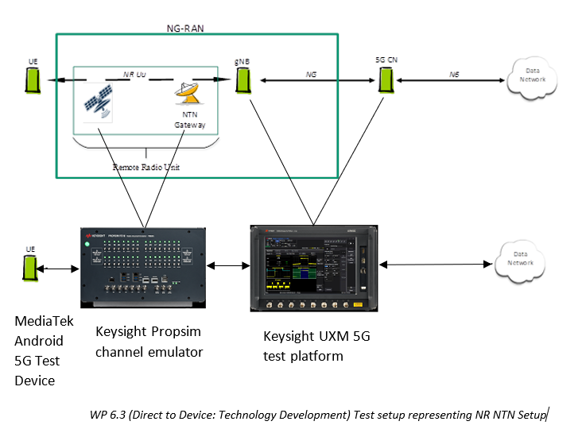
Figure 27: WP6.3 Test setup representing NR NTN Setup
WP 6.3 (Direct to Device: Technology Development) aims to replicates NR NTN setup in a lab using Keysight test equipment and MediaTek Android Test phone with 5G modem supporting both NTN and MBS features to test and validate NR MBS over NTN. SeeFigure 30.
- Keysight UXM is 5G emulator which emulates gNB and 5GC to test 5G device. This would also support MBS broadcast test capability to allow to test MBS broadcast reception in the UE.
- Keysight Propsim channel emulator emulates NTN channel (delay, doppler and other NTN channel conditions) which allows to test NTN in lab by emulating various NTN scenarios.
- MediaTek would provide 5G test device with 5G modem supporting both NTN and MBS functionality.
All Sub-WP’s in WP 6.3 except WP 6.3.11 are either implementing or validating parts of the test-bed or using the test-bed itself to verify the MBS over NR-NTN modem technology itself (see section 6.1 for a description of each sub-WP).

6.2.3 Validation methodology

WP 6.3.1 Integration of NTN & MBS features in modem software
 | Test Objective | Test Methodology | Milestone
1 | Test MBS code integration | Test MBS unit tests of different modules and make sure they all pass  Test MBS Integration tests of different modules and make sure they all pass | MS1
2 | Test NTN code integration | Test NTN unit tests of different modules and make sure they all pass  Test NTN integration and regression tests for basic NTN features using Keysight NTN test equipment and make sure they all pass | MS1

WP 6.3.2 Independent MBS Broadcast over 5G verification
 | Test Objective | Test Methodology | Milestone
1 | Keysight network emulation: Test R17 MBS Broadcast protocol aspects including 5G Layer1, Layer2 and RRC layer | - Test MBS protocol aspects using internal module tests for each layer, L1, L2 & RRC independently.  - Test inter-working between each layer using internal test environment to ensure interface consistency and correct behaviour on receipt of MBS related messages from different layer.  - Test state machine management at each protocol layer using internal test environment for the following protocol procedures:  - Updates to MIB, SIB1 for MBS updates  - Transmission of SIB20  - Transmission of PDCCH - DCI 4_0  - Transmission of MCCH  - Transmission of MBS Broadcast Configuration – initial configuration  - Support for MBS related procedures at RRC in IDLE state  - Verify all the above steps using capable MediaTek UE. | MS2
2 | Keysight network emulation: Test DL MBS data generation and delivery over single MBS bearer | - Test state machine management at each protocol layer using internal test environment for the following protocol procedures:  - Transmission of MBS Broadcast Configuration  - MRB-InfoBroadcast (L2 Support – SDAP/PDCP/RLC)  - MRB - MBS Radio Bearer  - Transmission of MBS Broadcast Configuration – Change Notification  - Test Broadcast data transmission across whole of protocol stack using internal data generator implemented at PDCP layer for single MRB and verify by inspecting Keysight generated log files.  - Verify all the above steps using capable MediaTek UE. | MS3
3 | Keysight network emulation: Verify support for multiple MBS Broadcast session configuration, data transmission and teardown | - Test state machine management using internal test environment for each protocol layer for the following protocol procedures:  - Transmission of SIB21  - Reception only of MBSInterestIndication  - Support multiple sessions (5)  - Support for MBS related procedures at RRC in INACTIVE/ Connected state  - Test Broadcast data transmission across whole of protocol stack using internal data generator implemented at PDCP layer for multiple MRBs and verify by inspecting Keysight generated log files.  - Verify all the above steps using capable MediaTek UE. | MS3

WP 6.3.3 Support R17 MBS Broadcast Delivery over NR NTN
 | Test Objective | Test Methodology | Milestone
1 | Keysight network emulation: Verify support for DL HARQ Feedback disabling | - Test and verify feature of DL HARQ feedback disabling using internal test environment to ensure all protocol layers are behaving as per relevant 3GPP specifications.  - Verify DL throughput with this feature enabled is more when it is disabled.  - Verify all the above steps using capable MediaTek UE. | MS2
2 | Keysight network emulation: Verify support for NTN GEO functionality | Verify all the GEO features using capable MediaTek UE. | MS3
3 | Keysight network emulation: Verify MBS Broadcast delivery with NTN | Test all the steps identified for verification of WP 6.3.2 with NTN feature enabled using capable MediaTek UE. | MS3

WP 6.3.4: Support of GEO and other high orbit satellite
 | Test Objective | Test Methodology | Milestone
1 | Support for large timing advance (~540 msec) | Test NTN GEO scenario using Keysight NTN test equipment with large timing advance (e.g. Gatway and UE located near arctic circle) and verify that UE can still receive data in connected state. | MS1
2 | Support for DL HARQ Feedback disabling | Test NTN GEO scenario using Keysight NTN test equipment with DL HARQ feedback disabled and verify using Keysight equipment that UE does not transmit HARQ feedback and DL throughput is higher with HARQ feedback disabled with other configuration same | MS2
3 | Support for UL HARQ mode B and logical channel prioritisation | Test NTN GEO scenario using Keysight NTN test equipment with UL HARQ mode B and UL data logical channel prioritised for HARQ processes with UL HARQ mode B and verify that UE does not perform UL retransmissions and UL throughput is higher with UL HARQ mode B with other configuration same. | MS3
4 | Support for all GEO features together | Test NTN GEO scenario using Keysight NTN test equipment with all GEO features (DL HARQ feedback disabled, UL HARQ Mode B & logical channel prioritisation) and verify that UE can receive data in connected mode. | MS3

WP 6.3.5 Support Channel and Network emulator test environment
 | Test Objective | Test Methodology | Milestone
1 | Keysight network emulation: Verify support of chosen subset of channel models identified in WP 6.1 | Verify final NTN & MBS channel models, test scenarios and parameterization identified in WP 6.1 using Keysight channel emulation and Keysight network emulation with capable MediaTek UE. | MS3

WP 6.3.6 Interoperability testing of MBS over NTN between gNB and 5G device
 | Test Objective | Test Methodology | Milestone
1 | Support of MBS over NTN GEO | Test MBS over NTN GEO scenario using Keysight NTN test equipment, i.e. test all MBS broadcast tests tested over TN (without NTN) earlier with NTN GEO and verify that UE can still receive MBS broadcast in connected and idle mode. | MS3

WP 6.3.9 Verify using industry standard test packages for NR NTN
 | Test Objective | Test Methodology | Milestone
1 | Validation of MediaTek devices for NR NTN Conformance configurations | Execute the available test packages from Keysight which exercise extensive NR NTN configurations including industry standard Conformance definitions using the testbed in Figure 17 and validate the behaviour of MediaTek device. | MS3

6.2.4 Key results

WP 6.3.1:

 | Test Objective | Status
1 | Test MBS code integration | Pass*
2 | Test NTN code integration | Pass*

*All unit and regression tests passed as of MS1. As part of the MS2 work they are now used for regression testing on an automated test bed in MediaTek UK labs. The details of these tests are company sensitive and cannot be shared publicly, but they consist of 178329 unit and integration tests to validate the quality of the modem software.

WP 6.3.2:

 | Test Objective | Status
1 | Keysight network emulation: Test R17 MBS Broadcast protocol aspects including 5G Layer1, Layer2 and RRC layer | Pass
2 | Keysight network emulation: Test DL MBS data generation and delivery over single MBS bearer | Step 1 and Step 2 are now complete.  Step 3 is ongoing.  MCCH is successfully received by the MediaTek device.  MBSBroadcastConfiguration message is successfully decoded, and the MediaTek device configured correctly.  Currently debugging the reception of the MTCH between Keysight UK and MediaTek UK.
3 | Keysight network emulation: Verify support for multiple MBS Broadcast session configuration, data transmission and teardown | Step 1 and Step 2 are currently ongoing.  KeySight UK is working on these to provide the required functionality to be tested by MediaTek UK in early MS3.

WP 6.3.3:

 | Test Objective | Status
1 | Keysight network emulation: Verify support for DL HARQ Feedback disabling | Pass
2 | Keysight network emulation: Verify support for NTN GEO functionality | Ongoing
3 | Keysight network emulation: Verify MBS Broadcast delivery with NTN | To be started on completion of WP 6.3.2 tests

WP 6.3.4:

 | Test Objective | Status
1 | Support for large timing advance (~540 msec) | Pass
2 | Support for DL HARQ Feedback disabling | Pass
3 | Support for UL HARQ mode B and logical channel prioritisation | Ongoing*
4 | Support for all GEO features together | To be started on completion of test 3) above

*Functionality has been proven with MediaTek UK integration tests. Waiting on a new release of UXM firmware from KeySight UK to complete the verification. Release date is set for 13/02/2026.

WP 6.3.5:

 | Test Objective | Status
1 | Keysight network emulation: Verify support of chosen subset of channel models identified in WP 6.1 | To be started after MS2

WP 6.3.6:

 | Test Objective | Status
1 | Support of MBS over NTN GEO | To be started after completion of tests specified in WP 6.3.2, WP 6.3.3 and WP 6.3.4*

*In order to complete the basic verification of the following deliverable for MS2;
“5G Modem build with NTN (with GEO) and MBS”
further interoperability testing has been performed with the MediaTek gNodeB emulator from MediaTek Finland that will be used for WP 6.4.4.
This has successfully proved the ability of the MediaTek devices used in the 5G EMERGE project to received MBS broadcast data over a GEO NR NTN connection with real hardware.

WP 6.3.9:

 | Test Objective | Status
1 | Validation of MediaTek devices for NR NTN Conformance configurations | To be started after MS2

6.3 Keysight Performance Testbed – WP 6.4.2: Verification in System Emulator

6.3.1 High-level description of the test plan
The test plan for WP6.4.2 defined the verification activities for an NR-NTN handheld device using a laboratory system emulator. The primary objective of the plan is to assess the device's PDSCH demodulation performance under a range of emulated real-world channel conditions, including multipath fading, shadowing, and ionospheric scintillation.
The plan is based on channel emulation scenarios defined in WP6.1.4. A key strategic decision outlined in the plan was to focus testing on three distinct scenarios to ensure efficient yet comprehensive coverage:
• Scenario C: A representative Low Earth Orbit (LEO) case.
• Scenario F: A general Geostationary Orbit (GSO) case for LEO/GSO comparison.
• Scenario H: A specific GSO Ku-band case designed to emulate the final DTD OTA demonstration channel condition.
The performance evaluation was designed to be comprehensive, centered on metrics that assess both physical layer robustness (primarily through PDSCH BLER) and the overall connection quality (including data rate and stability). While the broader project addresses MBS, the scope of this specific test plan was strictly limited to NTN unicast functionality. Ultimately, the results of this verification are intended to confirm that the device meets the necessary performance standards for its intended operational scenarios.

6.3.2 Test bed and setup
The verification process utilizes a testbed created and integrated in WP6.3, employing a system emulator consisting of NW emulator and Channel emulator provided by Keysight. The NW emulator, channel emulator and UE are cable connected, and the UE is placed in a shield box to avoid interference from external sources. The testbed depicted in Figure 28 is designed to simulate real-world channel impairments, providing a comprehensive environment for performance testing, and enabling evaluation of how the NR-NTN handheld device behaves under various conditions.

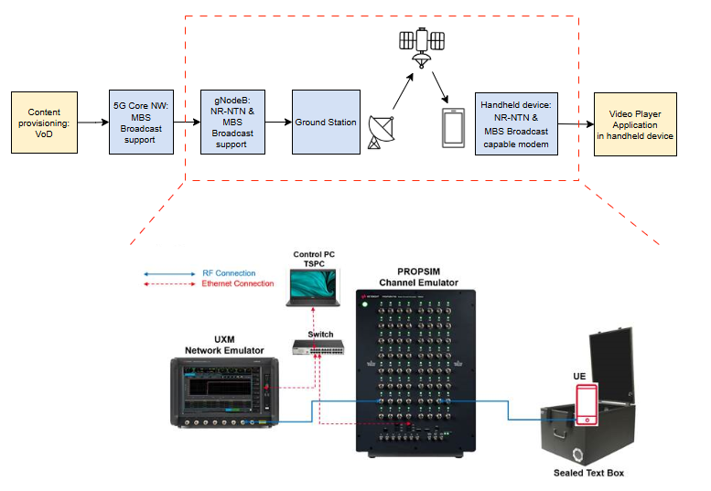
Figure 28: Keysight Performance Testbed for handheld device over NT-NTN

6.3.3 Validation methodology
The test case specifications and test plan for WP6.4.2 are based on inputs from WP 6.1.4, which defines the channel emulation test scenarios.
A fundamental step in the validation methodology was defining the evaluation criteria. Performance was measured against a primary KPI (PDSCH Block Error Rate) to assess demodulation performance, and a set of secondary KPIs (Data Rate, Connection Drops, Setup Time) to evaluate connection stability. For this phase of testing, the methodology was applied exclusively to NTN unicast scenarios, with MBS functionality remaining out of scope.
The methodology began with an evaluation of a broad set of six orbit types and satellite scenarios, summarized in the table below.

Main orbit types | Scenario | Description
Theoretical orbits | A | Satellite trajectory: Polar circular LEO orbits at 600 km height for alignment with simulation.  UE location: Specific default position in the middle and below of the satellite trajectory.
3GPP-defined Keplerian orbits | B | Satellite trajectory: 3GPP-defined LEO orbit at 600 km height using initial state vectors.  UE location: MediaTek, HQ, Taipei, Taiwan.
Real satellite TLE-based orbits | C | Satellite trajectory: Real TLE-based LEO orbit  UE location: European Space Research and Technology Centre, Noordwijk, Netherlands.
 | D | Satellite trajectory: Real TLE-based LEO orbit  UE location: Liminka (Rural area), Finland.
 | E | Satellite trajectory: Real TLE-based LEO orbit HO scenario  UE location: European Space Operations Centre, Darmstadt, Germany.
 | F | Satellite trajectory: Real TLE-based GSO orbit  UE location:

Based on preliminary findings that showed high similarity across the LEO scenarios (A-E), the test campaign was focused on three distinct scenarios (C, F, and H) to provide representative coverage of LEO, GSO, and the specific Ku-band OTA demonstration environments (Scenario H).
Plan is to simulate various environmental conditions, such as
- shadowing variations
- multipath effects
- scintillation
- user equipment (UE) movement (virtual speed/static)
Channel models and impairments that are used in NTN tests are defined in Table below:

Channel model / impairment | Reference
No Interference | TS 38.101-5 Annex B.0
Static | TS 38.101-5 Annex B.1
NTN-TDLA-100-200Hz  NTN-TDLC-5-200Hz | TS 38.101-5 Annex B.2
TDL-A (Suburban/Rural)  TDL-C (Suburban/Rural) | TR38.811 Clause 6.9.2
CDL-A (Suburban/Rural)  CDL-C (Suburban/Rural) | TR38.811 Clause 6.9.1
Scintillation (Weak/Moderate/Strong) | TR38.811 Clause 6.6.6
Shadowing | TR38.811 Clause 6.6.2
Note 1: Depending on the number of receive antennas in the NTN UE, the test signal is applied to each of the antenna connectors. By default, the number of UE antennas is four.
Note 2: Low correlation is assumed between UE antennas unless otherwise assumed in applicable reference.
The parameters used in test cases follow the common test parameters that are specified in 3GPP TS 38.101-5 NTN NR test specification, with some exceptions to simplify testing. Regarding the test system, the Keysight network emulator and channel emulator are commercial products that undergo a rigorous verification process before being released to the market. The proposed channel emulation test scenarios were generated using the commercial software Keysight Channel Studio GCM, a multipurpose geometric channel modeling tool. Additionally, each orbital scenario will be tested both without impairments—to establish a performance baseline—and with various channel impairments, such as multipath fading, ionospheric scintillation, and shadowing..

The full list of test cases executed as part of this validation effort is summarized below.

Test ID | Description
C.1 | Scenario C (LEO, Netherlands) – Basic verification
C.2 | Scenario C – Reference case with multipath fading
C.3 | Scenario C – Impact of multipath fading with shadowing
C.4 | Scenario C – Impact of multipath fading with scintillation
C.5 | Scenario C – Impact of multipath with shadowing and scintillation
F.1 | Scenario F (GSO, Geneva) – Basic verification
F.2 | Scenario F – Reference case with multipath fading
F.3 | Scenario F – Impact of multipath fading with shadowing
F.4 | Scenario F – Impact of multipath fading with scintillation
F.5 | Scenario F – Impact of multipath with shadowing and scintillation
H.1 | Scenario H (GSO, Geneva, Ku-band) – Basic verification
H.2 | Scenario H – Reference case with multipath fading

6.3.4 Key results

The results from the test campaign will be presented in this section, organized by test scenario. For each scenario, a baseline is established, followed by reference performance curves against which all subsequent impairment tests are compared.

Scenario C: LEO Performance Results
- Baseline and Reference Performance: This section will present the baseline performance in static (ideal) conditions and the reference performance curves (PDSCH BLER vs. RSRP) under standard multipath fading (CDL-A/CDL-C).
- Impairment Impact Analysis: The quantified impact of adding shadowing and/or scintillation will be analyzed by comparing the resulting performance curves against the established reference benchmark.
- Link Stability and Secondary KPIs: Data on connection drops, setup time, and throughput variation during the emulated LEO pass will be provided.

Scenario F: General GSO Performance Results
- Baseline and Reference Performance: This section will present the baseline and reference performance curves for the general GSO scenario.
- Impairment Impact Analysis: The impact of layered impairments in the GSO context will be detailed.

Scenario H: Ku-band GSO (OTA Demo Scenario) Performance Results
- Baseline and Reference Performance: This section will present the baseline and reference performance curves for the emulated Ku-band environment.
- Impairment Impact Analysis: The performance degradation due to impairments in the Ku-band channel will be analyzed.

Overall Conclusion

(To be added after analysis of all results is complete.)

6.4 Verkotan OTA Testbed – WP 6.4.3: Towards OTA Testing

6.4.1 High-level description of the test plan
The test plan involves over-the-air (OTA) testing in Verkotan’s anechoic chamber, focusing on UE handheld device performance and satellite connectivity within FR1 NTN frequency bands (Rel17).

6.4.2 Test bed and setup
In WP 6.4.3, the end-to-end solution for the OTA scenario utilizes a test platform developed and integrated by Keysight in WP6.4.2, with the connection to the device established over the air instead of via cable. The OTA test environment is built in Verkotan’s anechoic chamber, where satellite and radio signal propagation are emulated using a network emulator and NTN channel emulator connected to the appropriate antenna system. This setup allows for the artificial generation of radio signals similar to those produced by satellites for NR NTN devices.
Figure 29 describes the architecture of the system.
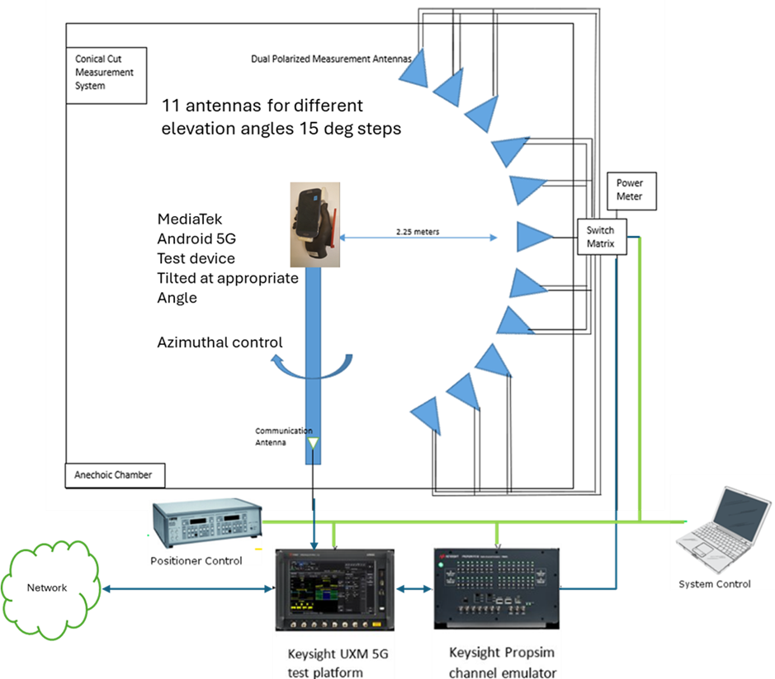

Figure 29: OTA test environment is built in Verkotan’s anechoic chamber

6.4.3 Validation methodology
The following tests are planned to be executed. All tests are done in FR1 NTN frequency bands (Rel17). The tests are divided into two categories: 1) NTN termina (UE) OTA tests, 2) Satellite connectivity, single satellite tests
NTN Terminal (UE) OTA tests summary

 | Test Objective | Test Methodology | Milestone
1.1 | 5G Reference TRP  free space | EIRP pattern is measured in anechoic chamber with a 15-degree grid to determine radiated power in specific directions. TRP is calculated as average of EIRP values. Measurement in N7 band (low, mid, high channel)  KPI: TRP, Pass limit: ≥15,1dBm | MS3
1.2 | 5G Reference TRP  hand phantom | The UE is placed in a hand phantom. Measurement done the same way as in 1.1.  KPI: TRP, Pass limit: ≥9,1dBm | MS3
1.3 | 5G reference TRS  free space | EIS pattern is measured in anechoic chamber with a 30-degree grid to determine sensitivity in specific directions. Sensitivity is defined as input signal power when BLER is 5%. TRS is calculated as average of EIS values. Measurement in n7 band (low, mid, high channel)  KPI: TRS, Pass limit:≤ -92dBm | MS3
1.4 | 5G reference TRS  hand phantom | The UE is placed in a hand phantom. Measurement done the same way as in 1.3  KPI: TRS, Pass limit: ≤-86dBm | MS3
1.5 | NTN band TRP  free space | The measurements are done as in 1.1. Measurements in n255 and n256 bands. Low, mid and high channels measured.  KPI: TRP ,Pass limit: ≥15,1dBm | MS3
1.6 | NTN band TRP  hand phantom | The UE is placed in a hand phantom. Measurement done the same way as in 1.5  KPI: TRP Pass limit:≥9,1 dBm | MS3
1.7 | NTN band TRS  free space | The measurements are done as in 1.3. Measurements in n255 and n256 bands. Low, mid and high channels measured.  KPI: TRS Pass limit: ≤-93dBm | MS3
1.8 | NTN band TRS  hand phantom | The UE is placed in a hand phantom. Measurement done the same way as in 1.7  KPI: TRS Pass limit: -87dBm | MS3
1.9 | Intra Channel sensitivity  hand phantom | Intra channel sensitivity tests sensitivity within the operating band. Small resource block allocation is moved within channel/band to see sensitivity variations. To simulate realistic usage hand phantom hand is used with video playback and Bluetooth audio. The sensitivity test is done similarly to EIS testing.  KPI: sensitivity degradation Pass/Fail limits: 3dB | MS3

Satellite connectivity tests summary, single satellite

 | Test Objective | Test Methodology | Milestone
2.1 | Setup time of the NTN connection  free space | NTN Channel emulator and 5G Network emulator are used to create a signal which as closely as possible resembles the signal from satellite at the UE antenna (signal level, doppler, delay, fading characteristics etc.). The UE and the antenna, which emulates the satellite antenna, is placed in the anechoic chamber and a wireless connection on NTN band is set up. The setup time of the connection is measured in different conditions. Measurements are done in different conditions: elevation angles, atazimuth angles etc.  KPI: NTN connection setup time Pass limit: ≤10s | MS3
2.2 | Throughput of the NTN connection  free space | NTN Channel emulator and 5G Network emulator are used to create a signal which as closely as possible resembles the signal from satellite at the UE antenna (signal level, doppler, delay, fading characteristics etc.). The UE and the antenna, which emulates the satellite antenna, is placed in the anechoic chamber and a wireless connection on NTN band is set up. In these tests the MBS connection in NTN band is measured. In the initial conditions the UE has the MBS connection. The throughput variation is measured over the period. In this way the impacts of fading channel can be observed.  KPI: data throughput Pass limit:≥5Mbit/s | MS3
2.3 | Impact of 5G interfering signal to connection set up time  free space | 5G downlink interfering signal is fed to anechoic chamber. Connection set up time is measured like in 2.1. Measurements done in different conditions: satellite elevation angle, azimuth angle, interferer directions and level etc.  KPI: NTN connection setup time Pass limit: ≤10s | MS3
2.4 | Impact of 5G interfering signal to throughput  free space | 5G downlink interfering signal is fed to anechoic chamber. Throughput is measured like in 2.3. Measurements done in different conditions: satellite elevation angle, azimuth angle, interferer directions and level etc.  KPI: data throughput Pass limit:≥ 5Mbit/s | MS3

6.4.4 Key results

TBD

6.5 Core Network Testbed – WP 6.3.11: Support of mandatory R-17 feature for MBS within the Core Network

6.5.1 High-level description of the test plan

The validation testbed of MBS features of the R17/18 SnT 5G network will be built based on the development and implementation of the feature in an agile environment. Each individual function will be developed with a set of features to add for each iteration until reaching internal milestones and then major 5G-EMERGE milestones. SnT uses modern DevOps techniques with an automated CI/CD pipeline to develop, integrate, and deploy individual 5G NF. Internal automation tools also constantly monitor the status of the Core and automate the development and integration of each function inside the global Core Network.

6.5.2 Test bed and setup
The validation testbed for the 5G MBS functionalities in the Core Network will be built incrementally based on the architecture in Figure 30.
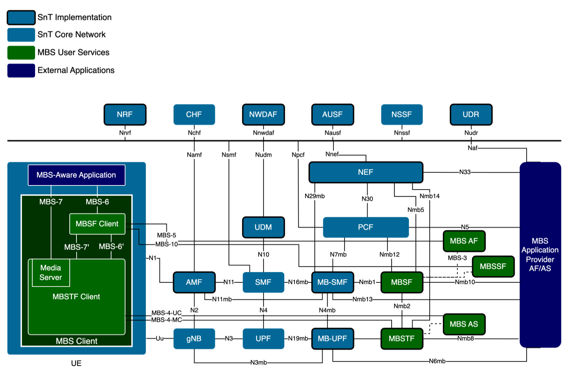
Figure 30: MBS Enabled R17/R18 5G Network

6.5.3 Validation methodology

NF | Interfaces | Endpoint | Method | Target Milestone | REST
AMF | Namf_MBSBroadcast (/namf-mbs-bc/v1) | /mbs-contexts | POST | MS1 | Pass
 |  | /mbs-contexts/{mbsContextRef} | DELETE | MS1 | Pass
 |  | /mbs-contexts/{mbsContextRef}/update | POST | MS1 | Pass
 | Namf_MBSCommunication (/namf-mbs-comm/v1) | /n2-messages/transfer | POST | MS1 | Pass
UDM | Nudm_SDM (/nudm-sdm/v2) | {supi}/5mbs-data | GET | MS1 | Pass
PCF | Npcf_MBSPolicyAuthorization (/npcf-mbspolicyauth/v1) | /contexts | POST | MS1 | Pass
 |  | /contexts/{contextId} | GET | MS1 | Pass
 |  | /contexts/{contextId} | PATCH | MS1 | Pass
 |  | /contexts/{contextId} | DELETE | MS1 | Pass
MB-SMF | Nmbsmf-MBSSession (/nmbsmf-mbssession/v1) | /mbs-sessions | POST | MS1 | Pass
 |  | /mbs-sessions/contexts/update | POST | MS1 | Pass
 |  | /mbs-sessions/{mbsSessionRef} | PATCH | MS1 | Pass
 |  | /mbs-sessions/{mbsSessionRef} | DELETE | MS1 | Pass
 |  | /mbs-sessions/subscriptions | POST | MS1 | Pass
 |  | /mbs-sessions/subscriptions/{subscriptionId} | PATCH | MS1 | Pass
 |  | /mbs-sessions/subscriptions/{subscriptionId} | DELETE | MS1 | Pass
 |  | /mbs-sessions/contexts/subscriptions | POST | MS1 | Pass
 |  | /mbs-sessions/contexts/subscriptions/{subscriptionId} | PATCH | MS1 | Pass
 |  | /mbs-sessions/contexts/subscriptions/{subscriptionId} | DELETE | MS1 | Pass
 | Nmbsmf_TMGI (/nmbsmf-tmgi/v1) | /tmgi | POST | MS1 | Pass
 |  | /tmgi | DELETE | MS1 | Pass
MBSF | Nmbsf-mbs-us (/nmbsf-mbs-us/v1)  Nmbsf-mbs-ud-ingest (/nmbsf-mbs-ud-ingest/v1) | /mbs-user-services | GET | MS1 | Pass
 |  | /mbs-user-services | POST | MS1 | Pass
 |  | /mbs-user-services/{mbsUserServId} | GET | MS1 | Pass
 |  | /mbs-user-services/{mbsUserServId} | PUT | MS1 | Pass
 |  | /mbs-user-services/{mbsUserServId} | PATCH | MS1 | Pass
 |  | /mbs-user-services/{mbsUserServId} | DELETE | MS1 | Pass
 |  | /sessions | GET | MS1 | Pass
 |  | /sessions | POST | MS1 | Pass
 |  | /sessions/{sessionId} | GET | MS1 | Pass
 |  | /sessions/{sessionId} | PUT | MS1 | Pass
 |  | /sessions/{sessionId} | PATCH | MS1 | Pass
 |  | /sessions/{sessionId} | DELETE | MS1 | Pass
 |  | /status-subscriptions | GET | MS1 | Pass
 |  | /status-subscriptions | POST | MS1 | Pass
 |  | /status-subscriptions/{subscriptionId} | GET | MS1 | Pass
 |  | /status-subscriptions/{subscriptionId} | PUT | MS1 | Pass
 |  | /status-subscriptions/{subscriptionId} | PATCH | MS1 | Pass
 |  | /status-subscriptions/{subscriptionId} | DELETE | MS1 | Pass
MBSTF | Nmbstf-distsession (/nmbstf-distsession/v1) | /dist-sessions | POST | MS1 | Pass
 |  | /dist-sessions/{distSessionRef} | PATCH | MS1 | Pass
 |  | /dist-sessions/{distSessionRef} | DELETE | MS1 | Pass
 |  | /dist-sessions/{distSessionRef} | GET | MS1 | Pass
 |  | /dist-sessions/{distSessionRef}/subscriptions | POST | MS1 | Pass
 |  | /dist-sessions/{distSessionRef}/subscriptions/{subscriptionId} | DELETE | MS1 | Pass
 |  | /dist-sessions/{distSessionRef}/subscriptions/{subscriptionId} | PATCH | MS1 | Pass
UPF | PFCP Protocol | UDP 8805 (N4mb) |  | MS2 | Pass
 | GTP-U | UDP 2152 (N3/N6/N9) |  | MS2 | Pass

Procedure | Functions Involved | Support Target | Target Milestone | Test
MBS Session Management
MBS Session Creation without PCC | MB-UPF, MB-SMF, NRF, NEF/MBSF, MBSTF, AF | Yes | MS1 | Pass
MBS Session Deletion without PCC | MB-UPF, MB-SMF, NRF, NEF/MBSF, MBSTF, AF | Yes | MS1 | Pass
MBS Session Update without PCC | MB-UPF, MB-SMF, NRF, NEF/MBSF, AF | Yes | MS1 | Pass
MBS Session Update with PCC | MB-UPF, MB-SMF, NRF, NEF/MBSF, AF, PCF | Yes | MS1 | Pass
MB-SMF discovery and selection for multicast/broadcast session | NRF, MB-SMF | Yes | MS1 | Pass
MB-UPF discovery and selection for multicast/broadcast session | MB-SMF, MB-UPF, NRF | Yes | MS1 | Pass
MBS procedures for multicast Session
MBS join and Session establishment procedure
Establishment of a PDU Session that can be associated with multicast session(s) | UE, NG-RAN, AMF, MB-SMF, NRF, UDM, UDR, PCF, MB-UPF, UPF | Yes | MS2 | Test planned
Multicast session join and session establishment procedure | UE, NG-RAN, AMF, MB-SMF, NRF, UDM, UDR, PCF, MB-UPF, UPF, AF | Yes | MS2 | Test planned
Establishment of shared delivery toward RAN node | NG-RAN, AMF, MB-SMF, MB-UPF | Yes | MS2 | Test planned
Multicast MBS Session leave and Multicast MBS Session release procedure
Multicast Session leave requested by the UE | UE, NG-RAN, AMF, SMF, UPF, MB-SMF, MB-UPF | Yes | MS2 | Test planned
Multicast session leave requested by the network or MBS session release | UE, NG-RAN, AMF, SMF, UPF, MB-SMF, MB-UPF | Yes | MS2 | Test planned
Release of shared delivery toward RAN node | NG-RAN, AMF, MB-SMF, MB-UPF | Yes | MS2 | Test planned
Mobility Procedures for MBS
Xn based handover from MBS supporting NG-RAN node | UE, SNG-RAN, TNG-RAN, AMF, SMF, UPF, MB-SMF, MB-UPF | Yes | MS2 | Test planned
N2 based handover from MBS supporting NG-RAN node | UE, SNG-RAN, TNG-RAN, S-AMF, T-AMF, SMF, UPF, MB-SMF, MB-UPF | Yes (indirect not supported) | MS2 | Test planned
Xn/N2 based handover from non-MBS supporting NG-RAN node | UE, SNG-RAN, TNG-RAN, S-AMF, T-AMF, SMF, UPF, MB-SMF, MB-UPF | Yes | MS2 | Test planned
Xn/N2 based handover for inactive MBS session | NG-RAN, MB-SMF, MB-UPF | Supported | MS2 | Test planned
MBS session activation and deactivation
MBS session activation procedure | UE, NG-RAN, AMF, SMF, UPF, MB-UPF, MB-SMF | Yes | MS2 | Test planned
MBS session deactivation procedure | UE, NG-RAN, AMF, SMF, UPF, MB-UPF, MB-SMF | Yes | MS2 | Test planned
Multicast session update procedure | UE, NG-RAN, AMF, SMF, UPF, AF | Yes | MS2 | Test planned
MBS procedures for broadcast Session
MBS Session Start for Broadcast | UE, NG-RAN, AMF, MB-SMF, MB-UPF, NEF/MBSF, AF | Yes | MS2 | Pass for 1 UE and simulated gNB
MBS Session Release for Broadcast | UE, NG-RAN, AMF, MB-SMF, MB-UPF, PCF, NEF/MBSF, AF | Yes | MS2 | Test planned
MBS Session Update for Broadcast | UE, NG-RAN, AMF, MB-SMf, MB-UPF, NEF/MBSF, AF | Yes | MS2 | Test planned
MBS Session Delivery Status Indication for Broadcast | MB-SMf, NEF, MBSF, AF, AS | Yes | MS2 | Test planned
Broadcast MBS Session Release Require | UE, NG-RAN, AMF, MB-SMF, MB-UPF, NEF/MBSF, AF | Yes | MS2 | Test planned

6.5.4 Key results

Initial test results show that MBS session creation is successful, including the TMGI allocation (supporting PDU / MBS). This test was performed after 5GMSd (5G-MAG) AF and AS were integrated. Other MBS procedures are planned to be tested, and this will be performed soon.

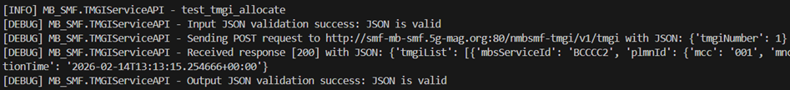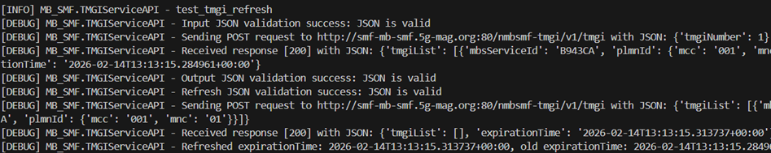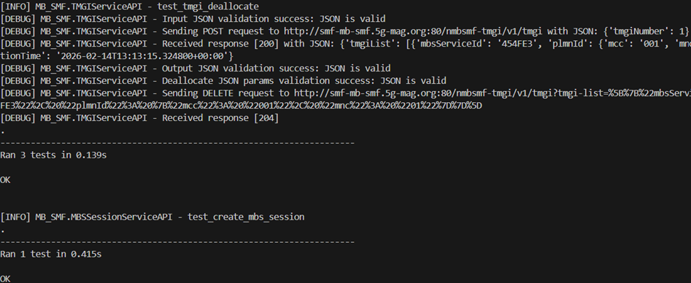

6.6 DTD End-to-End Testbed – WP 6.4.4

6.6.1 High-level description of the test plan
One of the key innovations in consumer media delivery is the ability to stream video content directly from satellites to handheld devices, enabling both on-demand and live video services in areas beyond the reach of terrestrial networks. To realize this vision within the 5G-EMERGE project, a formal test plan was developed. This plan is designed to formally structure the execution of a landmark technical achievement: the world's first complete, end-to-end delivery of 5G Multicast Broadcast Services (MBS) over a live NR-NTN satellite link.
To this end, the test plan's main objective is to verify the functionality, effectiveness, and viability of the DTD solution. The document details a comprehensive framework for this demonstration, which is based on a 3GPP-compliant architecture adhering to the Release 17 framework with essential features from Release 18. It outlines the testbed setup, validation methodology, and specific test scenarios designed to assess the system's capabilities. A core part of the plan is the evaluation of Key Performance Indicators (KPIs) such as throughput and Block Error Rate (BLER), as well as Key Value Indicators (KVIs) like video quality and rebuffering events.
While this plan provides a comprehensive foundation for the demonstration, it is designed to be a living document that may be refined as the integration and testing phases progress. Ultimately, it is designed to demonstrate the feasibility and potential of the DTD solution, providing valuable insights for further development within the 5G-EMERGE project.

6.6.2 Test bed and setup
The testbed defined in the plan integrates the various technologies required to broadcast video content directly to handheld devices via satellite. The architecture is aligned with the 3GPP TS 26.501 media streaming framework to ensure standards-based compatibility and includes a real satellite link, content provisioning, and an end-user video player application. High-level block diagram of the DTD end-to-end tested is depicted in high-level in Figure 31.
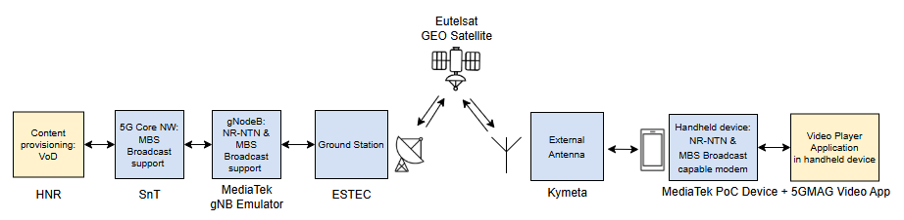
Figure 31: High-Level Block Diagram of the DTD end-to-end Testbed

The key components of the planned testbed are as follows:
- Content Source (HNR): The originator of the live and/or on-demand video content.
- 5G Core (5GC) (SnT): A comprehensive service platform provided by SnT, responsible for ingesting the content, managing the MBS session lifecycle, and routing the broadcast traffic.
- gNodeB (gNB) (MediaTek): A gNB emulator compliant with NR-NTN and MBS specifications, responsible for transmitting the signal and managing the radio complexities of satellite communication.
- Ground Station (ESTEC): The satellite gateway connecting the terrestrial gNB to the satellite.
- Satellite Link (Eutelsat): The Eutelsat 10B Geostationary Earth Orbit (GEO) satellite, which acts as a transparent relay in the Ku-band.
- External Antenna (Kymeta): A Kymeta U8 Hawk terminal used to receive the satellite signal.
- User Equipment (UE) (MediaTek): A MediaTek Android test phone with a 5G modem supporting both NR-NTN and MBS, equipped with the 5GMAG application for video playback.
To provide a clear technical foundation, the test plan specifies a set of critical configuration parameters. The setup is designed around a 20 MHz channel bandwidth with 15 kHz Subcarrier Spacing (SCS) and supports modulations up to 64-Quadrature Amplitude Modulation (QAM). The system is configured to operate in MBS Broadcast Mode. The entire test methodology is shaped by the fact that MBS broadcast operates without Hybrid Automatic Repeat Request (HARQ) retransmissions. This makes the radio link's robustness paramount and necessitates the development of a detailed Modulation and Coding Scheme (MCS) selection strategy within the plan. Furthermore, the plan formally accounts for environmental constraints, particularly the potential impact of rain fade on the Ku-band link, to set realistic performance targets and define contingency scenarios.

6.6.3 Validation methodology

The validation methodology outlined in the test plan is centered on a phased approach to demonstrate a functional and reliable system. It is designed to evaluate the quality and reliability of the video streaming service under real-world Over-the-Air (OTA) conditions.
A critical aspect of the planned methodology is the acknowledgement that 5G MBS broadcast, unlike unicast, does not utilize Layer 1 HARQ or Layer 2 Radio Link Control (RLC) Automatic Repeat Request (ARQ) retransmissions. This requires the system to maintain a very low BLER to ensure a high-quality user experience, a factor that is central to the performance evaluation criteria.
The validation process described in the plan is structured around several key activities:
- Phased Integration: The plan calls for a step-by-step integration strategy where each component-to-component interface is validated individually before full system testing. This is designed to mitigate integration risks.
- End-to-End Performance Testing: A series of formal test cases are defined to evaluate the system's ability to deliver video streams at different quality levels (SD, Full HD, and an optional 4K stress test). These tests have specific pass/fail criteria tied to application throughput and radio performance (BLER, MCS).
- Service Resilience Testing: The plan includes a test scenario to validate the system's ability to recover from a temporary loss of signal by observing the automatic resumption of the video stream.
- KPI Collection: The methodology specifies the collection of a comprehensive set of KPIs to objectively measure performance against the plan's success criteria.

The validation process is structured around several key activities, including phased integration, KPI collection, and the execution of formal test cases. The key test scenarios defined in the plan are summarized in the table below.

Case ID | Test Case Title | Objective
TC-01a | E2E Successful SD Video Broadcast | To validate baseline end-to-end functionality with a low-bitrate SD (480p) stream, confirming fundamental connectivity under the most robust radio conditions.
TC-01b | E2E Successful Full HD Video Broadcast | To demonstrate high-quality service delivery with a Full HD (1080p) stream, meeting the ideal performance targets for BLER and throughput.
TC-01c (Optional) | E2E 4K Video Broadcast | To stress the system's maximum throughput capabilities with a high-bitrate 4K (2160p) video stream.
TC-02 | Service Resilience - Interrupted Transmission | To verify the system's resilience and its ability to automatically recover from a temporary loss of the satellite signal.
TC-03 (Optional) | Parallel Non-MBS Service Evaluation | To evaluate the UE's capability to handle a parallel non-MBS service (e.g., a voice call) during an active MBS broadcast.

The key KPIs defined in the test plan for collection and analysis are summarized in the table below:

KPI Category | KPI | Description / Measurement Point
Application Layer | Application Layer Throughput | Measures the effective data rate ("goodput") received by the video streaming application. Validated against target bitrates for SD, HD, FHD, and 4K.
 | Consumption Reporting | UE reports media consumption metrics to the network as specified in TS 26.501.
 | Video Quality | Subjective evaluation of video playback (e.g., no visible artifacts, freezes).
 | Rebuffering Events | Number and duration of stalls/rebuffering events during a test session.
Modem/Network Layer | Block Error Rate (BLER) | Measures the percentage of transport blocks received with errors. A low BLER is essential due to the lack of L1/L2 retransmissions. <br> • Ideal Target: < 1% <br> • Acceptable Threshold: < 5%
 | Physical Layer Throughput | Measures the raw data rate over the NR-NTN link, monitored from the device modem level.
 | Throughput Stability | Evaluates variations in the data rate, monitored from the device modem level.
 | NTN Connection Setup Time | Time taken to establish the initial NR-NTN Radio Resource Control (RRC) connection.
 | Service Continuity | Confirmation that the MBS session is not dropped during minor link fluctuations.

6.6.4 Key results

TBD

7 Strand 2: Cross-edge functionality tests and validation

7.1 WP2.2: Edge Security

The integration of security components into the 5G-EMERGE testbeds is now progressing through ongoing bilateral discussions between security providers and testbed operators. These exchanges aim to align the security solutions with the specific constraints and architectures of each testbed, and to progressively define the corresponding integration and validation approaches.
As part of this process, the Security Working Group has moved from initial coordination to concrete integration planning activities, with a particular focus on refining the security testing strategies to be applied in each testbed.
In this context, this document provides a catalogue of potential security tests, covering the main functionalities of the security components introduced in WP2.2. This catalogue serves as a common baseline that will be tailored to the specific needs and priorities of each testbed through ongoing discussions.
The objective is to finalize the test plans by the end of April, enabling the execution of security tests within the testbeds starting from May.

7.1.1. Far Edge Security (SF4)

ID | Test Name | Objective | Test Description | Target Component | Associated KPIs
SEC-SF4-01 | Secure Boot Integrity Validation | Verify that only trusted system images can boot | Attempt to boot with modified bootloader, kernel, or root filesystem | ARCA Trusted OS | Secure boot integrity verification rate; Unauthorized system modification detection rate
SEC-SF4-02 | Disk Extraction and Offline Access | Validate confidentiality of data at rest | Remove storage and attempt to read data on external system | ARCA Trusted OS | Data protection at rest effectiveness
SEC-SF4-03 | Unauthorized OS Boot Attempt | Ensure disk cannot be accessed from untrusted OS | Boot device with alternative OS and attempt access to encrypted partitions | ARCA Trusted OS | Data protection at rest effectiveness; Secure boot integrity verification rate
SEC-SF4-04 | TPM Key Release Validation | Ensure keys are released only in trusted state | Compare TPM key release under valid and tampered boot conditions | ARCA Trusted OS | Secure boot integrity verification rate; System recovery and Key Management robustness
SEC-SF4-05 | Key Recovery and Rotation | Validate key lifecycle management | Perform key rotation and recovery procedures | ARCA Trusted OS | System recovery and Key Management robustness

7.1.2. Satcom Link Security Tests (SF3)

ID | Test Name | Objective | Test Description | Target Component | Associated KPIs
SEC-SF3-01 | Encrypted Traffic Verification | Validate confidentiality of transmitted data | Capture traffic on SATCOM link and inspect payload | ARCA SATCOM VPN | Encryption coverage; Resistance to traffic interception
SEC-SF3-02 | Secure Tunnel Establishment | Validate authentication and tunnel setup | Attempt connection with valid and unauthorized endpoints | ARCA SATCOM VPN | Secure tunnel establishment success rate
SEC-SF3-03 | Throughput under Encryption | Measure performance impact of security | Compare throughput with and without ARCA SATCOM enabled | ARCA SATCOM VPN | Throughput efficiency under Encryption
SEC-SF3-04 | Packet Loss Resilience | Evaluate robustness to lossy links | Introduce controlled packet loss and measure performance | ARCA SATCOM VPN | Packet Loss resilience under secure transport
SEC-SF3-05 | Link Aggregation and Failover | Validate resilience and continuity | Simulate link failure and observe failover behaviour | ARCA SATCOM VPN | Throughput efficiency; Availability / Service continuity

7.2 WP2.4: Optimising storage, cache efficiency and content steering at the edge
Following Brightcove’s departure, there is currently no VOD system available in WP2.4, which complicates the definition of testing due to the absence of this critical component and lack of clarity when it will be available and in what scope.
However, except for Task 2.4.3 (Brightcove), all other developments within WP2.4 focus on enhancements and optimizations of existing components—such as the FTA mABR Gateway, Gcore’s CDN, and the Varnish Far Edge Cache—which have already been integrated into all testbeds since Phase 1.
Therefore, functional testing of the new features will be carried out within the respective WP2.4 sub-work packages. Upon completion, software updates can be provided to each testbed individually - or simultaneously to all - ensuring that the new functionalities are incorporated into the end-to-end testbed evaluations and end-to-end tests as per test plan definition of each test-bed.

7.3 WP2.5: 5G Components at the Edge
The main objective of this section is to report the planning, execution and results of the tests performed in WP2.5 (5G Components at the Edge) on a local testbed distributed among NXW, RomARS, MBI and HPE premises for the integration and functional validation of the prototypes developed in WP2.5.x. Tests in WP2.5 are designed to validate the global functionalities of 5G components for far-edge and near-edge deployments in a generalized infrastructure for a 5G Non Public Network with orchestration functionalities, edge computing resources, multi-technology access (5G and WiFi), multicast communications and hybrid backhaul with terrestrial and satellite links. Tests will be executed with a sample set of cloud-native open-source multimedia applications deployed in a K8S virtual environment and extended to interact with the 5G network via CAMARA API. The test activities will cover the functionalities developed in the single WP2.5.x, as well as end-to-end integrated functionalities enabled by the interaction of the whole set of WP2.5 components.

7.3.1 High-level description of the test plan
The main objective of WP2.5 Testbed is the validation of how a 5G Non Public Network (NPN) with integrated hybrid backhaul comprising terrestrial and satellite networks can support the orchestrated delivery of multimedia services with application functions deployed at the near-edge and far-edge. The testbed integrates the components developed in WP2.5 activities, as well as open-source software to compose the end-to-end service chain. The testbed includes a combination of proprietary and open-source software developed by WP2.5 partners. Moreover, it integrates 3rd party legacy software components when needed to represent or emulate elements not directly addressed in 5G-EMERGE WP2.5 but required to demonstrate the overall service chain.
The joint orchestration and automation of multimedia application services, terrestrial and non-terrestrial networks and edge computing resources in far-edge and near-edge domains for 5G Non Public Networks is a novel feature introduced during the Phase of the 5G-EMERGE project.
The WP2.5 tests will focus on the following features:
- On-demand provisioning and termination of a sample multimedia service, featuring cloud-native components deployed in far-edge and near-edge domains, with integrated activation and configuration of an end-to-end network slice across terrestrial and non-terrestrial domains.
- Joint monitoring of terrestrial and non-terrestrial networks, computing resources and service applications in the 5G Non Public Network.
- Automated, dynamic selection and re-configuration of satellite gateway due to the change of location of a nomadic user.
- Application-driven Quality on Demand enforcement to increase the uplink data rate, involving the re-configuration of the satellite link from narrowband to broadband communication on return link.
- Integration of 3GPP and non-3GPP wireless access networks.
- Validation of multi-site 5G system deployments, with distributed user-plan functionalities.

7.3.2 Test bed and setup
- The overall WP2.5 testbed is represented in Figure 32. The testbed is distributed over four labs in Italy, in Nextworks premises (Pisa), RomARS premises (Rome), MBI premises (Pisa), and HPE premises (Bolzano Vicentino), respectively. All the labs are interconnected via VPN, with the VPN server installed in RomARS lab. Each testbed hosts one or more domains of the system architecture, as follows:
- RomARS testbed hosts the Far Edge domain, with the related 5G Core Network components for non-3GPP access, multicast communication and far edge compute resources;
- HPE testbed hosts the Near Edge domain, with 5G Core and Radio Access Network components for 3GPP access and near edge compute resources;
- MBI testbed hosts the Satellite domain, including the Starfish platform;
- NXW testbed hosts the Management and Orchestration functions and provides an emulation of far-edge and near-edge domains with the deployment of an open-source 5G network with emulated RAN for 3GPP access.
At the far-edge domain the 5G network includes the user plane of the 5G Core Network, with the User Plane Function (UPF) that interconnects to a local data network where the multimedia application functions are connected. The UPF is extended with IGMP for support of multicast communications. The N3IWF enables the support of non-3GPP access networks. The near-edge domain hosts the control plane functions of the 5G Core Network, supporting REST-based management APIs for orchestration purposes, and another UPF.
The management and orchestration plane includes functions for service, 5G network and resource orchestration, assuming a cloud-native service and 5G network deployment with network and application functions executed as containers or VMs in virtualized environments. The orchestration plane is complemented with a multi-source Monitoring Platform with specialized data collectors to retrieve metrics from the satellite domain, the 5G network, the edge computing platforms and custom multimedia applications. Monitoring data is used for administration purposes, e.g., for visualization in configurable dashboards, as well as to feed service and network automation logic. An Exposure Gateway exposing CAMARA APIs is used to enable a bi-directional interaction between multimedia applications and network at runtime, e.g., to request a change in the guaranteed QoS for certain traffic flows, to search for new edge servers, query location information or other network insights, etc.

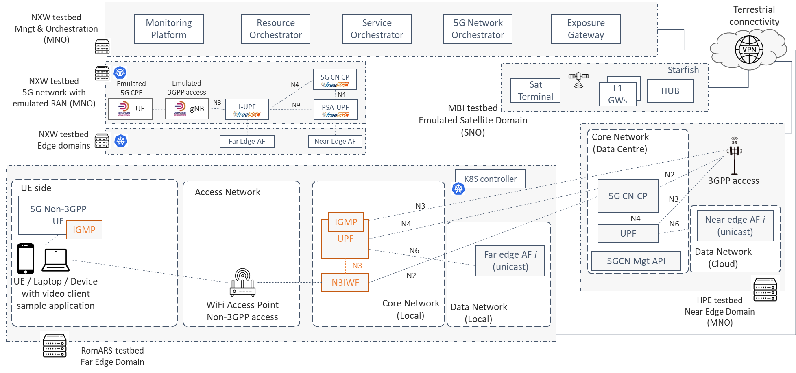
Figure 32: Conceptual diagram of WP2.5 Testbed

The main components of the WP2.5 testbed are described in Table 15

Table 15: Main components of WP2.5 Testbed
System Function | Component | Type (HW/SW) | Responsible partner
SF1 | M&O – Service Orchestrator | SW | NXW
SF2 | M&O – 5G Network Orchestrator | SW | NXW
SF3 | M&O – Resource Orchestrator | SW | NXW
SF4 | M&O – Monitoring Platform | SW | NXW
SF5 | M&O – Exposure Gateway | SW | NXW
SF6 | Emulated RAN – UE | SW | NXW
SF7 | Emulated RAN – gNB | SW | NXW
SF8 | Open Source 5G CN – I-UPF | SW | NXW
SF9 | Open Source 5G CN – PSA-UPF | SW | NXW
SF10 | Open Source 5G CN – Control Plane | SW | NXW
SF11 | Commercial 5G CN – CP and UP | SW + HW | HPE
SF12 | RAN – gNB | SW + HW | HPE
SF13 | N3IWF – CP and UP | SW | RMA
SF14 | Non-3GPP UE | SW | RMA
SF15 | WiFi Access Point | HW | RMA

7.3.3 Validation methodology

Functional testing methodology
The WP2.5 testbed will be used for the troubleshooting and functional testing of the components developed in WP2.5.x as well as their preliminary integration. This will allow to validate their functionalities and produce a set of mature prototypes, ready to be installed in some of the strand 3-4-5-6 testbeds for their customization and integration in specific use cases. WP2.5 tests will have the main objective of verifying the correct internal functionalities of each component, the compliance of their interfaces with the target specification and the workflows among the system modules of the 5G NPN at the far-edge and near-edge domains. For this purpose, the plan is to use open-source software solutions for sample multimedia applications and emulated 5G network deployments that would replicate components available in strand [3-6] testbed. Moreover, where needed, mock-ups of specific modules will be used to speed-up the testing process and emulate variable context conditions.
The validation of the interactions with components developed in other WP2.x are out of scope and will be performed in the context of strand [3-6] activities. Similarly, the assessment of the performance in 5G-EMERGE use cases, under different configurations, deployment models, network traffic loads, and integrated with multimedia applications developed specifically in 5G-EMERGE, will be performed in strand [3-6].

Test cases

The following test cases have been defined with a per-WP2.5.x scope.

NXW – WP2.5.1
The following test cases, in WP2.5.1 scope, are targeting the validation of the management and orchestration functionalities for the following operations:
- On-demand provisioning and termination of a sample multimedia service, featuring cloud-native application components deployed in far-edge and near-edge domains, with integrated activation and configuration of an end-to-end network slice across terrestrial and non-terrestrial domains (Test Case 1; Test Case 2).
- Joint monitoring of terrestrial and non-terrestrial networks, computing resources and service applications in the 5G Non Public Network (Test Case 3).
- Automated, dynamic selection and re-configuration of satellite gateway due to the change of location of a nomadic user (Test Case 4).
- Application-driven Quality on Demand enforcement to increase the uplink data rate, involving the re-configuration of the satellite link from narrowband to broadband communication on return link (Test Case 5).
Figure 33 system considered for the functional tests. It should be noted that the M&O system interacts with other components, e.g., Starfish platform for satellite network monitoring and configuration, 5G Core Network by HPE for collection of 5G metrics and management of 5G Core Network functions, Kubernetes controller for deployment and configuration of containers, as well as collection of computing metrics. In the initial phases of the tests suitable mock-ups will be used to emulate the server side of these external components, while the integration with the real elements will be performed in the following stages for the validation of the end-to-end service chain.

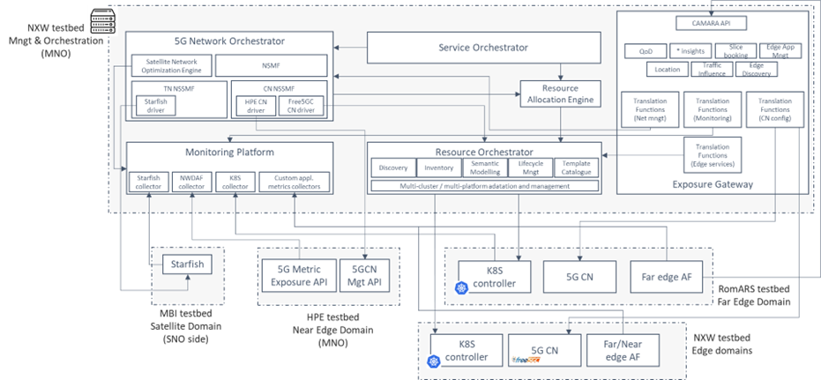

Figure 33: 5G NPN Management and Orchestration system for functional tests

Test Case 1-a
Title: | Service provisioning in 5G network with non-3GPP access
Responsible Partner: | NXW
Preconditions: | Pre1: | The following M&O components are up and running:  - Service Orchestrator with Resource Allocation Engine  - 5G Network Orchestrator (with HPE CN driver at CN NSSMF and Starfish driver at TN NSSMF)  - Resource Orchestrator  - Monitoring Platform
 | Pre2: | HPE 5G CN Management API up and running, reachable by the 5G Network Orchestrator.  HPE 5G CN configuration parameters correctly set in HPE CN driver at CN NSSMF in 5G Network Orchestrator.
 | Pre3: | K8S platform up and running, reachable by the Resource Orchestrator.  K8S platform configuration parameters correctly set in Resource Orchestrator.
 | Pre4: | Starfish platform up and running.  Starfish configuration parameters correctly set in Starfish driver at TN NSSMF in 5G Network Orchestrator.
 | Pre5: | Sample multimedia application available in the service orchestrator catalogue. Related network slice template available in 5G Network Orchestrator catalogue.
Description: | On-demand provisioning of a sample multimedia application in far-edge and near-edge domains, with integrated activation and configuration of an end-to-end network slice across terrestrial (5G CN from HPE and non-3GPP access) and non-terrestrial domains.
Test Steps: | S1: | From the Service Orchestrator GUI request the provisioning of the sample multimedia application.
 | S2: | Verify from the logs of the M&O components the following:  - Correct processing of service provisioning request at Service Orchestrator  - Reception and correct processing of Network Slice provisioning request at 5G Network Orchestrator  - Correct interaction with HPE 5G CN Management API  - Correct interaction with Starfish  - Reception and correct processing of resource allocation request at Resource Allocation Engine  - Reception and correct processing of service deployment request at Resource Orchestrator  - Reception and correct processing of monitoring jobs requests at Monitoring Platform, with correct instantiation and configuration of data collectors for Starfish, 5G CN and K8S.
 | S3: | Verify from K8S CLI or dashboard the presence and the status of the containers for the application components.
 | S4: | Verify from Starfish API or dashboard the presence of the slice in the satellite domain.
 | S5: | Verify from 5G CN dashboard the correct configuration of the 5G network slice.
 | S6: | Verify from Service Orchestrator dashboard the status of the service instance.
 | S7: | Verify the traffic from the application on the UE side to the application components on the far-edge side.
Associated KPI: | Service provisioning time  Slice provisioning/configuration time
Expected Result: | - End-to-end service successfully provisioned, configured and activated, including application  - Mobile connectivity successfully available across 5G and satellite domain, with network slice successfully established  - Service provisioning time < 2 minutes  - Slice provisioning time < 1 minute
Actual Result:

Test Case 1-b
Title: | Service provisioning in 5G network with emulated 3GPP access
Responsible Partner: | NXW
Preconditions: | Pre1: | The following M&O components are up and running:  - Service Orchestrator with Resource Allocation Engine  - 5G Network Orchestrator (with Free5GC driver at CN NSSMF and Starfish driver at TN NSSMF)  - Resource Orchestrator  - Monitoring Platform
 | Pre2: | K8S platform up and running, reachable by the Resource Orchestrator.  K8S platform configuration parameters correctly set in Resource Orchestrator.
 | Pre3: | Starfish platform up and running.  Starfish configuration parameters correctly set in Starfish driver at TN NSSMF in 5G Network Orchestrator.
 | Pre4: | Sample multimedia application available in the service orchestrator catalogue. Related network slice template available in 5G Network Orchestrator catalogue.
 | Pre 5: | UERANSIM software for emulated RAN up and running on both UE and gNB side.
Description: | On-demand provisioning of a sample multimedia application in far-edge and near-edge domains, with integrated activation and configuration of an end-to-end network slice across terrestrial (open-source 5G CN and emulated 3GPP access) and non-terrestrial domains.
Test Steps: | S1: | From the Service Orchestrator GUI, request the provisioning of the sample multimedia application.
 | S2: | Verify from the logs of the M&O components the following:  - Correct processing of service provisioning request at Service Orchestrator  - Reception and correct processing of Network Slice provisioning request at 5G Network Orchestrator  - Correct interaction with Resource Orchestrator to request the provisioning of the 5G CN functions  - Correct interaction with Starfish  - Reception and correct processing of resource allocation request at Resource Allocation Engine  - Reception and correct processing of service deployment request at Resource Orchestrator  - Reception and correct processing of monitoring jobs requests at Monitoring Platform, with correct instantiation and configuration of collectors for Starfish and K8S.
 | S3: | Verify from K8S CLI or dashboard the presence and the status of the containers for 5G CN and application components.
 | S4: | Verify from Starfish API or dashboard the presence of the slice in the satellite domain.
 | S5: | Verify from 5G CN dashboard the correct configuration of the 5G network slice.
 | S6: | Verify from Service Orchestrator dashboard the status of the service instance.
 | S7: | Verify the traffic from the application on the UE side to the application components on the far-edge side.
Associated KPI: | Service provisioning time  Slice provisioning/configuration time
Expected Result: | - End-to-end service successfully provisioned, configured and activated, including application instances at the edge  - Mobile connectivity successfully available across 5G and satellite domain, with network slice successfully established  - Monitoring jobs successfully activated  - Service provisioning time < 2 minutes  - Slice provisioning time < 1 minute
Actual Result:

Test Case 2-a
Title: | Service termination in 5G network with non-3GPP access
Responsible Partner: | NXW
Preconditions: | Pre1: | Successful service provisioning as in Test Case 1-a
Description: | On-demand termination of the multimedia application instance, with integrated termination of end-to-end network slice across terrestrial (5G CN from HPE and non-3GPP access) and non-terrestrial domains.
Test Steps: | S1: | From the Service Orchestrator GUI, request the termination of the sample multimedia application instance previously created.
 | S2: | Verify from the logs of the M&O components the following:  - Correct processing of service termination request at Service Orchestrator  - Reception and correct processing of Network Slice termination request at 5G Network Orchestrator  - Correct interaction with HPE 5G CN Management API  - Correct interaction with Starfish  - Reception and correct processing of service termination request at Resource Orchestrator  - Reception and correct processing of monitoring jobs termination requests at Monitoring Platform, with termination of collectors for Starfish, 5G network and K8S.
 | S3: | Verify from K8S CLI or dashboard the removal of the containers for 5G CN and application components.
 | S4: | Verify from Starfish API or dashboard the termination of the slice in the satellite domain.
 | S5: | Verify from 5G CN dashboard the correct termination of the 5G network slice.
 | S6: | Verify from Service Orchestrator dashboard the terminated status of the service instance.
Associated KPI: | Service termination time  Slice termination time
Expected Results: | - Service virtual components successfully released  - Network slice successfully released  - Monitoring jobs successfully terminated  - Service termination time < 1 minute  - Slice termination time < 30 seconds
Actual Result:

Test Case 2-b
Title: | Service termination in 5G network with emulated 3GPP access
Responsible Partner: | NXW
Preconditions: | Pre1: | Successful service provisioning as in Test Case 1-b
Description: | On-demand termination of the multimedia application instance, with integrated termination of end-to-end network slice across terrestrial (open-source 5G CN and emulated 3GPP access) and non-terrestrial domains.
Test Steps: | S1: | From the Service Orchestrator GUI, request the termination of the sample multimedia application instance previously created.
 | S2: | Verify from the logs of the M&O components the following:  - Correct processing of service termination request at Service Orchestrator  - Reception and correct processing of Network Slice termination request at 5G Network Orchestrator  - Correct interaction with Resource Orchestrator to request the termination of the 5G CN functions  - Correct interaction with Starfish  - Reception and correct processing of service termination request at Resource Orchestrator  - Reception and correct processing of monitoring jobs termination requests at Monitoring Platform, with termination of collectors for Starfish, 5G network and K8S.
 | S3: | Verify from K8S CLI or dashboard the removal of the containers for 5G CN UPF and application components.
 | S4: | Verify from Starfish API or dashboard the termination of the slice in the satellite domain.
 | S5: | Verify from 5G CN dashboard the correct termination of the 5G network slice.
 | S6: | Verify from Service Orchestrator dashboard the terminated status of the service instance.
Associated KPI: | Service termination time  Slice termination time
Expected Results: | - Service virtual components successfully released  - Network slice successfully released  - Monitoring jobs successfully terminated  - Service termination time < 1 minute  - Slice termination time < 30 seconds
Actual Result:

Test Case 3-a
Title: | Unified monitoring
Responsible Partner: | NXW
Preconditions: | Pre1: | Successful service provisioning as in Test Case 1-a
Description: | Collection, storage, visualization and query of monitoring data from the 5G network, the satellite network, and the computing platform.
Test Steps: | S1: | At the Monitoring Platform level, verify the correct collection and storage of the monitoring data from 5G network, satellite network and computing platform.
 | S2: | Verify the presence of the collected data from the dashboard of InfluxDB.
 | S3: | Using a Kafka client subscribe to the monitoring data for (i) 5G networks, (ii) satellite network, and (iii) computing platform, and verify the correct streaming of the data.
 | S4: | Using a REST client query some data from InfluxDB and verify the correct response.
Associated KPI: | Reliability (% loss metrics assuming a given collection frequency and load)  Notification time for new data on Kafka bus
Associated Use Case and Tests | Use Case: Direct-to-Home (WP3.2 – EBU testbed)  Test: “Detection of far-edge updated location”, ref. section 3.3.3
Expected Results: | For all types of monitoring data (computing, satellite, 5G network related):  - Monitoring data correctly stored in timeseries DB  - Monitoring data correctly visualized in the dashboard  - Monitoring data correctly streamed to subscribers  - Stored monitoring data correctly returned to REST queries
Actual Result:

Test Case 4-a
Title: | Satellite gateway re-configuration
Responsible Partner: | NXW
Preconditions: | Pre1: | Successful service provisioning as in Test Case 1-a
 | Pre2: | Successful monitoring of satellite data as in Test Case 3-a
 | Pre3: | Available satellite gateways properly configured in 5G Network Orchestrator
Description: | Dynamic selection of satellite gateway with automatic re-configuration triggered by a change in the location of a nomadic user.
Test Steps: | S1: | Emulate a change in the position of the nomadic user with consequent change in the localization data generated by Starfish.
 | S2: | Verify from the logs of the M&O components the following:  - Change in the localization data stored at the Monitoring Platform.  - Detection of the change at the 5G Network Orchestrator and correct processing for the selection of the new gateway and trigger of the gateway re-configuration on Starfish  - Correct interaction with Starfish
 | S3: | Verify from Starfish API or dashboard the correct update of the slice details in the satellite domain (changed satellite gateway).
 | S4: | Verify from 5G Network Orchestrator API or dashboard the correct update of the transport network slice subnet details (changed satellite gateway in the satellite domain).
Associated KPI: | Detection time  New satellite gateway selection time  Satellite gateway re-configuration time
Associated Use Case and Tests | Use Case: Direct-to-Home (WP3.2 – EBU testbed)  Test: “5G-orchestrated Satellite Gateway-switch”, ref. section 3.3.3
Expected Results: | - Successful process of satellite gateway re-configuration  - Nomadic user position detected in less than 60 seconds  - New satellite gateway selection time < 60 seconds  - Satellite gateway total re-configuration time < 3 minutes from change of position
Actual Result:

Test Case 5-a
Title: | Quality on Demand
Responsible Partner: | NXW
Preconditions: | Pre1: | Successful service provisioning as in Test Case 1-a
 | Pre2: | The Exposure Gateway component of the M&O is up and running, with QoD and Translation Function for network management active and properly configured.  Service profiles corresponding to narrowband and broadband satellite connectivity configured in the QoD module of the Exposure Gateway.
Description: | Processing of a Quality on Demand request from an emulated application with re-configuration of satellite link from narrowband to broadband communication on return link.
Test Steps: | S1: | Using a REST client send a QoD request to the Exposure Gateway for the activation of the broadband service profile.
 | S2: | Verify from the logs of the M&O components the following:  - Correct reception, processing and translation of the QoD request at the Exposure Gateway.  - Correct reception and processing of the satellite transport network slice subnet update request at the 5G Network Orchestrator.  - Correct interaction with Starfish.
 | S3: | Verify from Starfish API or dashboard the correct update of the slice details in the satellite domain (broadband connectivity).
 | S4: | Verify from 5G Network Orchestrator API or dashboard the correct update of the transport network slice subnet details (new uplink data rate).
 | S5: | Verify from Exposure Gateway API or dashboard that the broadband service profile is currently active.
Associated KPI: | Re-configuration time (from application request reception)
Associated Use Case and Tests | Use Case: Direct-to-Vehicle (WP4.1 – Viasat testbed)  Test: “Return link protocol switch (Viasat-MBI-NXW)”, ref. section 4.1.3
Expected Results: | - Successful translation of QoD request from Translation Function at the Exposure Gateway into commands towards network orchestrator and re-configuration of 5G and satellite network  - Successful activation of requested service profile  - Re-configuration time < 30 seconds
Actual Result:

HPE, RomARS – WP2.5.[2-3]
The following test cases, in synergy with WP2.5.2 (RomARS) and 2.5.3 (HPE) scope, are targeting the validation of the novel functionalities developed in the 5G Emerge project. These functionalities include QoS enforcement, multicast, and unicast streaming over 5G 3GPP and non-3GPP Access via the N3IWF component.

Test Case 6
Title: | 5GC – RAN integration at near and far edge
Responsible Partners: | HPE, RomARS
Preconditions: | Pre1: | 5GC’s control plane is installed and operational at near edge.
 | Pre2: | RAN equipment is installed and operational at near edge (actual gNB) and far edge (emulated gNB) sites.
 | Pre3: | Communication over N2 interface is configured.
Description: | This test case validates the integration of the deployed 5GC and RAN components for what concerns gNB registration and control-plane interaction.
Test Steps: | S1: | Follow the standard 3GPP NGAP NG Setup procedure (Ref. TS 38 413).
Associated KPI: | Fail/pass test
Expected Result: | gNBs are registered with AMF; RAN and 5GC are interconnected and ready to provide end-to-end connectivity over 3GPP access.
Actual Result: | PASS

Test Case 7
Title: | 5GC – N3IWF integration at far edge
Responsible Partners: | HPE, RomARS
Preconditions: | Pre1: | 5GC’s control plane is installed and operational at near edge.
 | Pre2: | N3IWF is installed and operational at near edge.
 | Pre3: | Communication over N2 interface is configured.
Description: | This test case validates the integration of the deployed 5GC and N3IWF components for what concerns N3IWF registration and control-plane interaction.
Test Steps: | S1: | Follow the standard 3GPP NGAP NG Setup procedure (Ref. TS 38 413).
Associated KPI: | Fail/pass test
Expected Result: | N3IWF is registered with AMF; N3IWF and 5GC are interconnected and ready to provide end-to-end connectivity over non-3GPP access.
Actual Result: | PASS

Test Case 8
Title: | 5G Registration and PDU Session Establishment over 3GPP Access
Responsible Partner: | HPE, RomARS
Preconditions: | Pre1: | 5GC and RAN are installed, operational, and integrated at near and far edge.
 | Pre2: | UE data is provisioned in the 5GC.
 | Pre3: | 5GC and RAN components are configured to grant the UE access to the targeted DN.
Description: | This test case is designed to validate the end-to-end availability of the connectivity service provided by the 5GC over 3GPP access.
Test Steps: | S1: | Start the UE.
 | S2: | Follow the 3GPP registration and PDU session establishment procedures (Ref. TS 23 502).
Associated KPI: | Fail/pass test
Expected Result: | The UE can exchange traffic with the DN.
Actual Result: | PASS

Test Case 9
Title: | 5G Registration and PDU Session Establishment over non-3GPP Access
Responsible Partner: | HPE, RomARS
Preconditions: | Pre1: | The N3IWF and the 5G Core are installed, operational, and integrated at near and far edge.
 | Pre2: | The UE can reach at IP-level the N3IWF
 | Pre3: | UE data is provisioned in the 5GC.
 | Pre4: | 5GC and N3IWF are configured to grant the UE access to the targeted DN.
Description: | This test case is designed to validate the non-3GPP access to the 5GC, demonstrating the N3IWF interoperability and the end-to-end availability of the connectivity service provided by the 5GC over non-3GPP access.
Test Steps: | S1: | Start the UE.
 | S2: | Follow the untrusted non-3GPP registration and PDU session establishment procedures (Ref. TS 23 502).
Associated KPI: | Fail/pass test.
Expected Result: | The UE can exchange traffic with the DN.
Actual Result: | PASS

Test Case 10
Title: | N3IWF QoS Enforcement over 5G non-3GPP Access
Responsible Partner: | HPE, RomARS
Preconditions: | Pre1: | The N3IWF and the 5G Core are installed, operational, and integrated at near and far edge.
 | Pre2: | The UE can reach at IP-level the N3IWF
 | Pre3: | UE QoS subscription data is provisioned in the 5GC. This includes the definition of the maximum data rate achievable by the UE.
 | Pre4: | 5GC and N3IWF are configured to grant the UE access to the targeted DN.
Description: | This test case is designed to validate the QoS enforcement functionality over non-3GPP access, demonstrating also N3IWF interoperability with the 5GC and the creation of an end-to-end connectivity service with dedicated QoS over non-3GPP access.
Test Steps: | S1: | Start the UE.
 | S2: | Follow the untrusted non-3GPP registration and PDU session establishment procedures.
Associated KPI: | Fail/pass test.
Expected Result: | The UE can exchange traffic with the DN at the maximum rate specified in the 5GCN.
Actual Result: | PASS

Test Case 11
Title: | Multicast Delivery over 5G non-3GPP Access
Responsible Partner: | HPE, RomARS
Preconditions: | Pre1: | The N3IWF and the 5G Core are installed, operational, and integrated at near and far edge.
 | Pre2: | The UE can reach at IP-level the N3IWF
 | Pre3: | UE data is provisioned in the 5GC.
 | Pre4: | 5GC and N3IWF are configured to grant the UE access to the targeted DN.
 | Pre-5 | A multicast AS is deployed in the DN.
Description: | This test case is designed to validate the support of multicast procedures and data packets over 5G non-3GPP access, demonstrating the capability of N3IWF, UPF and 5GC to support the end-to-end delivery of multicast traffic flows.
Test Steps: | S1: | Start the UE.
 | S2: | Follow the untrusted non-3GPP registration and PDU session establishment procedures.
 | S3: | UE Requests the media content joinining the corresponding multicast group.
Associated KPI: | Fail/pass test.
Result: | The UE is able to receive the requested content.
Actual Result: | PASS

Test Case 12
Title: | Unicast Media Delivery over 5G non-3GPP Access
Responsible Partner: | HPE, RomARS
Preconditions: | Pre1: | The N3IWF and the 5G Core are installed, operational, and integrated at near and far edge.
 | Pre2: | The UE can reach at IP-level the N3IWF
 | Pre3: | UE data is provisioned in the 5GC.
 | Pre4: | 5GC and N3IWF are configured to grant the UE access to the targeted DN.
 | Pre5: | An AS is deployed in the DN hosting the content.
Description: | This test case is designed to validate the support of unicast streaming traffic over 5G non-3GPP access, demonstrating the capability of both N3IWF, UPF and 5GC to support the coexistence of unicast and multicast traffic flows.
Test Steps: | S1: | Start the UE.
 | S2: | Follow the untrusted non-3GPP registration and PDU session establishment procedures.
 | S3: | UE requests the media content.
Associated KPI: | Fail/pass test.
Expected Result: | The UE is able to receive the requested content.
Actual Result:

MBI – WP2.5.[4-5]
Test Case 2.5.4-1
Title: | KPI Delivery to Monitoring Platform
Responsible Partner: | MBI
Preconditions: | Pre1: | The Starfish platform is operational and configured to generate KPIs and address the received queries.
 | Pre2: | The monitoring platform is running and able to perform queries.
 | Pre3: | The REST API interface for KPI delivery is documented and available.
Description: | This test verifies the ability of the Starfish platform to provide KPI metrics to the monitoring platform upon queries, ensuring correct formatting, real-time availability, and data integrity.
Test Steps: | S1: | Simulate generation of relevant KPIs (e.g., throughput, latency, error rate).
 | S2: | Configure and start the Starfish HUB API listening for queries on the REST interface.
 | S3: | Verify the reception of queries from the monitoring platform and the transmission of KPIs as reply.
 | S4: | Verify that the received KPIs match the transmitted values and timestamps.
Associated KPI: | Fail/pass test.
Actual Result: | -

Test Case 2.5.4-2
Title: | Reception of configuration parameters from the orchestrator
Responsible Partner: | MBI
Preconditions: | Pre1: | The Starfish platform is operational and configured to receive configuration parameters on the exposed API.
 | Pre2: | The orchestrator is running and able to perform configuration operations.
 | Pre3: | The Starfish HUB API REST interface for reception of configuration parameters is documented and available.
Description: | This test verifies the ability of the Starfish platform to receive configuration parameters on the REST interface and dynamically update the platform configuration accordingly, ensuring correct formatting, real-time availability, and data integrity.
Test Steps: | S1: | Configure and start the Starfish HUB API listening for reception of configuration parameters via REST calls on the interface towards the orchestrator.
 | S2: | Verify the reception of REST calls from the orchestrator.
 | S3: | Verify that the received configuration is correctly applied and the Starfish platform is updated accordingly.
Associated KPI: | Fail/pass test.
Actual Result:

Test Case 2.5.5-1
Title: | Multi-Gateway Orchestrated Connection Test
Responsible Partner: | MBI
Preconditions: | Pre1: | The upgraded Starfish platform supporting multi-gateway functionality is installed.
 | Pre2: | All gateways are set up and configured for orchestration.
 | Pre3: | Satellite terminal capable of switching between different gateways is operational.
 | Pre4: | The monitoring platform and the orchestrator are running and able to perform operations.
 | Pre5: | The Starfish HUB API is ready to address queries and configuration calls.
Description: | This test case is designed to validate the ability of the Starfish platform and the satellite terminal to switch between multiple satellite gateways driven by the orchestrator and triggered by specific KPIs, ensuring that the communication is restored after the migration. It will also verify whether the system adheres to the required QoS parameters after the migration process.
Test Steps: | S1: | The terminal performs a logon to the primary gateway.
 | S2: | Information on the terminal geographic location are sent to the monitoring platform.
 | S3: | The orchestrator notifies the hub the need of a gateway switch.
 | S4: | The Starfish HUB instructs the terminal to switch to the secondary gateway.
 | S5: | The terminal updates its configuration and performs a logon on the new gateway.
Associated KPI: | KPI 1: Time taken for migration between gateways.  KPI 2: Connectivity after gateway switch
Actual Result: | -

Test Case 2.5.5-2
Title: | Orchestrated RTN link protocol switch Test
Responsible Partner: | MBI
Preconditions: | Pre1: | Starfish platform supporting double RTN protocol (FSIM + DVB-RCS2) is installed.
 | Pre2: | The satellite terminal supporting FSIM + DVB-RCS2 is operational and able to receive signals.
 | Pre3: | The monitoring platform and the orchestrator are running and able to perform operations.
 | Pre4: | The Starfish HUB API is ready to address queries and configuration calls.
Description: | This test case will validate the ability of the Starfish platform and the satellite terminal to switch between FSIM and DVB-RCS2 RTN link protocols, driven by the orchestrator and triggered by specific KPIs.
Test Steps: | S1: | The terminal performs a logon and is configured to transmit with FSIM.
 | S2: | The orchestrator notifies the hub the need of a RTN link protocol switch based on terminal KPIs.
 | S3: | The Starfish HUB instructs the terminal to switch to DVB-RCS2 and updates RTN link parameters (e.g. tx frequency, symbol rate).
 | S4: | The terminal updates its configuration and performs transmission with the new protocol.
 | S5: | Verify successful demodulation of DVB-RCS2 signal.
 | S6: | S2 to S5 are repeated to test roll-back to FSIM RTN link protocol.
Associated KPI: | KPI 1: Time taken for migration between RTN link protocols.  KPI 2: Terminal RTN link throughput for each RTN link protocol.
Actual Result: | -

7.3.4 Key results

[TBD]

7.4 Mapping Strand 2 components to 5G-EMERGE test beds
This is an overview of the components developed in Strand 2:

WP No: | Component Description | Component Owner
WP 2.1.1 | Media Streaming Platform and Integrations | HNR
WP 2.1.2 | Business Continuation Management application | Swiss TXT
WP 2.1.3 | Media Streaming Scale Testing | HNR
WP 2.1.4 | Mobile applications | FTA
WP 2.2.1 | Security applications at the edge based on AI and behavioural analysis (Gcore WAAP AI) | Gcore
WP 2.2.2 | Far Edge Firewall | SixSq
WP 2.2.2 | ARCA Trusted OS: far-edge nodes security | CYSEC
WP 2.2.2 | ARCA Satcom: satcom link security | CYSEC
WP 2.3.1 | Metrics hub | EBU
WP 2.3.2 | Compliance of the orchestration software with ETSI MEC, 3GPP standards | SixSq
WP 2.4.1 | Caching optimisations of content to edges in ecosystem for lightweight CDN | G-Core
WP 2.4.2 | Caching population and ​federation component | Varnish
WP 2.4.3 | Service Discovery and Content Steering | HNR
WP 2.4.4 | mABR server developments on near and far edge | FTA
WP 2.4.5 | Micro edge server on far edge | FTA
WP 2.4.6 | Distribution recommendations and end user profile setting from content providers | EBU
WP 2.5.1 | 5G orchestrator for edge environments | Nextworks
WP 2.5.2 | N3IWF prototype with QoS, multicast and trust management | RomARS
WP 2.5.3 | Private 5G mobile network, Edge-UPF | HPE
WP 2.5.4 | Bi-directional satellite communication | MBI
WP 2.5.5 | Integration of satellite platform with satellite terminal | MBI

The mapping of Strand 2 components to 5G-EMERGE test beds is provided here: Strand 2 Component to Testbed Mapping - MS2.xlsx

8. Conclusions

Editor’s note:
A summary of preliminary test results, where available, has been provided as follows:
- For Strand 3 in section 3.4
- For Strand 4 in sections 4.1.4 and 4.2.4
- For Strand 6 in section 5.3.4
- For strand 6 in sections 6.1.3 and 6.2.4
Detailed test results are reported in Strand / WP specific technical notes.
An analysis of the test results and the overall conclusions is foreseen in this chapter at MS3.

Appendix 1
Below are listed all the Test Scenarios based on the KVIs and KPIs,.
The Test Case Scenarios are sectioned into those tests the different Testbeds believe they can carry out in Phase 2 of the project and should be listed as the test cases in their respective documents. These tests are listed in section A.1, as follows:
- Scenario B: Assess if watch time drops with degraded quality
- Scenario E: Test correlation between delivery method and playback continuity
- Scenario G: Test if completions are higher in resilient methods (less buffering)
- Scenario J: Identify abandonment spikes after buffering events
- Scenario K: Test if users drop at predictable quality loss points
- Scenario M: Directly test startup times distribution across methods
- Scenario O: Stress-test buffering under poor networks vs resilient distribution
- Scenario P: Compare buffering frequency under different methods
- Scenario R: Track frequency of resolution switches under different delivery
- Scenario T: Test retries under network drops or overloaded servers
- Scenario V: Measure load effect on failure rates under stress tests
- Scenario W: Quantify cost of wasted connection attempts
- Scenario A.2: Track downtime as resilience indicator
Section A.2 are the tests that cannot be performed in Phase 2.
- Scenario A: Compare watch times across regions/distribution methods to test accessibility
- Scenario C: Evaluate trade-off between longer engagement vs. Energy consumption
- Scenario D: Measure whether different methods (CDN vs Edge) support longer sessions globally
- Scenario F: Compare energy per minute of viewing across methods
- Scenario H: Measure impact of delivery on full content enjoyment
- Scenario I: Quantify wasted resources if streams are abandoned early
- Scenario L: Calculate energy/data wasted due to mid-stream exits
- Scenario N: Estimate resource cost of longer startup overheads
- Scenario Q: Energy wasted during idle buffering quantified
- Scenario S: Test link between bitrate volatility and energy inefficiency
- Scenario U: Evaluate impact of failures on playback experience
- Scenario X: Record app crashes under varying load/network conditions
- Scenario Y: Test if crashes correlate with poor QoE
- Scenario Z: Costs linked to re-initializing playback sessions
- Scenario A.1: Verify geographic reach by uptime reporting across regions
- Scenario A.3: Measure uptime under simulated high concurrency
- Scenario A.4: Calculate costs of downtime incidents
- Scenario B.1: Test resilience to sudden spikes (flash crowd scenarios)
- Scenario B.2: Measure load balancing efficiency at scale when 2 million, 5m, 10m, 15m, 20m people are watching
- Scenario B.3: Test performance & resilience when 2m, 5m, 10m, 15m, 20m people are watching
- Scenario B.4: Model cost of overprovisioning vs. efficient load sharing
- Scenario C.1: Measure response times across different geographies
- Scenario C.2: Compare latency effects on playback smoothness
- Scenario C.3: Test multi-region scaling capabilities
- Scenario C.4: Estimate impact of latency on energy use
- Scenario D.1: Direct measurement of kWh required to deliver one stream under each method
- Scenario E.1: Standardized test: measure kWh per viewing hour across methods
- Scenario F.1: Compare idle vs active energy use under stress
- Scenario F.2: Measure energy use under scaling workloads
- Scenario F.3: Efficiency gains of high vs. low utilization
- Scenario G.1: Compare network-level energy usage per GB delivered
- Scenario H.1: Test resilience of systems under demand spikes
- Scenario H.2: Compare scaling cost during peaks vs. baseline
- Scenario H.3: Identify inefficiencies caused by peak overcapacity
For a good overview please see the section titled Traceability Matrix. A full list was provided to be comprehensive.

A.1 Performable Tests
The test cases below are viable to be carried out by the relevant Testbed in Phase 2.

Scenario B: Assess if watch time drops with degraded quality

KVIs: Quality
KPIs: Average Watch Time per User
Test Beds: DTE
Input
- Playback session logs with timestamps, including video quality indicators (bitrate, resolution, buffering events).
- Controlled test conditions where distribution methods are subjected to quality degradation (e.g., reduced bitrate, simulated packet loss, induced buffering).
- User engagement data (session length, completion rates) under both optimal and degraded conditions.
Output
- Average watch time (minutes per user) segmented by distribution method and quality level.
- Correlation analysis between quality degradation and watch time reduction.
- Comparative data showing sensitivity of each distribution method to quality losses.
Expectations
- Watch time will decrease as quality deteriorates, but the degree of impact will vary by distribution method.
- More stable or adaptive methods (e.g., CDN with adaptive bitrate streaming) may mitigate the reduction in watch time.
- Results will highlight which distribution methods are more resilient to maintaining user engagement under degraded quality.

Scenario E: Test correlation between delivery method and playback continuity

KVIs: Quality
KPIs: Average Session Duration
Test Beds: DTE
Input
- Playback session logs with timestamps for session start, pauses, interruptions, and session end.
- Distribution method identifiers (e.g., CDN, Edge, etc).
Quality indicators collected during sessions (bitrate shifts, buffering events, dropped frames).
Output
- Average session duration mapped against playback continuity (percentage of uninterrupted playback time).
- Correlation metrics between delivery method and continuity of playback.
- Comparative results showing which methods sustain uninterrupted sessions more effectively.
Expectations
- Delivery methods with adaptive streaming and localized infrastructure (e.g., Edge caching) should show higher playback continuity and, in turn, longer sessions.
- Methods with higher variability in network reliance (e.g. unstable conditions) may show weaker correlations between method and playback continuity.
- Results will highlight how strongly user session duration depends on uninterrupted delivery, guiding evaluation of each method’s quality of service.

Scenario G: Test if completions are higher in resilient methods (less buffering)

KVIs: Resilience
KPIs: Content Completion Rate
Test Beds: DTE
Input
- Playback session logs showing start and end points for each stream, segmented by distribution method.
- Event data on buffering frequency, duration, and severity during playback.
- Network condition parameters (e.g., packet loss, bandwidth fluctuations) used in controlled testing.
Output
- Content completion rates (% of streams played to the end) per distribution method.
- Correlation between buffering events and likelihood of early abandonment.
- Comparative dataset showing which methods sustain higher completion under variable conditions.
Expectations
- Resilient distribution methods (e.g., adaptive bitrate via CDN or caching at the edge) will support higher completion rates by mitigating buffering.
- Methods with weaker error handling or reliance on unstable peer connections may show lower completion rates.
- Results will demonstrate the degree to which resilience mechanisms directly influence user engagement and stream completion.

Scenario J: Identify abandonment spikes after buffering events

KVIs: Resilience
KPIs: Content Abandonment Points
Test Beds: DTE
Input
- Playback logs showing exact abandonment timestamps.
- Event data on buffering (frequency, duration, severity) preceding abandonment.
Output
- Correlation between buffering events and abandonment points.
- Identification of thresholds where buffering causes significant user drop-off.
Expectations
- Abandonment spikes will cluster immediately after prolonged or repeated buffering.
- Resilient methods with smoother playback will show fewer abandonment spikes.

Scenario K: Test if users drop at predictable quality loss points

KVIs: Quality
KPIs: Content Abandonment Points
Test Beds: DTE
Input
- Playback logs recording quality degradation events (e.g., bitrate reductions, resolution drops).
- Session abandonment logs aligned with those events.
Output
- Patterns showing correlation between quality loss and session drop-offs.
- Comparative data across distribution methods.
Expectations
- Predictable abandonment points will emerge at moments of severe quality loss.
- Distribution methods with adaptive bitrate may prevent sharp drops, sustaining engagement longer.

Scenario M: Directly test startup times distribution across methods

KVIs: Quality
KPIs: Start-up delay
Test Beds: DTE & DTH
Input
- Time measurements from user request initiation to video playback start across CDN, Edge, etc.
- Controlled tests under consistent network conditions.
Output
- Startup delay (seconds) for each method (histograms, indicating average, min, max, percentiles 95 and 99.9).
- Comparative dataset of responsiveness across methods.
Expectations
- Edge or adaptive methods may achieve lower average startup delays.
- Decentralized or centralized methods may show longer average delays depending on availability or server distance.

Scenario O: Stress-test buffering under poor networks vs resilient distribution

KVIs: Resilience
KPIs: Buffering Ratio / Rebuffering Events
Test Beds: DTE
Input
- Playback tests under controlled poor network conditions (e.g., reduced bandwidth, induced packet loss).
- Session logs capturing buffering time and total playback time.
Output
- Buffering ratios across methods under identical degraded conditions.
- Comparative resilience scores showing tolerance to poor networks.
Expectations
- Resilient methods will keep buffering ratios lower even under stress.
- Less adaptive methods may show high buffering ratios, reducing playback continuity.

Scenario P: Compare buffering frequency under different methods

KVIs: Quality
KPIs: Buffering Ratio / Rebuffering Events
Test Beds: DTE & DTH
Input
- Playback logs recording frequency of buffering events per stream.
- Method identifiers (CDN, Edge, etc.).
Output
- Average buffering frequency per session across methods.
- Comparative quality dataset ranking methods by smoothness of playback.
Expectations
- Edge caching or CDN methods will have fewer buffering events.
- Other methods may vary more based on availability and network stability.

Scenario R: Track frequency of resolution switches under different delivery

KVIs: Quality
KPIs: Bitrate Stability / QoE
Test Beds: DTE & DTH
Input
- Playback logs recording resolution/bitrate changes during sessions.
- Distribution method identifiers (CDN, Edge, etc).
- Session metadata (network conditions, location).
Output
- Frequency of resolution switches per stream across delivery methods.
- Comparative dataset of playback stability.
Expectations
- Methods with strong adaptive bitrate control and localized infrastructure should minimize resolution switching.
- High switch frequency indicates instability, reducing perceived quality of experience.

Scenario T: Test retries under network drops or overloaded servers

KVIs: Resilience
KPIs: Error Rate (Failed Attempts)
Test Beds: DTE
Input
- Simulated network drops and server overload scenarios.
Playback logs tracking connection attempts and retry events.
Output
- Number of retries per session across distribution methods.
- Comparative error tolerance dataset.
Expectations
- Resilient methods (e.g., Edge, multi-path delivery) should maintain fewer retries under stress.
- Centralized methods may show higher retry rates when servers are overloaded.

Scenario V: Measure load effect on failure rates under stress tests

KVIs: Scalability
KPIs: Error Rate (Failed Attempts)
Test Beds: DTE
Input
- Load testing scenarios simulating increasing numbers of concurrent users.
- Logs of connection errors and playback failures.
Output
- Error rate curve plotted against concurrent user load per distribution method.
- Comparative scalability benchmark.
Expectations
- Scalable methods should show stable error rates even under high concurrency.
- Less scalable methods will show sharp increases in error rates under load.
- Scalable methods should show linear resources consumption increase with number of users.

Scenario W: Quantify cost of wasted connection attempts

KVIs: Cost efficiency
KPIs: Error Rate (Failed Attempts)
Test Beds: DTE
Input
- Logs of failed connection attempts per method.
- Energy and network usage data linked to each attempt.
Output
- Resource cost per failed attempt (kWh, MB).
- Aggregate wasted resources by method.
Expectations
- Methods with frequent failed attempts will incur higher wasted resource costs.
- Efficient retry and error handling mechanisms will reduce wasted costs.

Scenario A.2: Track downtime as resilience indicator

KVIs: Resilience
KPIs: Availability (Uptime %)
Test Beds: DTE & DTH
Input
- Continuous monitoring of service availability across distribution methods.
- Logs of outage events, duration, and cause.
Output
- Percentage of uptime vs downtime across methods.
- Frequency and severity of downtime incidents.
Expectations
- Resilient methods (e.g., with redundancy or failover) will show fewer and shorter downtime events.
- Centralized methods may show more vulnerability to single points of failure.

A.2 Non-Performable Tests
The test cases below are those the Testbeds do not feel can be performed for a number of reasons and these will be highlighted under each case.

Scenario A: Compare watch times across regions/distribution methods to test accessibility

KVIs: Reach, Scalability
KPIs: Average Watch Time per User
Test Beds: All
Input
- Playback session logs segmented by geographic region and distribution method (e.g., CDN, D2E, etc).
- Metadata on network conditions (bandwidth availability, latency by region).
- Number of accessible streams initiated per region.
Output
- Average watch time (minutes per user) for each region and method.
- Comparative dataset showing differences in accessibility and sustained engagement across regions.
- Identification of regions where distribution methods perform significantly better or worse.
Expectations
- Regions with reliable infrastructure and well-matched distribution methods (e.g., CDN in urban areas) will show higher watch times.
- Lower watch times in some regions may indicate accessibility barriers such as poor connectivity, high startup delay, or frequent interruptions.
- The results will provide evidence of how well each distribution approach supports equitable access across diverse geographies.
We cannot scale the number of users or content in order to make this viable.

Scenario C: Evaluate trade-off between longer engagement vs. Energy consumption

KVIs: Cost-efficiency
KPIs: Average Watch Time per User
Test Beds: All
Input
- User engagement data: average watch time, session duration, and completion rates for different distribution methods.
- Energy consumption logs (server-side, network, and client device) during streaming sessions.
- Mapping of watch time against total energy usage per method.
Output
- Dataset linking average engagement levels (minutes/hours watched) with corresponding energy consumed (kWh per session or per hour).
- Comparative efficiency metrics: energy consumed per hour of engagement across distribution methods.
- Identification of methods where higher engagement coincides with disproportionately higher or lower energy usage.
Expectations
- Some methods may support longer engagement but at higher energy costs (e.g., centralized CDN with heavy replication).
- Others may achieve acceptable engagement with lower energy footprints (e.g. edge caching).
- Results will highlight the balance point between user experience and sustainability, helping assess whether energy-efficient methods compromise or maintain engagement.
We do not have significant number of users watching the content to be able to calculate the energy consumption that could provide a viable result.

Scenario D: Measure whether different methods (CDN vs Edge) support longer sessions globally

KVIs: Reach, Quality
KPIs: Average Session Duration
Test Beds: All
Input
- Playback session logs recording session duration across multiple geographic regions.
- Distribution method identifiers (e.g., CDN, Edge, etc).
- Network performance data per region (latency, throughput, availability).
Output
- Average session duration (minutes/hours) segmented by distribution method and geographic region.
- Comparative analysis of session longevity across methods and global locations.
- Identification of geographic areas where one distribution method outperforms others.
Expectations
- Distribution methods optimized for regional delivery (e.g., Edge) are expected to sustain longer sessions in areas with higher latency to centralized servers.
- CDN approaches may perform well in regions with strong backbone infrastructure but less effectively in underserved regions.
- Results will show how global reach and infrastructure proximity influence session duration and accessibility.
The number of users over the different geographic regions are not enough to be able to test this case.

Scenario F: Compare energy per minute of viewing across methods

KVIs: Cost efficiency
KPIs: Average Session Duration
Test Beds: All
Input
- Streaming session logs including total watch time (minutes) per user across distribution methods.
- Energy consumption data from servers, network components, and client devices during those sessions.
- Mapping of energy use (kWh) to session length for each distribution method.
Output
- Energy consumption per minute (kWh/minute) of active viewing, segmented by distribution method.
- Comparative efficiency benchmarks showing energy cost of sustaining user sessions across methods.
- Identification of methods where session duration scales efficiently (or inefficiently) with energy consumption.
Expectations
- Methods with efficient resource allocation (e.g., Edge caching) should demonstrate lower energy per minute of viewing.
- Centralized or redundant methods may show higher proportional energy costs, especially for longer sessions.
- Results will clarify whether longer sessions are being supported sustainably or at significant energy overhead.
Not all methods and components used are production but pilot or test for 5G-Emerge.

Scenario H: Measure impact of delivery on full content enjoyment

KVIs: Quality
KPIs: Content Completion Rate
Test Beds: All
Input
- Playback completion data per user and distribution method.
- Quality indicators (bitrate stability, buffering frequency, resolution shifts).
- User feedback data.
Output
- Completion rates cross-referenced with delivery quality indicators.
- Comparative analysis of how different methods influence full content enjoyment.
Expectations
- Distribution methods with smoother quality (low buffering, stable bitrate) will show higher completion rates.
- Methods that deliver variable or degraded quality may reduce enjoyment, resulting in lower completion.
We do not have “real” users to be able to fulfil this test case.

Scenario I: Quantify wasted resources if streams are abandoned early

KVIs: Cost efficiency
KPIs: Content Completion Rate
Test Beds: All
Input
- Session logs indicating abandonment points (time stopped vs total content length).
- Network and server resource usage data for each incomplete session.
Output
- Calculation of resource and energy consumption for abandoned streams.
- Wasted data (MB/GB) per incomplete session, compared across methods.
Expectations
- Inefficient distribution methods may show higher wasted resources when abandonment occurs.
- Resilient methods may minimize early exits, thus lowering waste.
We do not have “real” users to fulfil this test case.

Scenario L: Calculate energy/data wasted due to mid-stream exits

KVIs: Cost efficiency
KPIs: Content Abandonment Points
Test Beds: All
Input
- Abandonment point data vs full stream length.
- Energy and network usage up to abandonment point.
Output
- Estimate of energy (kWh) and data (MB/GB) consumed per incomplete stream.
- Aggregated waste totals across distribution methods.
Expectations
- Higher abandonment rates translate to greater wasted energy and bandwidth.
- More resilient methods that reduce mid-stream exits will waste fewer resources.

We do not have scale or real users that would make this test case viable.

Scenario N: Estimate resource cost of longer startup overheads

KVIs: Cost efficiency
KPIs: Start-up delay
Test Beds: All
Input
- Energy and server logs during startup phase across methods.
- Session length and startup time correlation data.
Output
- Resource usage (kWh, bandwidth) per stream startup.
- Comparative analysis of overheads for longer vs shorter startup times.
Expectations
- Longer startup delays may create disproportionately higher energy and resource use.
- Efficient methods minimize startup overheads relative to session length.
We do not have scale or real users that would make this test case viable. Also, not all components utilised are production ready but pilot.

Scenario Q: Energy wasted during idle buffering quantified

KVIs: Cost efficiency
KPIs: Buffering Ratio / Rebuffering Events
Test Beds: All
Input
- Energy consumption data from servers, network, and client devices during buffering events.
- Duration of buffering vs active playback per session.
Output
- Total energy wasted during idle buffering, expressed in kWh per session and aggregated per method.
- Ratio of wasted to productive energy use.
Expectations
- Inefficient distribution methods will waste more energy during idle buffering.
- Resilient methods with faster recovery from interruptions will show lower wasted energy shares.
We do not have scale or “real” users to make this case viable.

Scenario S: Test link between bitrate volatility and energy inefficiency

KVIs: Cost-efficiency
KPIs: Bitrate Stability / QoE
Test Beds: All
Input
- Playback logs showing bitrate variation over time.
- Energy consumption data for streaming sessions.
Output
- Correlation analysis between bitrate volatility and energy consumption.
- Comparative energy efficiency scores across methods.
Expectations
- Frequent bitrate shifts may increase energy use (due to re-buffering, retransmissions, or higher encoding/decoding demand).
- More stable methods are expected to show both smoother playback and lower energy cost per stream.
We do not have “real” users and scenarios to be able to test this case.

Scenario U: Evaluate impact of failures on playback experience

KVIs: Quality
KPIs: Error Rate (Failed Attempts)
Test Beds: All
Input
- Logs of failed playback attempts and playback interruptions.
- User engagement data (session duration, completion rates).
Output
- Correlation between error events and playback continuity/abandonment.
- Comparative data showing impact of errors on quality of experience.
Expectations
- More frequent failures will reduce playback continuity and increase early abandonment.
- Methods with stronger redundancy or retry handling will mitigate impact on quality.
We do not have “real” users and scenarios to make sense of this test.

Scenario X: Record app crashes under varying load/network conditions

KVIs: Resilience
KPIs: Crash rate
Test Beds: All
Input
- Simulated load and network variability scenarios.
- Application logs recording crash events and conditions.
Output
- Crash rate per 1,000 sessions under different stress conditions.
- Comparative resilience of applications across distribution methods.
Expectations
- Resilient methods should exhibit fewer crashes under adverse conditions.
- Poorly optimized or unstable methods may see elevated crash rates.
We do not have scale to achieve this test case.

Scenario Y: Test if crashes correlate with poor QoE

KVIs: Quality
KPIs: Crash rate
Test Beds: All
Input
- Application crash logs with timestamps.
- Playback logs showing session quality indicators (buffering, bitrate changes).
Output
- Correlation analysis between crashes and poor playback conditions.
- Identification of triggers linking crashes to degraded quality.
Expectations
- Crashes will frequently occur in sessions already experiencing poor quality.
- Methods with better error handling may prevent cascading failures into crashes.
We do not have scale, “real” users or scenarios to make this test a viable case.

Scenario Z: Costs linked to re-initializing playback sessions

KVIs: Cost efficiency
KPIs: Crash rate
Test Beds: All
Input
- Logs of sessions interrupted by crashes and re-initialized.
- Resource usage (energy, bandwidth) for restarting playback.
Output
- Average additional cost (kWh, MB) per crash-related restart.
- Aggregate cost per distribution method.
Expectations
- Frequent crashes will increase costs due to re-initialization overhead.
- Stable methods will reduce wasted energy and bandwidth.
Not all components utilised are production but pilot. We also do not have “real” users.

Scenario A.1: Verify geographic reach by uptime reporting across regions

KVIs: Reach
KPIs: Availability (Uptime %)
Test Beds: All
Input
- Uptime monitoring data from test nodes deployed in different global regions.
- Distribution method identifiers.
Output
- Uptime percentage per region and method.
- Comparative availability map highlighting geographic differences.
Expectations
- CDN and Edge-based methods should achieve higher uptime across regions.
- Less distributed methods may show uneven uptime in under-served regions.
We do not have scale or “real” users.

Scenario A.3: Measure uptime under simulated high concurrency

KVIs: Quality, Scalability
KPIs: Availability (Uptime %)
Test Beds: All
Input
- Stress test scenarios with simulated user loads (e.g., 10k, 50k, 100k concurrent users).
Monitoring of service uptime during tests.
Output
- Uptime percentage maintained at different concurrency levels.
- Identification of scaling thresholds where uptime is degraded.
Expectations
- Scalable methods should maintain near-100% uptime under high concurrency.
- Bottlenecks in centralized methods may cause partial or total outages at peak load.
We do not have the scalability, number of users in 5G Emerge that would produce tangible test results.

Scenario A.4: Calculate costs of downtime incidents

KVIs: Cost efficiency
KPIs: Availability (Uptime %)
Test Beds: All
Input
- Downtime event logs including duration and affected user count.
- Resource usage and recovery costs (e.g., server resets, re-streams).
Output
- Estimated cost per downtime incident (e.g., wasted energy, lost data delivery).
- Aggregate downtime-related costs per distribution method.
Expectations
- Methods with frequent or prolonged downtime will generate higher operational costs.
- More resilient methods will reduce cost impact by minimizing outages.
We do not have “real” users and not all components used are production.

Scenario B.1: Test resilience to sudden spikes (flash crowd scenarios)

KVIs: Resilience
KPIs: Load Distribution Performance
Test Beds: All
Input
- Simulated flash crowd events (sudden spikes in concurrent requests).
- Performance metrics during and after the spike.
Output
- Stability of delivery under flash crowd conditions.
Error rates, buffering, and session continuity outcomes.
Expectations
- Methods with adaptive load balancing (e.g., Edge caching, etc.) will handle sudden spikes better.
- Centralized methods may show failures or degraded performance.
We cannot test sudden spikes as we are not production ready and do not have scalable features.

Scenario B.2: Measure load balancing efficiency at scale when 2 milions, 5m, 10m, 15m, 20m people are watching

KVIs: Scability
KPIs: Load Distribution Performance
Test Beds: All
Input
- Load testing scenarios simulating 2M–20M concurrent users.
- Logs of server distribution, data routing, and request fulfillment.
Output
- Load distribution efficiency (percentage of requests served without overload).
Comparative load management across methods.
Expectations
- Efficient methods should evenly distribute requests across infrastructure, sustaining performance at scale.
- Less efficient methods may show overload at higher user levels.
We cannot scale the system for huge number of users.

Scenario B.3: Test performance & resilience when 2m, 5m, 10m, 15m, 20m people are watching

KVIs: Security
KPIs: Load Distribution Performance
Test Beds: All
Input
- Simulated user concurrency scenarios (2M–20M).
- Metrics: error rates, buffering, latency, completion rates.
Output
- Performance profiles of distribution methods under extreme scale.
- Comparative resilience benchmarks.
Expectations
- Scalable, distributed methods (CDN, Edge) should maintain performance with high resilience.
- Centralized or less optimized methods may fail progressively with load.
We cannot scale to those numbers.

Scenario B.4: Model cost of overprovisioning vs. efficient load sharing

KVIs: Cost efficiency
KPIs: Load Distribution Performance
Test Beds: All
Input
- Resource provisioning data (servers, bandwidth, energy usage).
- Load balancing efficiency metrics.
Output
- Comparative cost of overprovisioning capacity vs optimized load sharing (using techniques such as multi-CDN, edges, P2P, etc.).
- Cost efficiency index per method.
Expectations
- Efficient load distribution methods reduce need for overprovisioning.
- Centralized or rigid methods may rely on costly overcapacity to handle peaks.
It is difficult to carry out load balancing without a significant number of users.

Scenario C.1: Measure response times across different geographies

KVIs: Reach
KPIs: Latency by Region
Test Beds: All
Input
- Playback request-response logs from multiple geographic test nodes.
- Network condition metadata (routing distance, latency baseline).
Output
- Latency (ms) distribution by region and distribution method (histograms).
- Global latency maps of min, max, avg, p95 and p99.9.
Expectations
- Edge or regionally distributed methods will show lower average latency globally.
- Centralized methods may show high average latency for remote regions.
We do not have “real” scenarios in terms of audience numbers across different geographies.

Scenario C.2: Compare latency effects on playback smoothness

KVIs: Quality
KPIs: Latency by Region
Test Beds: All
Input
- Playback session logs recording startup delay, buffering, and bitrate switches.
- Latency measurements per session.
Output
- Correlation between latency levels and playback smoothness.
- Comparative impact across methods.
Expectations
- Higher latency correlates with more interruptions and degraded smoothness.
- Adaptive or edge methods may reduce sensitivity to latency.
Comparing latency is viable under normal circumstances whereby there is a large event with many users watching this event concurrently. We do not have this, therefore not achievable.

Scenario C.3: Test multi-region scaling capabilities

KVIs: Scability
KPIs: Latency by Region
Test Beds: All
Input
- Simulated multi-region demand with growing concurrent users per region.
- Latency and error rate logs under scaling conditions.
Output
- Performance profile showing latency and error changes as regional scale increases.
- Comparative scalability benchmarks across methods.
Expectations
- Methods with global infrastructure (CDN, Edge) should scale effectively across regions.
- Centralized or regionally limited methods may struggle with multi-region scaling.
We do not have scalability of users in 5G Emerge, and therefore, it’s not viable to test this case.

Scenario C.4: Estimate impact of latency on energy use

KVIs: Cost efficiency
KPIs: Latency by Region
Test Beds: All
Input
- Latency measurements (ms) across sessions under different delivery methods and network conditions.
- Energy consumption data (kWh) from servers, networks, and client devices during playback.
Playback session logs (duration, buffering, retries, resolution switches).
Output
- Correlation between latency levels and incremental energy consumption.
Breakdown of energy overhead attributable to latency-related events (e.g., retries, extended buffering, re-initialization).
- Comparative efficiency profiles for distribution methods.
Expectations
- Higher latency will correlate with greater energy use per stream, due to prolonged buffering, repeated retries, and less efficient resource use.
- Edge or regionally distributed methods should reduce latency and therefore lower energy per viewing minute.
- Results will quantify the trade-off between infrastructure investment in reducing latency and overall energy efficiency benefits.
This scenario would make sense if we had the scalability of users concurrently watching a large live event.

Scenario D.1: Direct measurement of kWh required to deliver one stream under each method

KVIs: Cost efficiency
KPIs: Energy Consumption per Stream
Test Beds: All
Input
- Energy monitoring data from servers, CDN/Edge nodes, and network elements.
- Logs of individual streams (start, end, distribution method).
Output
- Average kWh per delivered stream, segmented by method.
- Comparative dataset across methods.
Expectations
- Methods with efficient caching or peer delivery may reduce per-stream energy.
- Centralized methods could show higher energy per stream due to distance and redundancy.
We do not have a production system and therefore we do not have the “real” components in the delivery system.

Scenario E.1: Standardized test: measure kWh per viewing hour across methods

KVIs: Cost efficiency
KPIs: Energy Consumption per Hour of Viewing
Test Beds: All
Input
- Controlled playback sessions of fixed length (e.g., 1 hour).
- Energy consumption data during sessions across different methods.
Output
- kWh consumed per hour of viewing, per method.
- Benchmark for direct cross-method efficiency comparison.
Expectations
- More efficient methods (e.g. Edge) should show lower kWh per viewing hour.
- Variability may highlight inefficiencies in scaling or encoding strategies.
We do not have a production system.

Scenario F.1: Compare idle vs active energy use under stress

KVIs: Resilience
KPIs: Server Energy Utilization Rate
Test Beds: All
Input
- Energy consumption logs during idle buffering vs active playback.
- Stress test scenarios simulating network variability (throughput, latency and packet losses).
Output
- Energy consumption ratio of idle vs active states.
- Comparative waste metrics per method.
Expectations
- Idle buffering should consume significantly less energy than active playback, but some methods may show disproportionate idle waste.
- Results highlight where resilience mechanisms fail to optimize idle efficiency.
We will not be able to do “real” number of users stress test.

Scenario F.2: Measure energy use under scaling workloads

KVIs: Scalability
KPIs: Server Energy Utilization Rate
Test Beds: All
Input
- Energy monitoring data during load tests with increasing concurrent users (e.g., 100k, 500k, 1M).
- Playback logs of concurrent sessions.
Output
- Energy consumption curve as concurrency increases.
- Comparative scaling efficiency per method.
Expectations
- Efficiently scalable methods should show near-linear energy scaling.
- Poorly optimized systems may show exponential energy growth with load.
We will not achieve the number of concurrent users we need to perform this test.

Scenario F.3: Efficiency gains of high vs. low utilization

KVIs: Cost efficiency
KPIs: Server Energy Utilization Rate
Test Beds: All
Input
- Energy consumption and server utilization metrics across workloads.
- Comparison between low-load and high-load conditions.
Output
- Efficiency curve showing energy per stream at varying utilization levels.
- Comparative performance load across the entire system as different pathways can change the utilization of energy use. The concept is to view the holistic ecosystem and not one part of it.
Expectations
- Systems optimized for high utilization (e.g., CDN, Edge) will demonstrate efficiency gains at scale.
- Underutilized or overprovisioned systems will show inefficiency at low loads.
We will not be able to scale to perform this test.

Scenario G.1: Compare network-level energy usage per GB delivered

KVIs: Cost efficiency
KPIs: Network Energy Intensity (kWh/GB)
Test Beds: All
Input
- Network energy consumption data (routers, backhaul, data transfer).
- Delivered traffic logs (GB per session).
Output
- Energy intensity (kWh per GB delivered) across methods.
- Comparative efficiency benchmarks.
Expectations
- Methods with regional delivery and optimized routing should show lower energy per GB.
- Long-haul centralized delivery will increase network energy intensity.
We do not have a complete production system to make this test case viable.

Scenario H.1: Test resilience of systems under demand spikes

KVIs: Resilience
KPIs: Peak vs. Average Energy Demand
Test Beds: All
Input
- Simulated sudden spikes in user demand (flash crowds).
- Energy consumption logs during spikes and recovery.
Output
- Energy consumption stability under sudden load changes.
- Comparative resilience-energy profiles per method.
Expectations
- Resilient methods should manage spikes with minimal additional energy overhead.
- Inefficient scaling may cause excessive energy use during demand surges.
We will not be able to achieve the scale needed to perform this test.

Scenario H.2: Compare scaling cost during peaks vs. baseline

KVIs: Scalability
KPIs: Peak vs. Average Energy Demand
Test Beds: All
Input
- Energy consumption at baseline (normal load) vs peak load (high concurrency).
- Operational cost models linked to energy usage.
Output
- Relative cost multiplier for peak vs baseline operation.
- Comparative efficiency per method.
Expectations
- Efficient methods will show moderate cost increases at peak.
- Inefficient methods will show disproportionate cost escalation during peaks.
We cannot have peak tests as we cannot scale.

Scenario H.3: Identify inefficiencies caused by peak overcapacity
KVIs: Cost efficiency
KPIs: Peak vs. Average Energy Demand
Test Beds: All
Input
- Resource allocation data (servers provisioned vs actually used).
- Energy consumption under overprovisioned scenarios.
Output
- Quantification of wasted resources due to overcapacity.
- Comparative inefficiency benchmarks per method.
Expectations
- Overprovisioned centralized methods should show significant inefficiency.
- Adaptive or distributed methods will minimize energy waste by better aligning capacity with demand.
As we don’t have scalability of users or production system, this test cannot be carried out.

Traceability Matrix

Table: KVI to KPI Coverage traceability matrix

KVI  KPI | Reach | Resilience | Quality | Scalability | Security | Cost Efficiency
Average Watch Time per User | A, B | – | B | A | – | C
Average Session Duration | D | – | D, E | – | – | F
Content Completion Rate | – | G | H | – | – | I
Content Abandonment Points | – | J | K | – | – | L
Startup Delay | – | – | M | – | – | N
Buffering Ratio / Rebuffering Events | – | O | P | – | – | Q
Bitrate Stability / QoE | – | – | R | – | – | S
Error Rate (Failed Attempts) | – | T | U | V | – | W
Crash Rate | – | X | Y | – | – | Z
Availability (Uptime %) | A.1 | A.2 | – | A.3 | A.3 | A.4
Load Distribution Performance | – | B.1 | – | B.2 | B.3 | B.4
Latency by Region | C.1 | – | C.2 | C.3 | – | C.4
Energy Consumption per Stream | – | – | – | – | – | D.1
Energy Consumption per Hour of Viewing | – | – | – | – | – | E.1
Server Energy Utilization Rate | – | F.1 | – | F.2 | – | F.3
Network Energy Intensity (kWh/GB) | – | – | – | – | – | G.1
Peak vs. Average Energy Demand | – | H.1 | – | H.2 | – | H.3

These tests have been initially included in Strand 2 TVR document which was presented at Delta MS1. Later on, the Strand 2 TV document was merged into this document. The tests that are feasible in the Phase 2 and will be carried out in test beds have been included in their respective test plans. Other proposed tests that are not feasible in the Phase 2 are provided in the Appendix.
Eutelsat has allocated continuous bidirectional satellite to 5G-Emerge from Monday 13 October 2025 to end of March 2026. This capacity has been crucial for the developments and achievements done on the EBU DTH testbed with Minwave, MBI and FTA. However, Eutelsat has informed that after end of March 2026, the capacity on HOTBIRD is already booked for Professional Video customers. It is therefore uncertain if a similar capacity will be allocated for the remaining tome of the project. To be noted that further capacity over April, May, June, September and October will be necessary to carry out the remaining developments and tests on the EBU DTH testbed.

